Apps for fine motor skill development
Physical Needs Team
These are suitable for Early Years/ Key Stage 1 to support fine motor skills and handwriting.
Tip: Use a stylus with the apps to add challenge. This will also help pencil skills- great for reluctant writers.
Tip: When using free apps, disable the adverts by activating your Guided access through Settings – Accessibility. Once you’ve set up Guided Access you can mask out the adverts and every time you enable Guided access, the adverts will automatically be disabled.
Fine Motor Apps
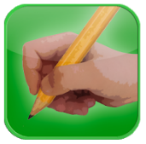 | Ready to print  Designed by an Occupational Therapist. Includes shape tracing, pinching , letter writing, connect the dots | Apple and Android | £9.99
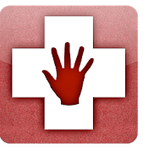 | Dexteria- fine motor skill development  Designed by an Occupational Therapist focuses on tablet skills such as pinching and locating an icon | Apple and Android | £6.99
 | Dexteria Junior  Designed by an Occupational Therapist this is a Multi-touch interface to help build strength, control, and dexterity.  A set of hand and finger exercises to develop fine motor skills and handwriting readiness | Apple and Android | 3.99
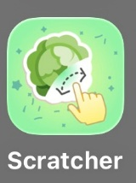 | Scratcher by Assistive Cards  Choose a category and then scratch out the cards to find the correct one. | Apple and Android | Free
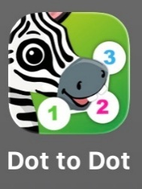 | Dot to Dot  Join the dots to reveal the farm animal or equipment. | Apple and Android | Free set available  In app Purchases to access other animals
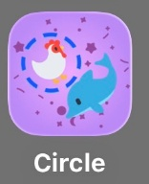 | Circle by Assistive Cards  Choose the category and circle around the correct picture. | Apple and Android | Free
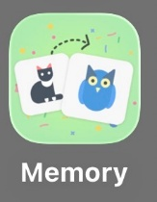 | Memory by Assistive Cards  Select a category and a difficult level.  Use your memory to remember where the cards are to match a pair. | Apple and Android | Free
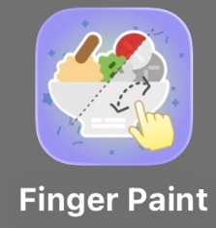 | Finger Paint by Assistive Cards  Select a category and paint the correct picture. | Apple and Android | Free
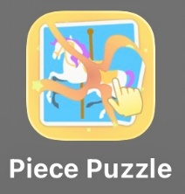 | Piece Puzzle by Assistive Cards  Select a category and out the puzzle together to match the picture. | Apple and Android | Free
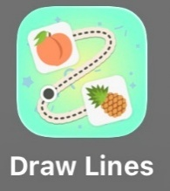 | Draw Lines by Assistive Cards  Select a category and follow the line to the correct picture. | Apple and Android | Free
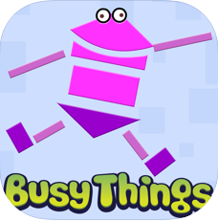 | Shape up lite Busy things  Trace over shapes  Good for Early Years age | Apple and Android | Free
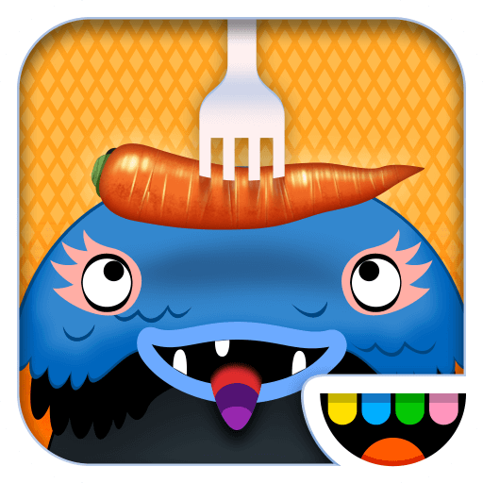 | Toca Kitchen  Choose your monster, prepare it some food to eat and then feed it. Good for Early Years. | Apple | Free
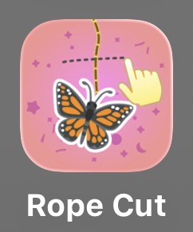  ##### | Rope Cut by Assistive Cards  Select a category and cut the rope of the correct item. | Apple and Android | Free
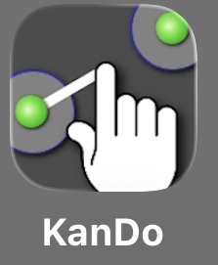 | Kando  Test your accuracy, steadiness and reaction times. | Apple and Android | Free
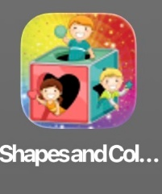 | Shapes and Colours  Select and move the correct shape to the area that matches the shape and colour. | Apple and Android. | Free

Handwriting Apps
Tip: Before downloading a handwriting app make sure you know what style of handwriting your child is learning. There are a variety of cursive and printed scripts so we strongly recommend you only use the script they are familiar with. Many of the apps have a variety of scripts within them in the settings menu. Check the free versions before committing!
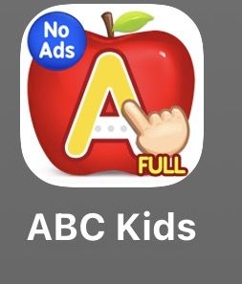 | Lucas and Friends: ABC Kids  Select the category and letters.  Follow the lines to complete the letter. | Apple and Android | Free
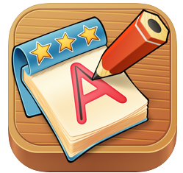 | ITrace  3 different handwriting styles. Can add own words for spelling practice. | Apple | £3.99  Free version available
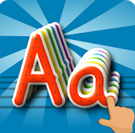 | letraKID pro- handwriting ABC  No cursive script, only printing available. Some nice pre-writing patterns to copy. | Apple and Android | £2.99  Free version available ABC&123
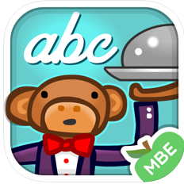 | Crazy cursive letters  KS1 includes link to 100 high frequency words in Reception and KS1 | Apple and Android | £2.99  Free lite version
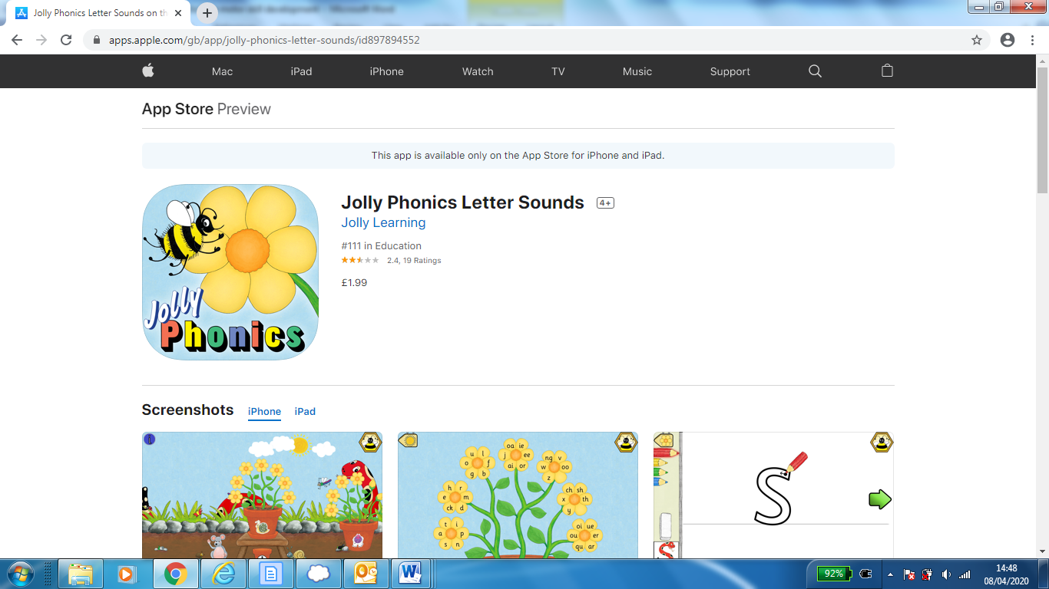 | Jolly Phonics letter sounds  Links to phonics letter sounds print or pre cursive script | Apple and android. | £1.99
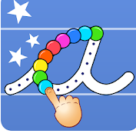 | Cursive writing wizard  Pre writing shapes, learn cursive style | Apple and Android | £4.99  Free starter available
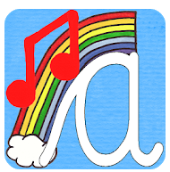 | Singalong cursive handwriting  Each letter has it’s own song. Links to letter families | Apple and Android | £1.99  Free trial version
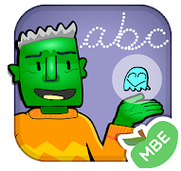 | Spooky letters  Spooky themed activities to encourage letter writing | Apple and android | £2.99  Free lite version

