Gross motor skills
Gross motor skills enable us to do things that involve using large muscles in our torso, arms and legs.
They allow us to roll over, sit up, craw and walk, catch a ball, balance, climb, jump and run.
Working on your child’s gross motor skills will help them to gain strength and confidence in their body.
It will also help them get some exercise and physical activity, which is important for a healthy lifestyle.
Developing these skills helps a child’s ability to do more complex things like sport as they get older, which I guess, is what you would expect?
What you might not realise is that gross motor skills are also essential for handwriting.
It’s simple really - In order for your child to be able to sit upright at a table for any length of time, they need to have developed strength and stability in their:
- Trunk
- Neck
- Shoulders
- Hips
Some children struggle with:
- Simply sitting at their desk, they may flop forwards after a short time in order to give themselves a break from sitting up straight because the muscles in their trunk, neck and hips tire.

- Placing their pencil at the left hand side of the page and writing along the full line from left to right, because their shoulder strength isn’t developed enough for the job of crossing that mid line over and over again.

- Maintaining the correct pressure, size and spacing of their writing because the muscles in their wrist and shoulder are not able to sustain the effort with the amount of writing they are expected to produce.

Here are some ideas for activities for your child to help build
Gross motor skills for handwriting.

Trunk Stability:

Press ups against the wall | 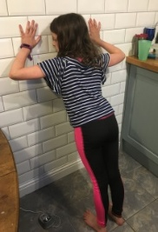
Superman  - lay on your tummy with arms outstretched in front  - and legs straight and lifted off the floor | 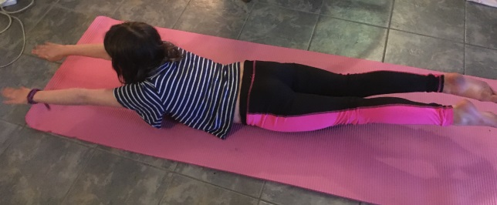
2 Handed Bat game  - Children lay out flat on their tummy facing each other  - Arms outstretched in front of them  - Hold a bat (or a book) in both hands  - Bat a ball to and from each other. | 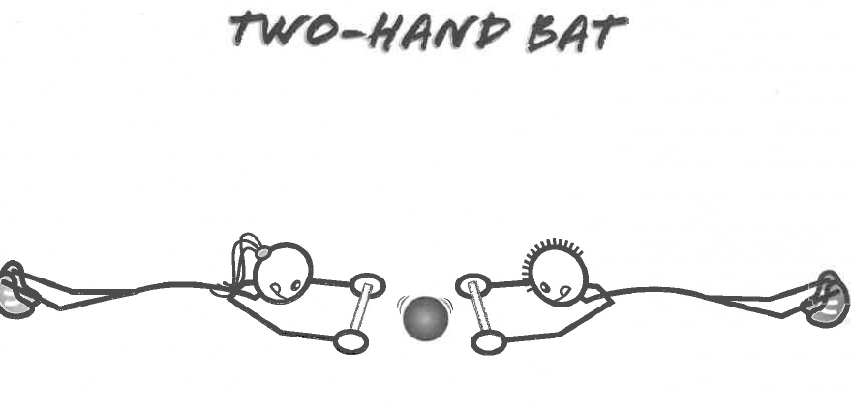  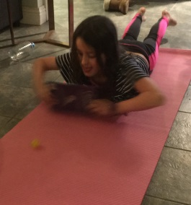  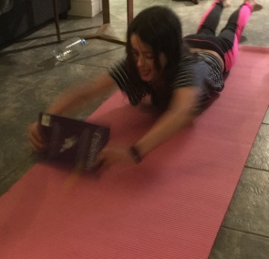
Bottom shuffle:  - Sit on the floor  - Place a toy in your lap  - Walk on your bottom without using your hands to deliver the toy to its destination.  - Try shuffling sideways or backwards | 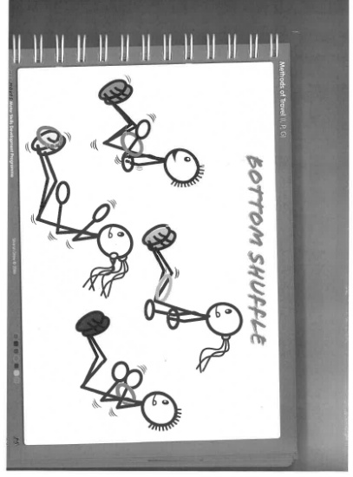
Neck Stability:

- Balance a beanbag or beanie toy on head.  - Walk along a straight line.  - Try making an obstacle course to increase difficulty. | 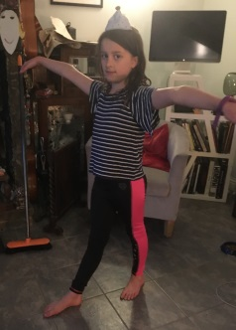
TV position  - Lay down on your back on the floor  - Lean back on elbows.  - Keep your head up and look forward.  - Hold the position for as long as possible and keep extending the time. | 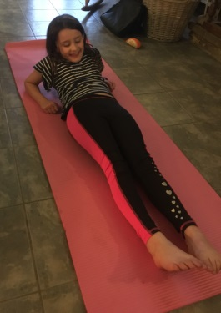
Shoulder stability:

Activities using dance streamers or ribbons | 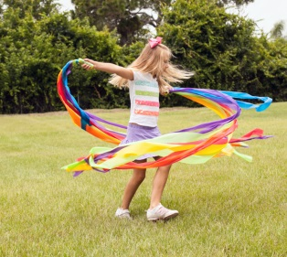  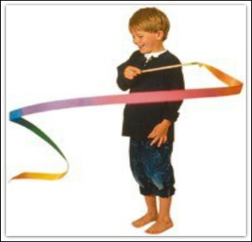
Keeping large balloon in the air above the head. | 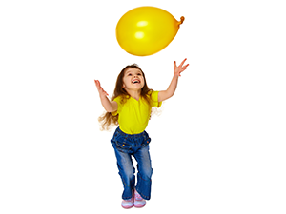
Pouring water from one container to another | 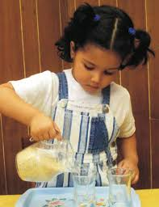
Chalking on a wall using whole arm movements | 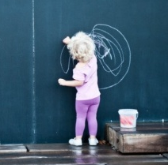
Twirling a skipping rope. | 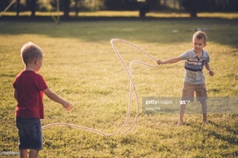
Animal Walks:  Puppy dog walking  Also good for hips, wrists and shoulders.  Crab walking  Also good for hips, wrists and shoulders  Bunny hops | 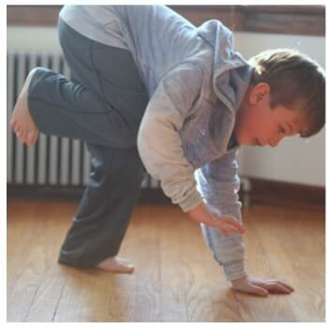  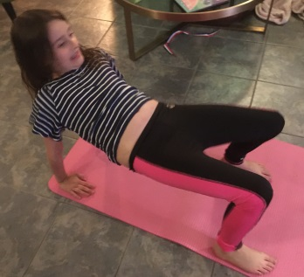  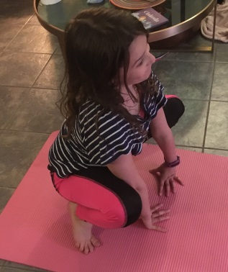
Tug of war. | 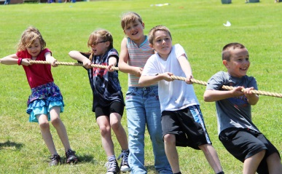
Hip stability:

Tight rope walker  - Walk along a straight line or skipping rope placed on the floor. | 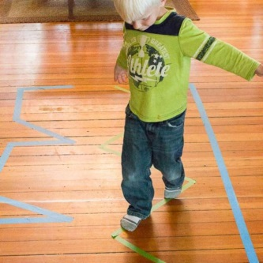
Crab grab  - Scatter soft toys around the floor  - Scoot around the floor in a crab position, collect the toys by sitting down and using their feet to pick them up.  - Once the toy has been picked up with feet they can then hold it with their hands and scoot back to a collecting point. | 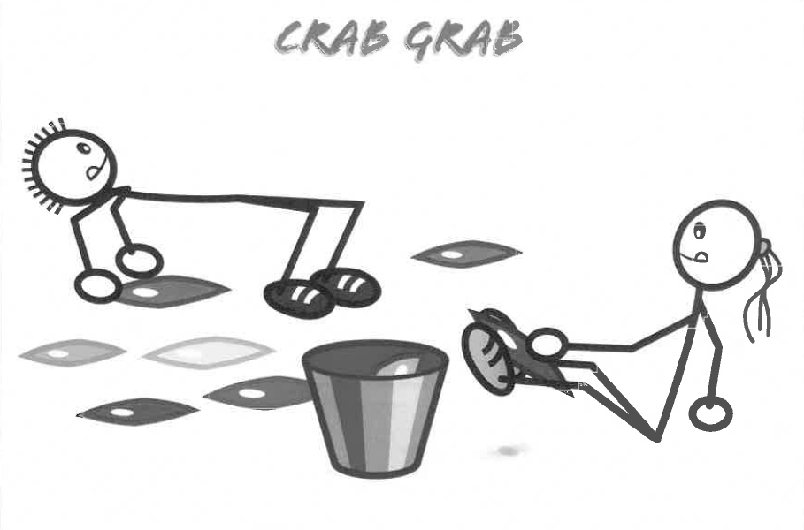
Bridges  - Lay on the floor on your back.  - Form an arch by placing feet flat on the floor and lifting up knees and hips (like a crab)  - roll a ball or push a car through the arch. | 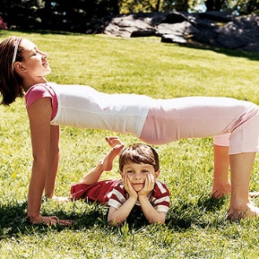
Wrist stability

Wringing out a dish cloth. | 