
Arfur Moe's
Transition Workbook
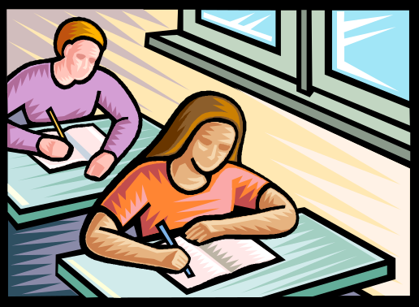
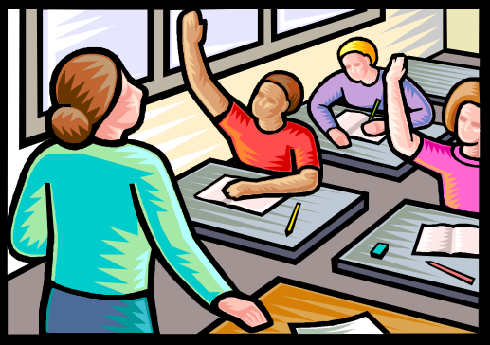
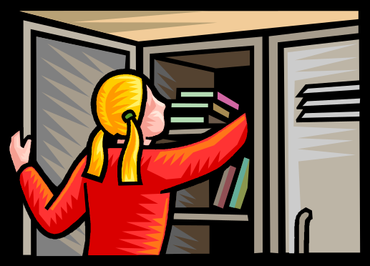

A.t.t.


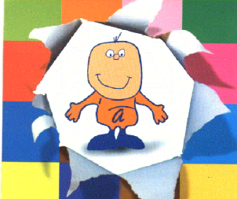


It may seem a long way off now but SATS will soon come and go and you’ll begin thinking about the big move from here to your secondary school. Changing school should be exciting but you might also feel a bit nervous. It will involve a lot of changes and new experiences for you in September.

This is ‘Arfur Moe’s Transition Workbook’ and you can use it both at school and at home. It will hopefully explain a lot about secondary school and answer some of your questions as well as help to prepare you for all the changes.

Arfur Moe hopes that you will enjoy all the different activities in the book. Once you’ve finished, you’ll receive a well-deserved certificate!

Good luck!

Find a photo of yourself in your primary school uniform and stick it here!

Name: ________________

Primary school I attend:
___________________________________

Secondary school I will attend in September:
___________________________________

Finding out about my new school




Use the information your teacher has been given by the new school to fill in this fact sheet…

The name of my new school is _________________

The address is __________________________________________________________________________________

The telephone number is _____________________

The name of the head-teacher is ______________

School starts at _______ and finishes at _______

I will travel by car/bus/walking/bike/train circle the right one

To get to school on time, I will need to leave my house at about _______________

I will attend the school from ____ September 200_

Finding your way around Pg. 1

School map Pg. 2

The timetable Pg. 3

Timetable practice Pg. 4

My new timetable Pg. 5

Homework Pg. 6

Homework questionnaire Pg. 7

Equipment Pg. 8

School rules Pgs. 9 & 10

Rumours Pg. 11

Meeting new people Pg. 12

Making friends Pg. 13

Most Year 6 pupils feel a little scared about going to a school which is so much bigger than their primary school. They feel worried about getting lost, or being late for a lesson because they’re not sure of where the room is.
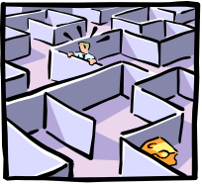

A map can help because it shows where all the different rooms are and you can easily see the quickest way to get there.
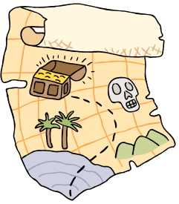

There is space to stick in your map on the next page.


If you like science you could look to see where the science labs are.

Or if you think dinnertime is the best thing about school then you can look to see where the canteen is!


Stick a copy of the school map here

One of the first pieces of information you will be given in September will be your timetable. It’s very important because it not only tells you which lessons you will have that day but it also gives you a clue about the equipment you will need to pack in your bag the night before. It also tells you what time each lesson starts and finishes and in which room they will take place. If you haven’t got a watch yet, it might be a good idea to buy one to practise telling the time and getting to places on time.



Usually the timetable will also let you know which teacher you will have for each subject. Instead of just one teacher, you’re going to have to get used to ten or more different people being in charge of your class! Often, the timetable will have the teacher’s initials next to the name of the lesson.
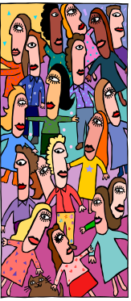

You will probably have 5 or 6 different subjects every day and some will be in special rooms. For example science will usually take place in a laboratory.


One thing to watch is whether your school has a two week timetable or not. If your school does use this system, you will have to remember whether you are on week one or week two.

Study the timetable from the secondary school and see if you can answer these questions……

1. When do you spend time with your tutor?
__________________________________________

2. Which days will you do P.E.?
__________________________________________

3. What equipment will you need to pack for Thursday’s lessons?
____________________________________________________________________________________

4. Which room or rooms will you have English in?
__________________________________________

5. When is your favourite lesson?
_____________________________________________________
Stick a copy of your timetable in the space provided. If the secondary school hasn’t decided on the new Year 7 timetable yet, stick in this years timetable as an example.

YEAR 7 TIMETABLE

Homework!


Homework – ugh! No one likes it but it’s just one of those things that you have to do and the more organised you are, the less amount of time you’ll have to spend doing it.

In Year 7 you may start to get a lot more homework than you have been used to. Teachers will be stricter about getting it done and handed in on time too.

To help you do this, you will probably be given a homework diary where you or the subject teacher can write down what you have to do and when it has to be finished by.


Why is homework important?
Homework is really important because it shows the teacher whether you’ve understood the work or not. It also means that you can cover more work than the time allowed by a lesson in school.

Questions to ask….
You need to make sure that you really understand all the rules about homework. On the next page there are some questions you could ask your form tutor. You can add a few more of your own if you like.


This is your chance to ask your form tutor everything you can think of about homework!

1. How long will I be expected to spend on homework each night? ______________________________________

2. How will I know what to do? ________________________
____________________________________

3. How long will I have to complete it? __________________

4. What should I do if I get confused when I’m writing the homework instructions in my diary?
__________________________________________________________

5. What will happen if I forget to do it or forget to bring it in?
____________________________________

6. What should I do if I find the homework is too difficult? __________________________________

_________________________________

7.______________________________________________
________________________________________________
8.____________________________________________________________________________________________



In primary school, most of the equipment you need is kept in the classroom. But at secondary school, you will be expected to have your own pencils and pens and you will have to carry them all around with you. There are lots of other things you might need too.

Circle the equipment you will probably need and draw in any more you can think of:












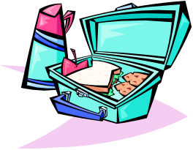


It might seem like an awful lot to remember but try not to worry about it. You can get your parents or your form tutor to write a list of the things you will need for each day. You could then tick each item off as you pack your bag. Make sure you pack your bag the night before!!

Adapted from Maines, B. & Robinson, G.

Why do we have them?

Every school will have some rules for the classroom, corridors and assembly as well as rules about homework, break-times and uniform. You might not like them or even agree with them but they are there to make life easier for everyone in school.

Can you think of the reasons why schools need rules? ________________________________________________________________________________________________________________________________________________

Breaking the rules!

There will always be consequences for breaking the rules too. So it’s not only important to know what the rules are but also what will happen if you don’t follow them.

Apologising

If you do break a rule, it is usually a good idea to admit that you got it wrong and to say sorry.

It might be useful to practise apologising. Look at the scenarios on the next page. In each one a rule has been broken. With a partner take it in turns to be the annoyed teacher and the pupil who says sorry. It can be hard to keep your cool if you’re being told off. Try to remember things will only get worse if you get angry!

Write down as many secondary school rules as you know:
_____________________________________________________________________________________________________________________________________________________________________________________________________________

What might happen if you break the rules?
_______________________________________________________________________________________________________________________________________________________________

What should you do in these situations?
1. You have not done your homework because you didn’t write the instructions down properly……
________________________________________________________________________________________________

2. A teacher tells you off for talking in class but you were just answering your classmate’s question…..
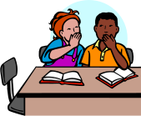
________________________________________________________________________________

3. You have forgotten a textbook you need for that lesson……
________________________________________________________________________________________________

4. The teacher sees you chewing gum in her lesson and isn’t happy….
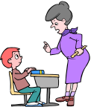
______________________________________________________________________________________


Most people in your class will probably want to talk about going to secondary school because it’s a big step for you all. It’s good to talk about all the exciting things ahead of you and it’s also good to tell each other about the things you’re a bit worried about.
Sometimes though pupils can scare each other unnecessarily because they have listened to rumours about what the school is like.
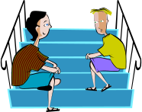

Look up the word “rumour” in the dictionary and write the definition here:
____________________________________________________________________________________________________________________________________________
Very often rumours are exaggerated stories. For example, a story that there are gangs of older students taking money from new Y7 pupils could be an exaggeration of a one off incident where a Y11 boy ran off with £1 when a Y7 girl dropped it.

Rumours may have an element of truth in them but usually they contain a lot of things which aren’t true. It’s best to listen to the facts that members of staff tell you rather than the rumours pupils from the school might tell you.

Write down some of the rumours you have heard:
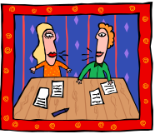

__________________________________________________________________________________________________________________________________________________________________________________________
______________________________________________________________

How many people are in your Y6 class?

How many years have you known them?

How many adults are there in the room?

Most children in your class will feel comfortable and happy because they know everyone very well and feel like they belong. Just having one teacher can make you feel safe too. Going to secondary school can be different because you won’t know everyone and it may take a bit of time to feel like you ‘belong’ in your new form.
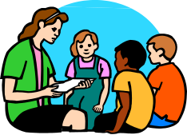

The important thing to remember is that EVERYONE will feel the same way and that you’re not alone. It’s actually a good opportunity to make new friends and learn from adults who have specialised in their particular subject.

I am looking forward to meeting… ____________________________________________________________________________________

I am not sure about meeting ___________ because…
____________________________________________________________________________________________________________________________________________
______________________________________________________________________

Everyone has strengths and weaknesses. Some pupils find it really easy to get to the top level on a computer game whilst others never get past Level 1. Some pupils have no problems drawing amazing life-like pictures whilst others find it difficult to draw a good stick-man.

It’s the same with making friends. Some pupils love meeting new people, are very chatty and make lots of friends easily. Others don’t know how to begin to make even one new friend.

Where do you think you are on the friendship scale?
No idea how to make a new friend
Quite confident I can make new friends
Looking forward to making lots of new friends

0 1 2 3 4 5 6 7 8 9 10

Below are a few hints and tips to help you make a new friend. Why don’t you practise with a classmate?
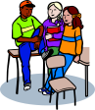
- Smile
- Tell them your name and ask what they’re called
- Find out what they are interested in
- Talk about shared interests – you both might like computers
- Ask them if they want to do something at break-time
Arfur Moe's
Transition Workbook Evaluation
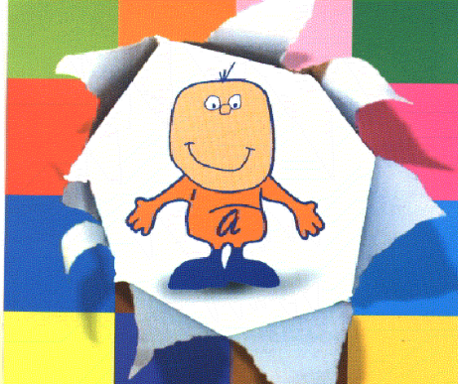

NAME: ___________________________________

PRIMARY SCHOOL:_________________________

SECONDARY SCHOOL: ______________________
Well done! You have completed the Transition Workbook. I hope you feel prepared for Secondary School now!
Please fill in this evaluation.
There are no right or wrong answers. Just be honest!

1. Did the questionnaire help you to think about which things you might need help with at Secondary School? YES/NO (circle your answer)

2. Did you like filling in the worksheets? YES/NO

3. Did you have enough time to complete the worksheets? YES/NO
4. The worksheets were meant to prepare you for Secondary School. They told you what to expect and gave you information about Secondary School.

Give a score for each worksheet:
1= didn’t help me 2= quite helpful 3=very helpful

 | 1 | 2 | 3
Finding your way around
School map
The timetable
Timetable practice
My new timetable
Homework
Homework questionnaire
Equipment
School rules
Rumours
Meeting new people
Making new friends

5. List other things you would have liked a worksheet on:
______________________________________________________________________________________________________________________________

Well done! Please give this to your teacher.
ACKNOWLEDGEMENTS


DfES: Philip Rhodes
Andy Simpkins: Greater Merseyside Regional SEN Facilitator

Halton:
Melanie Allen, Yvonne Drew, Heather Rawling

Knowsley:
Heather Burr, Steve Wilson,

Liverpool:
Joan Taylor, Liz Kelly, Paula Griffiths

St.Helens:

Simon Bigwood, Shirley Dean, Gaynor Duggan,

Sefton:
Gary Bevin, Denise Paynter, Jackie Rutter,

Wirral:
Shirley Stear, Mike Unwin, Debbie Chamberlain, Amanda Lewis, Muriel McCreedie, Elaine Ambrose, Julia Iatridou-Jones, Gill Johnson

Peterhouse School:
Gill Burnell

Wargrave House School:
Pam Maddock, Gennie Hyde, Liz Hitchen,

Additional:
Beryl Young Ed.Psych, Colette O’Brien, - SEN Liverpool, Jennifer Laute Ass.SEN Officer St.Helens, Gillian White – SpLT Blackpool and Wyre, Liz Roberts Liverpool Compact, Kath Corbin Soc.Services,

Jo Linley-Hallwood Park L.S.S.
Fiona Crampton – John Moores University

Sharon Hanner – Co-ordinator @ OSSME
The OSSME Team - Heather Boadle, Cindy Tomkinson, Noreen Lashley, Suzanne Stampone, Janet Byrne, Dawn Makinson, Stacey Pamment


Find a photo of yourself wearing the clothes that you usually wear to school now and stick it inside the orange box.

My name is:

Today’s date is:

Name of the school I attend now:

Name of the new school I will attend in September:

