"Listen To Me!"

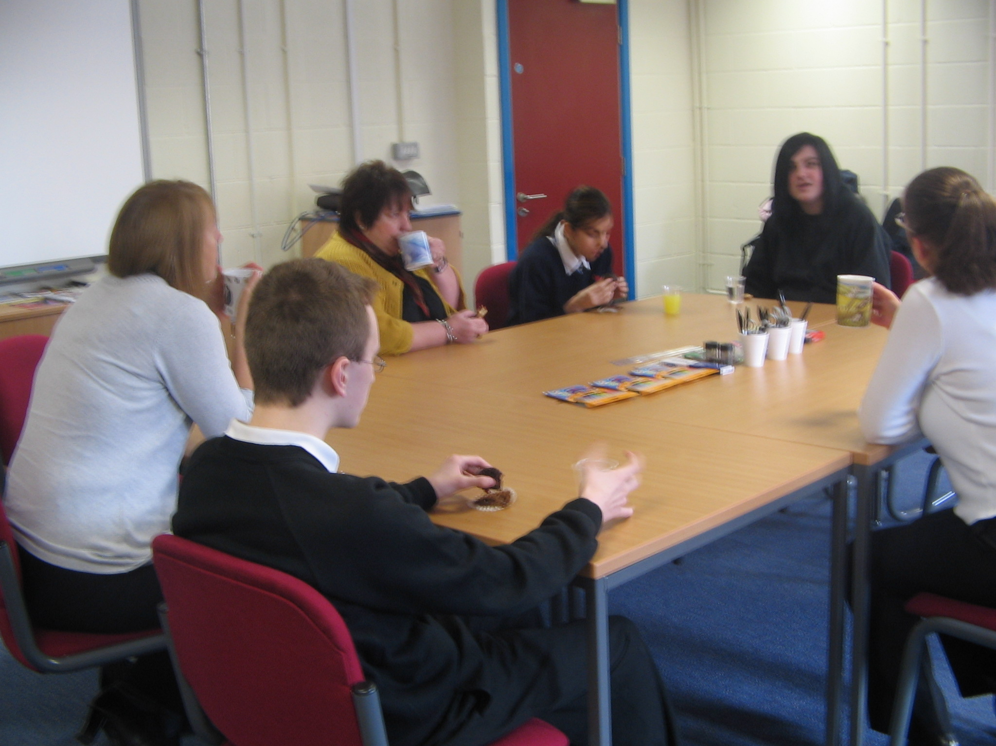


What Young People Who Have Autism Told Us About Changes & Moving Into Adulthood

Author Pauline Dempsey

Acknowledgements: The author would like to thank the children with autism who took part in the focus groups and who filled in the transition surveys that inform this report. Thanks also to the ASD Team staff (Education Bradford) who helped produce this report, including Julie Ackroyd, Amber Burton and Carol Shiret.

Introduction

This research project is part of a whole review process being undertaken by Education Bradford’s Autism Spectrum Disorder Team (ASD Team), in order to help us to identify and consider the priorities for the development of future provision, and support for pupils who have a diagnosis of autism (including conditions associated with the spectrum), i.e. the main aims of the ‘Listen To Me’ project are;

- To identify current practice in relation to transitions for young people who have autism in Bradford
- To view current practice in light of the national perspective in order to identify ‘gaps’ in provision
- To contribute towards better transitions through ‘pupil voice’ and to identify strategies to ensure this is heard

We have had a growing awareness of the inadequacy of arrangements for young people on the Autism Spectrum to make well planned, effective and supported transitions throughout secondary school and then to P16/adult services, including further/higher education. The aim of better transitions is to help individuals to choose their own futures, including the lifestyle they wish to lead.

This document explores the views and experiences of young people with an ASD about transition. The information used has been obtained from two focus group days held with pupils in April 2008, following responses to a survey in the form of a questionnaire.

The ‘Listen to Me’ project started in the summer term 2007. To capture the opinions of young people with autism, 50 students from 11 to 18, across a number of mainstream Secondary schools in the Bradford District completed a ‘Well Being’ survey form (see appendix 1).

Students were asked about their experiences of school and also to contribute their ideas for improvement and change. Twelve of the young respondents expressed an interest in attending a focus group, in order to meet with students from other schools and talk about how we can make secondary school better.

Also, in July 2007, 10 students who were moving up to secondary school completed a ‘Confidence Survey on Transition’ (GAP Good Autism Practice 2006 publication). Students were asked about their confidence to do certain activities, such as, travelling to and from school and taking the right things to school each day.

There are two drivers for the emphasis of the ‘Listen to Me’ project, both from a national perspective;

- National drivers –

  - ECM (Every Child Matters agenda)
  - New inspection framework, DFES (2004) statutory guidance to schools
  - SEN code of practice
  - Removing barriers to achievement
  - Children Act 2004

- Autism Spectrum Condition drivers –

  - ASD Guide to good practice (DfES)
  - NAS ‘Making Schools make sense’ (National Autistic Society, 2006)

The ‘Every Child Matters’ publication acknowledges the need for all children to feel safe, happy and included in order for learning to happen. The ASD Team within Education Bradford Learning Support Services feels that enabling children to feel well, secure and happy is a top priority for our team and effective transitions is a key part of this.

Why Pupil Voice?

Over the last 10 years there has been an increased commitment to consulting and involving people who use services, to enable their planning and development to be more productive. Whilst there are many transition programmes being used across the schools in Bradford, observation of existing practice indicates that some processes are not child centred enough and can be an exercise to fulfil the statutory requirements rather than it being ‘holistic’ and individualised planning taking into account ASD specific needs.

For students with ASD there is a tendency to focus too much on academic targets and not enough on ‘life skills’ which underpin their move to more adult and independent living.

In order to improve our service we want to listen to what pupils have to say about their experiences of school and transition. Recent literature on ASD’s has shown the importance of including the perspective of those with ASD when developing services and designing provision to meet their needs.

The ‘Listen to Me’ project is all about students with ASD being involved and consulted about their views on transition and changes, using their contributions to improve the transition process and promote well being in school.

The ‘Listen to Me’ project is about;

- The consultation process
- Development of information gathering materials
- Using feedback to inform future service planning

Pupil voice strategies make sense because;

- Young people have rights and responsibilities now enshrined in international law
- How will we know if provision and learning is appropriate if we don’t listen?
- They ensure young people feel valued and it enhances their self esteem
- Enables pupils to contribute their ideas for change and improvement

The Background to the Research

Autism is a complex lifelong condition which affects a person’s social and communication skills. It is a spectrum condition occurring in varying degrees of severity and affects more than 500,000 people in the UK today. Estimates suggest there may be about 1 in 100 people with an autistic spectrum condition and many will also have a learning disability. About four times as many boys as girls have ASD in the group with learning disabilities and it is thought that there may be ten times as many boys as girls in the high ability group. (NAS, 2008)

For most young people, the process of moving from childhood to adulthood is a difficult time. Young people have to cope with changes in roles, relationships, expectations and status, whilst also dealing with the physical aspects of growing up.

The process also typically involves changes in environments, for example moving to college. The process is doubly complicated for young people with an ASD, many of whom may rely to a greater or lesser extent on services.

Change and transition for pupils with an ASD is particularly hard because they prefer familiarity and change leads to high levels of anxiety. Some pupils have an obsessive desire for sameness. So any changes are particularly challenging, not just major ones such as leaving school.

Project Planning

- Planning for structured focus days to gather qualitative information – needs of ASD students considered.
- Processes - Mind mapping methods of information gathering and evidence that would be gathered
- Design of activities – careful scaffolding, using strengths e.g. ICT skills
- Consultation with:

  - Careers Bradford regarding project requirements
  - team leader regarding additional resources (scaling activity, explaining why we are doing this and that change takes time)
  - colleague regarding design and making of resources

Initial plans did not change but activities were added to those originally planned e.g. a visual scaling activity regarding how happy pupils are currently in school.

Description of the ‘Listen to me’ AR project

To obtain qualitative feedback;

Two structured focus groups were held involving secondary aged pupils who are on the autism spectrum, and who participated in discussions about well being in school, as well as issues around changes and transitions.

Pupils experiences were captured as were their thoughts about what they would like to change to make things better. Support workers were also asked to evaluate the focus group day and comment on;

- The activities as a way of capturing pupil views
- Was it a positive experience for the student?
- Would you have done anything differently?
- Could you see this process working in your school and/or with other providers, such as careers, health or social services?

(see appendix 2)

Materials developed and methods used to obtain quality feedback

It is important to stress that the structure of the focus days and the materials used were developed with the needs of ASD pupils in mind. People with an autism spectrum condition often have different perspectives and experiences of the world from ours. They may be affected in their ability to;

- Understand and use non verbal and verbal communication
- Interpret social behaviour and to interact with others
- Think and behave flexibly

Sensory perception and responses can also be different from typical people in the areas of sounds, sights, smell, touch and taste.

Focus Group – Day timetable and plan

Pathfinder Group Day

9.30 – 10.00 Drinks – scaling activity

10.00 – 10.15 Welcome

10.15 – 10.45 Mind map
My Ideal School

10.45 – 11.30 Leaflets/PowerPoint’s

11.30 – 12.00 Circle time / feedback

12.00 – 12.45 Lunch

12.45 – 2.00 Transition Questionnaire
(see appendix 3)
Hope Tree
(see appendix 4)

Hi, this is how we started our Hope Tree… What do you think?
We are getting on with our Mind Mapping exercise.

We’re using Lap Tops to present our ideas
This is some of the work we completed, next to our visual timetable.

Overall evaluation and recommendations

Outcomes of the project;

- The feedback from pupils with ASD will be used by Education Bradford to inform future service plans to improve transition planning and processes.

- Support staff felt that pupils benefited from being able to network with others with similar difficulties. Several commented that they felt students interacted well and gained from being able to listen to others and their experiences.

- Pupils were very positive about being able to express their views and about the information gathering process used on the day.

- Pupils often felt that decisions were made for them by school staff/parents/careers and connexions, without them being consulted, including courses they were directed towards.

- Pupil voice is imperative in all aspects of education and making life choices and, as such, young people should be given opportunities to have their say through ways and means that enable them, at their own level, to speak. This could take the form of;

  - School councils
  - 1:1 discussions with relevant adults
  - Focus days such as ‘Listen to Me’
  - Participation at annual reviews
  - Active involvement in transition plans

Summary

In order to make informed choices or contribute to the decision making process about transition, young people need access to information and to be able to make their views known. Information needs to be provided for and gathered from children in appropriate formats.

“to be able to choose your own course” – student comment on what they thought could have been done better

The focus group days showed that plenty of time should be allowed for the process of managing change and transition. Also for young people with an ASD it is very important for them to have a ‘key worker’ to support them throughout the independent decision making journey and not to have professionals ‘parachuted’ on them at key times e.g. careers workers. Pupils with an ASD also need time to build up quality relationships with support workers so that they trust them enough to accept support and share their ideas hopes and wishes for their own future.

Making informed choice is not simply about hopes and dreams, but about making choices between realistic options. Adults who work with students who are on the autism spectrum should be aware of all of the options available which will meet the student’s needs.

In effect, adults need to take time to ensure children understand what their options are and should be providing every opportunity for making informed choice and this should be done in a pro-active way, e.g. preparing the ground for effective choice making and pre-planning how this can be achieved.

Lastly, to conclude the ‘Listen to Me’ project, the main points that have been raised include;

- Students who are on the autism spectrum should be provided with appropriate autism specific strategies that enable them to express their opinions on their own lives and take into account their specific need which may not always coincide with mainstream views and opinions. It should not be taken for granted that the adults involved ‘know better’.

- The focus group day model should be considered as one of the ways of gathering pupil views about transition and their wishes for the future. Secondary schools should take notice of this strategy and where large numbers of students attend one school consider using this as a model for ‘Hearing the ASD Pupil Voice’.

- Agencies should be working together to ensure that planning with the student happens as soon as possible and not overlooked until the last minute on leaving school. Agencies should also be involving themselves with the student rather than just liaising with other adults. This should be done over a long period of time, not just at key meetings e.g. year nine and year 11 transition reviews. There should also be a focus on planning for those students at action plus as well as those with statements of SEN.

Appendix 1


Education Bradford

Learning Support Service
Autism Spectrum Team

Well Being Questionnaire

Introduction

‘Every Child Matters’ acknowledges the need for all children to feel safe, happy and included in order for learning to happen. Feeling well, secure and happy is especially important for pupils on the autistic spectrum.

Lack of wellbeing at school can have a huge emotional and physical impact on students with ASD and their families. For this reason we want to know about pupils’ feelings and experiences.

To do this we are conducting a simple questionnaire study to identify the school related issues that are most important to students. Initially this will be aimed at secondary school students.

Any information that is provided will be confidential. The research findings will provide us with information from our pupils about their social and emotional wellbeing at school.

These findings will help us to consider the priorities for the development of future provision and support.

Guidance for Support Staff on Assisting Students to Complete the Questionnaire

It is important to us that the student’s own views are recorded on this survey. We would therefore ask that you assist the pupil to record their own thoughts as accurately as possible.

Please also record on the scale below what help has been given to the pupil in order for them to complete the survey.

This information will help us to be aware of how independently the student was able to complete the survey.

Support Given (please circle the box that matches the amount of support the student required to fill in this questionnaire)

Independent (completed with no support) | Minimal Help (e.g. for reading, etc) | Some Help Required  (e.g. for some comprehension) | Fully Supported (interpretation required for all aspects)

Some Information about why My Ideas are Important to Learning Support Services

Schools are places where young people learn the skills that they will need as adults. Some young people go onto higher education, some do apprenticeships and some get jobs, when they leave school.

In order to learn students need to be well, safe and happy at school.

The learning Support Service would like to know what kind of things would make school better for you, so that more students can feel well, safe and happy in school.

Learning Support Service would like you to fill in a questionnaire to help us suggest changes. You will be given any help you need to fill in the questionnaire.

I would like to complete a questionnaire

I would not like to complete a questionnaire

Section A

This section asks you some facts about yourself

Please circle the answer that applies to you

My name is (this is optional);

I am male/female;

I am in year; 7 8 9 10 11 12 13

My school is;

Please circle the statement/s that applies to you

I want to fill in the survey myself

I would like help to fill in the survey

I would like someone to write my answers (scribe)

Section B

This part asks you about the support you receive in school from staff and other pupils.

Who do you ask for help when you are worried or don’t understand? Circle the person’s role below. If you feel there is nobody please circle nobody. You can have more than one person who helps you.

Teacher | Form Teacher
Mentor | Dinner time Staff
Support Assistant | Friend
Other (please say who) | Nobody

Are you happy with this support? | Yes | It’s OK | No | Not Sure
Is it a good way to get support or help when you need it? | Yes | It’s OK | No | Not Sure

Can you think of a better way to get help when you need it? If you can think of a better way please write it in the space below.

Section C

Please circle the answer that is closest to how you feel at school.

I feel happy | usually | not often | not at all
I feel relaxed | usually | not often | not at all
I feel sad | usually | not often | not at all
I feel worried | usually | not often | not at all
I feel scared | usually | not often | not at all
I feel safe | usually | not often | not at all
I am confident | usually | not often | not at all

I worry that people don’t like me | sometimes | often | almost always
I worry about not being able to cope in school as much as other students | sometimes | often | almost always

Section D

This part of the questionnaire asks about your views of some parts of school life. Please circle the answer that applies to you.

I like having clear rules and order at school | Applies to me | Applies to me a bit | Does not apply to me
I don’t like situations at school that are uncertain | Applies to me | Applies to me a bit | Does not apply to me
I tend to struggle with most choices at school | Applies to me | Applies to me a bit | Does not apply to me
I prefer only having a few friends as I know what to expect from them | Applies to me | Applies to me a bit | Does not apply to me
I like my routine to stay the same at school | Applies to me | Applies to me a bit | Does not apply to me
No-one really cares about what happens to me at school | Applies to me | Applies to me a bit | Does not apply to me
Staff have said kind, positive things about me | Applies to me | Applies to me a bit | Does not apply to me
Pupils often say kind, positive things about me | Applies to me | Applies to me a bit | Does not apply to me
Staff often say insulting, unkind things about me | Applies to me | Applies to me a bit | Does not apply to me
Pupils often say insulting, unkind things about me | Applies to me | Applies to me a bit | Does not apply to me
I have been bullied at school | Applies to me | Applies to me a bit | Does not apply to me
I like a quiet classroom at school | Applies to me | Applies to me a bit | Does not apply to me
I enjoy break-times at school | Applies to me | Applies to me a bit | Does not apply to me
I would like to do my homework well but am often confused about what to do | Applies to me | Applies to me a bit | Does not apply to me
I enjoy most of my time in school | Applies to me | Applies to me a bit | Does not apply to me

Section E

Please use the space below to write some sentences telling us how you feel about secondary school.

If you think that anything could be changed to make school a better experience for you, please write your ideas in the space below.

If you would like to draw and label your ideal classroom, this would help us. Please do this on the last sheet of paper attached to this questionnaire – only if you want to.

Please underline your choice below;

I would like to draw my ideal classroom

I would not like to draw my ideal classroom

Wellbeing Survey

We would be interested in talking to some students about how they think we could make a secondary school better.

Would you like to do this?

Yes | Not Sure | No

If you answered ‘yes’ please can you tell us your name, if you haven’t already done so?

My name is;

Thank you

My Ideal Classroom

Appendix 2

Questions for Support Staff

- Do you think these activities were a good way to gather information from pupils about their views of school life and about transitions/changes?

  - Yes I do think the activities were good. They made the students think about what they liked and disliked.
  - Yes this was a good way. The information is from the children who have experienced changes and know what went well and what didn’t.
  - Yes, the students seemed comfortable exchanging views.
  - Yes, they gave them chance to talk.
  - I do think so, but it could have also emphasised changes and expectations from and between year groups.

- Do you think that this has been a positive experience for the student?

  - It was a very positive experience for the students, they all interacted very well.
  - Yes very positive because they could listen to others and their experiences.
  - Yes, it was very interesting to see the students interact and very interesting to listen to their ideas about homework etc.
  - Very much.
  - Yes students interacted well together.

3. Is there anything you would have done differently – if so
what?

- I wouldn’t have done anything different. I found the session very well organised and positive.
- No everything was fine, perhaps a little bit longer to do the presentations.
- Don’t think so.
- May be some fresh air.
- No, J enjoyed a little indulgence (chocolate)
- Perhaps either a shorter duration or increasing the pace and extending the number of activities

4. Could you see this process/or similar process working in your own school and/or with other providers such as careers services, health and social services?

- I think this process could work in most services, as it enables problems to be discussed and sorted.
- Yes this may be a good way to communicate with other services that are usually connected to particular students.
- The students were delighted to be out of their own school for the day!
- The chance to talk about careers would be very helpful in key stage 4.
- Yes, it was good to work with J outside the school environment and observe his behaviour.
- Not particularly other than perhaps in careers groups in schools with students of mixed abilities and expectations.

Appendix 3

Transition Questionnaire

What changes will these children have in the next few years?

- Growing and changing
- Get jobs
- Babies
- Get married
- Moving to a new school
- New teachers
- New lessons
- Bigger buildings
- New rules
- More work
- They will have to stay still
- They will make decisions about friends they make, school they go to and the job they take
- Having to take the consequences for their actions
- Play less and have less fun
- I have never been to nursery so I don’t know
- They will go to primary school
- They will begin compulsory education

Say one change that has happened to you

- Moving schools
- I met P at primary school but she went to A and I went to B
- I got more confidence
- I went to College and got kicked out
- I’ve grown more mature

What could have been done better?

- Visit the school
- Making friends
- Talking to Mum about problems
- More happier teachers
- Trying to involve me more in activities and welcoming me better
- P should have gone to B with me
- People should stop annoying me and asking me questions I don’t know the answers to
- To keep the same support
- Support should have been in place initially as this is the weakest point
- They should not have changed my course from the one I signed up to – and then they didn’t tell the new course staff about my needs
- Go into new school more and go to different kinds of lessons

Do you know about any changes that are going to happen in the future?

- Leave school
- Go to a job
- I’m not going to do my exams – I’m going to get a job and get lots of money
- I will have to choose to go into further education or employment
- Puberty, leave home, college, marriage, children, children go to school, get a nice family house with a forest in the garden, retire with great pride
- I will go into years 8, 9 and 10 and in year 11 I will do my GCSE’s, then I will go to sixth form and to university
- Going to S College
- Moving out and going to university
- Changing physically

Do you feel you have been asked about your plans for the future?

Yes Not sure No

6 0 2

What could have been done better?

- Ask me what I want to do
- Giving you advice about career options
- To choose your own course
- A less laid back approach and more guidance at times as I have difficulty making decisions
- I think everything has been done ok and I would not change anything

Do you know about any other changes that are going to happen in your life?

- I am going to get a job when I leave school
- No
- To get married or not
- Graduation
- Get a house or a flat so that I can be on my own
- Get a job as a web designer
- I want to be an anatomical pathology technologist or a paramedic or an A and E doctor, or a dentist or GP
- I don’t really think about the future only now. I would like to be a scientist working in a lab

Appendix 4

Hopes for the future

For myself

- Happy life
- To complete my academic goals
- A job
- I would like to go to University and study to be a paramedic. Then I would like to go travelling round Australia and Japan and Europe. I like to live in a quiet part of England, or maybe somewhere in Australia
- Get a big house and a sports car and be rich scientist
- Get lots of GCSE’S and be an actor
- I want to go to Blackpool
- I wish to be really successful in the future

For the children that are in nursery now

- I hope they have a good life
- Trips to secondary school so they can see what it is like before they go there
- Make sure they are safe and happy
- To visit the school they are changing to more often and go into some lessons
- That they get the required amount of support starting at a young age (reception), gain the trust of the teacher and learn to ask for help when required. Build relationships with peers and to build good trustworthy friendships. I would also make sure they enjoyed school and to tell someone if they are being bullied

References

DfES (2002) Autistic Spectrum Disorders/Good Practice Guidance . 2 Vols. London: Department for Education and Skills and Department of Health

National Autistic Society: www.nas.org.uk

Background Reading

Attwood T (1998) Asperger Syndrome A Guide for Parents and Professionals. London: Jessica Kingsley

Batten A, Corbett C, Rosenblatt M, Withers L, Yuille R (2006) Make School Make Sense. London: The National Autistic Society

Heslop P, Mallet R, Simons K, Ward L, (2002) Bridging The Divide at Transition, What happens for young people with learning difficulties and their families? Kidderminster: BILD publications (www.bild.org.uk)

Jones G, Jordan R, Morgan H, (2001) All About Autistic Spectrum Disorders. London: The Mental Health Foundation

