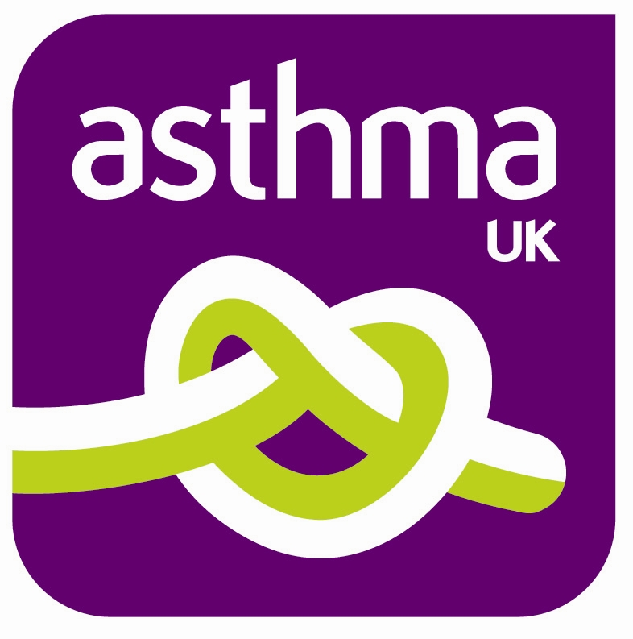
To: Head Teachers. |  | Blenheim House  Duncombe Street  Leeds  LS1 4PL
Date: 23 May 2011 |  | Blenheim House  Duncombe Street  Leeds  LS1 4PL
Dear Colleague,

I would like to bring to your attention the free asthma resources that are being made available to you via your comms teams.

As part of the Yorks and Humber Asthma Impact Project we would like to address the issue of awareness of asthma in children across the region. Affecting 1 in 9 children in every class, we wish to alert asthma sufferers to the increase in asthma admissions in September. School nurses will also be discussing these issues with you over the coming months.

Both resources are part of a larger package of support for schools being offered by school nursing teams, across the region and particularly in Wakefield, which is our pilot site for this project.
Included is the distribution of a pocket guide, asthma attack card which we trust you have now been supplied with and are carrying whilst in school, the card is an aide memoire when faced with a child with a suspected asthma attack. School nurses are also able to offer education and awareness sessions to schools and can assist schools to develop good asthma practice including, developing an asthma policy, use of resources around school and help and advice about issues relating to asthma.

We have provided a newsletter segment that can be cut and pasted into a paper newsletter and or sent electronically or inserted in to a school website.
We now know that during the summer months when children and young people feel well they may not remember to take their asthma medication and do not attend their GP for a review believing themselves to be well and it to be unnecessary, unfortunately this can lead to an increased risk of becoming unwell in September and an increase in absence from school.
Our newsletter alerts them to this issue and reminds them to take their medication.

The asthma assembly is aimed at raising awareness and can be delivered by school staff to groups of children or whole schools in June or July followed by the newsletter piece.
There are 2 asthma assemblies, one each for primary and secondary schools. I am pleased to be able to supply you with these resources and would welcome any comments or feedback. May I ask that you please to make use of them, to assist us in improving standards’ of care and overall disease control for the 1.1 million children with asthma in the Uk
Also should you wish to take part in the trial of the assembly and or require further information please contact me as below.

Best Regards

Sonja Buckle
Yorks and Humber Asthma Impact Project Lead.

Sonja.buckle@yorksandhumber.nhs.uk

07795602878
WWW.YHIP.ORG.UK/ASTHMA FOR RESOURCES.

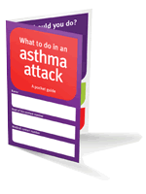
Health professionals in Yorks and Humber recommend that school staff carry an asthma attack card at all times during the school day.
Further supplies can be obtained via Asthma UK website.
http://www.asthma.org.uk/order_your_free_asth.html

