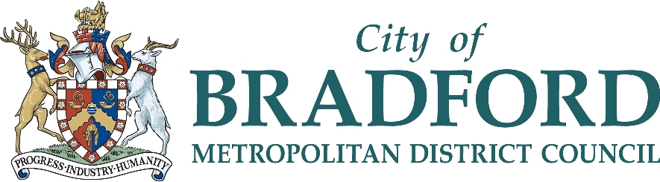

NEW DESIGNATED SAFEGUARDING LEAD (NAMED PERSON) TRAINING

Description of Course

Intended outcome for learners:
Children and young people will feel confident that their school is able to support them in respect of child abuse and neglect and will safeguard and promote their welfare.

Intended outcomes for participants:
To develop the knowledge and understanding of child abuse and neglect and to understand the role of the Designated Safeguarding Lead (Named Person) in school. Participants will be able to recognise the need for a child protection referral and to follow locally agreed procedures. Participants will understand the role that school plays in child protection and will be equipped to take a lead role within school.

Content of the course
The course programme covers:
- Understanding child abuse, signs, symptoms and indicators
- Child protection procedures and how to follow them
- Legislation
- Record keeping and sharing information
- Managing disclosures of abuse
- Understanding the short and long term effects of abuse on children and their learning

Intended participants
This course is designed specifically for NEW Named Persons. Experienced Named Persons should not repeat this course; they can refresh their training by attending the half day refresher course and by attending one of the multi-agency courses run by the Bradford Safeguarding Children Board.

Parking:
Free parking is available on site at Peel Park Primary School.

Choice of Dates and Venue:
Tuesday 6 & Wednesday 7 February 2018 - 9.30am – 4.30pm @ Peel Park Primary School
or
Monday 19 & Tuesday 20 March 2018 - 9.30am – 4.30pm @ Peel Park Primary School

Tutors
Jenni Whitehead / Carolyn Eyre – Experienced External Consultants, and Suzanne Ellis – Lead Officer Education Safeguarding

Cost
£170 per person from Maintained Bradford Schools
£310 per person from Academy, Free or Independent Schools and non-Bradford schools

To book your place please complete the attached booking form and return to School Governor Service either by email to school.governor@bradford.gov.uk or post to School Governor Service, Margaret McMillan Tower, Princes’ Way, Bradford, BD1 1NN.

Please email school.governor@bradford.gov.uk for further copies of the booking form.

Please ensure the school has agreed to pay for your attendance on the course before booking.

