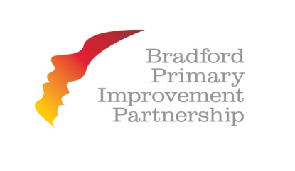
BPIP Middle Leadership – Accountability and Impact Programme
Do you need to strengthen Middle Leadership in your school?
Have you a new or recently appointed team or has this been identified through Ofsted or Developmental Reviews?
The Middle Leadership Accountability and Impact Programme is designed to build leadership capacity in Bradford’s Primary schools.
The course enables delegates to develop their monitoring and evaluation knowledge and skills whilst learning how to hold people to account and develop understanding of the use of data analysis. It is hoped that this will deepen confidence and skills in order to impact on the candidate’s school, standards and build capacity.
The programme consists of:
- Three days release from school working with Hugh Figgess, former National College Lead Facilitator.
- The opportunity to focus upon and extend middle leadership competencies.
- Development of expertise and confidence to hold colleagues to account through monitoring and evaluation, reviewing the impact of spending/pupil premium and gain familiarisation with RAISEonline.
- The opportunity to make a focused visit to another Bradford primary school during the period of the programme
- Leading a school-based project/case study focused on candidates own area of responsibility. Candidates will make a presentation on the impact of your work to your own SLT in school following the completion of the programme.
Dates:
- 10th November 2014
- 9th March 2015
- 29th June 2015
We are now taking booking forms for this programme. There are 20 places available; therefore selection will be on a first come first served basis with one place available per school in the first instance.
Headteachers/Middle Leaders (with Headteacher approval) need to request a booking form from cat.mccormack@southmere.bradford.sch.uk
Please note this course is free to BPIP members

