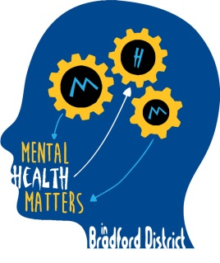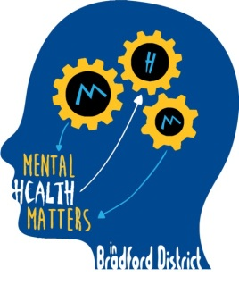

Mental Health Champions in Schools
Launch Conference 15th February 2017 9.30-4.30pm
FREE conference to launch an exciting new initiative to support schools in addressing the mental health needs of pupils in primary and secondary schools
An excellent opportunity to:
- Develop capacity to address mental health in your school?
- Hear from speakers of national renown, including Dr Janet Rose, ‘Emotion Coaching’ Consultant and Pip Long, author and creator of ‘Blob People.’
- Sign up to become a school participating in the Mental Health Champions initiative?
- Find out about the range of new initiatives transforming CAMHS across the Bradford, Airedale and Craven Districts?
- Contribute to dialogue shaping Child and Adolescent Mental Health Services across the district
Conference Details: Hockney Room, Margaret McMillan Tower, Princes Way, Bradford BD1
Lunch and refreshments provided
Oversubscription is anticipated so please book early to secure your place. In the event of over subscription places per school may be limited.
Please book by emailing: philippa.grace@bradford.gov.uk

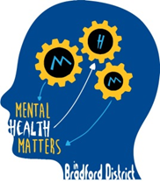
Timetable
9.30-10.30am Welcome and Introductions : The Conference Context
Mental Health in Bradford Schools – A Council Priority
Future in Mind: Transforming CAMHS
Mental Health Matters : Supporting Mental Health Champions in Schools
10.30-11.00am Mental Health in Schools: Top Tips for School
Barnado’s Young People’s Participation Group
Coffee
Emotion Coaching
Dr Janet Rose, Emotion Coach Consultant and Director of Norland Early Years Services
Lunch
Therapeutic Work and Therapeutic Conversations with Children who are Hurting
Pip Long, Author and Creator of the ‘Blob People’
Coffee
Who’s Who in Bradford Child and Adolescent Mental Health Services: An overview of the Future in Mind Projects
Mark Anslow, Project Lead, Early Help; Marteka Swain, Project Lead, Safer Spaces; Sue Sykes, CAMHS Trainer; Lisa Stead, Children and Young People’s IAPT; Denise Sutcliffe, CAMHS Partnerships; Eating Disorders
Plenary Session: Partnership working: Where next for Mental Health Services in Schools?

