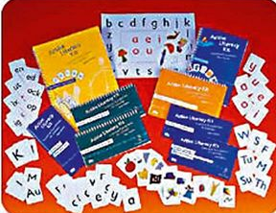
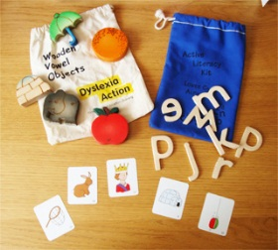

Active Literacy Kit (Dyslexia Action)
As part of the Cognition and Learning Team’s initiative to develop support for children with Specific Learning Difficulties, we are offering training to schools on Dyslexia Action’s very successful Active Literacy Kit (ALK). The training will be delivered over three mornings by Dyslexia Action. We are offering a £300.00 package to schools which includes:
- 3 mornings of training for 2 people, the SENCO and 1 experience teaching assistant.
- 2 x Active Literacy Kits – each worth £100 approx.
We will be holding three training events this year. The dates will be:
- Autumn Term: 8.11.16, 15.11.16 & 22.11.16 (9:00 – 12:00hrs)
- Spring Term: 28.2.17, 7.3.17, 14.3.17 (9:00 – 12:00hrs)
- Summer Term: 6.6.17, 13.6.17, 20.6.17 (9:00 – 1200hrs)
Please book using our Booking Form on our Courses Page on BSO
What is the Active Literacy Kit
The ALK a flexible ‘hands on’ multisensory phonic teaching intervention designed to develop and improve the retrieval of grapheme/phoneme links and so improve fluency in the reading and spelling process.
Originally designed for learners with a specific learning difficulty, the ALK can also be used with younger learners e.g. KS1 who have general phonic difficulties and secondary school age pupils. It was originally designed as a 1:1 intervention but can also be used in pairs and small groups as pupils progress.
ALK involves a series of short flexible practical tasks using cards and wooden letters, with timed activities, working towards target times, to show progress towards fluency. The ALK programme is highly structured with finely graded activities designed to build cumulatively with plenty of overlearning.
At the end of the intervention learners are secure in retrieval of grapheme /phoneme links for initial sounds and are able to read and spell CVC words. There are also extension activities to develop skills reading words with diagraphs and adjacent consonants
The course will:
- Provide you with an overview of the multisensory principles behind the Active Literacy intervention
- Enable you to identify pupils and administer the placement test
- Enable you to plan lessons and record progress
- Enable you to carry out activities and monitor progress

