The vestibular system - balance
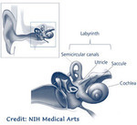This provides us with information about the direction and speed of movement. The vestibular apparatus contains two semi-circular channels – the cochlea and the vestibule. These form the core of the system. This is located within the inner ear. It helps us to:
- 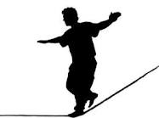detect movement and changes in the position of the head,
- co-ordinate both sides of the body – bilateral integration,
- maintain muscle control, holds the head upright and coordinates both sides of the body,
- make sense of messages received in the brain from the senses,
- control our speed and coordination,
- find our place when we look away from what we are reading/writing e.g. when copying from the board,
- stand on one leg long enough to kick a ball,
- walk on sand and uneven surfaces and use swings and slides.
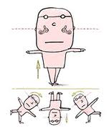If information through the system is faulty then messages received do not make sense. This will result in lack of coordination with children not being able to control their speed of movement. In PE for example they will not be able to stop quickly on command. They appear clumsy and uncoordinated. In the classroom it can result in poor fine motor control and not being able to reduce the amount of pressure applied when writing.
If the vestibular system is overactive children can be very sensitive to movement and will try to avoid activities such as climbing. They may also have car sickness or get dizzy easily. Their static and moving balance will be poor as will their sense of orientation in space.
If the vestibular system is underactive the children may be sensory seekers and will be constantly on the move – spinning, swinging, running and jumping. They do this to stimulate the vestibular system and get the feedback.

