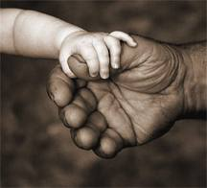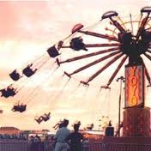Touch

The tactile system sends information to the brain, via cells in the skin about touch, pain, temperature and pressure. If feedback is faulty some children may hate to be touched or cuddled. They may also hate to get their hands dirty or to touch certain textures. This may also affect what foods they are willing to eat – avoiding foods with certain textures/lumps.
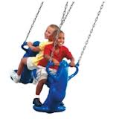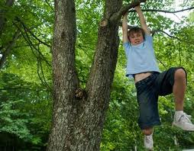Others may hate even the lightest of touch – tactile defensive. These children may be very sensitive to the texture of the clothes they wear and may refuse to wear items of certain textures or be so bothered by them that they are unable to concentrate. Some of these children may avoid touching certain textures or getting their hand dirty. They may avoid touching paint, clay, play dough, glue, mud etc.
They may also dislike being close to other children/adults and feel very uncomfortable when queuing.
Some may use too much pressure or too little pressure on pencils and constantly fiddle with objects or chew.
Some children may crave physical sensations and will crash around often recklessly and will enjoy rough play. They love the sensation that comes from vigorous physical movement.
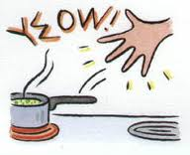Some children may be unable to control or moderate their own touch and may be seen as aggressive.

