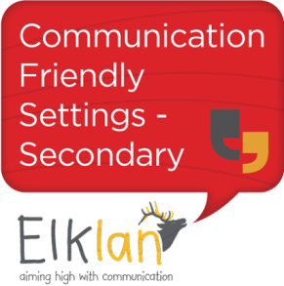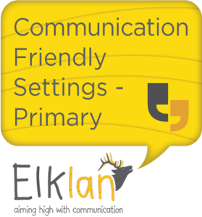
Department of Children’s Services Cognition and Learning Team
Elklan Communication Friendly Schools Accreditation
Elklan Communication Friendly Setting (CFS) accreditation is awarded to settings that have trained and support all their staff in communication and language development. They will also have shown evidence of embedding this knowledge in targeted interventions and through the implementation of a Communication Policy. Accreditation can be achieved in one year and can be renewed after three years. It is the most cost effective strategy available for whole-setting capacity building in communication. Becoming a CFS involves three elements each of which can be commissioned separately:
- Training Teaching Assistants and teachers
- Training the whole setting staff through trained Lead Communication Practitioners
- An audit of the embedding of practices and policies in the setting
Prices
CFS Step | Resources and accreditation | Cost
1 Training Teachers and TAs | Language builders book x4  Accreditation fees x 4  Elklan tutor delivery and portfolio marking (10 week course) | £400pp payable to Cogntition and Learning Team
2 Communication Counts | 18 posters, 6 x colourful stories and 5 session handouts  2 x LCP manuals | £240 payable to Elklan  £260 payable to Elklan (2 x £130)
3 Accrediation and audit | Accrediation | £100 payable to Elklan
Total cost per school for Communication Friendly Accredition = £2200

- Speech and Language Support for 5-11s/11-16s
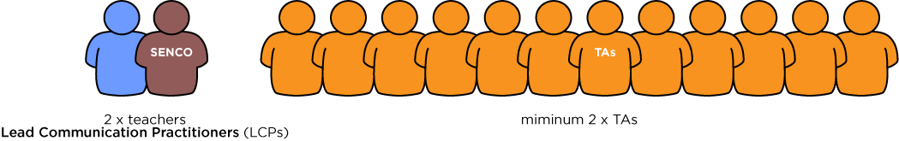
10 week course Level 3 Award (9 credits) @ £400 per person (incl accreditation fees and language builders book)

- Communication Counts

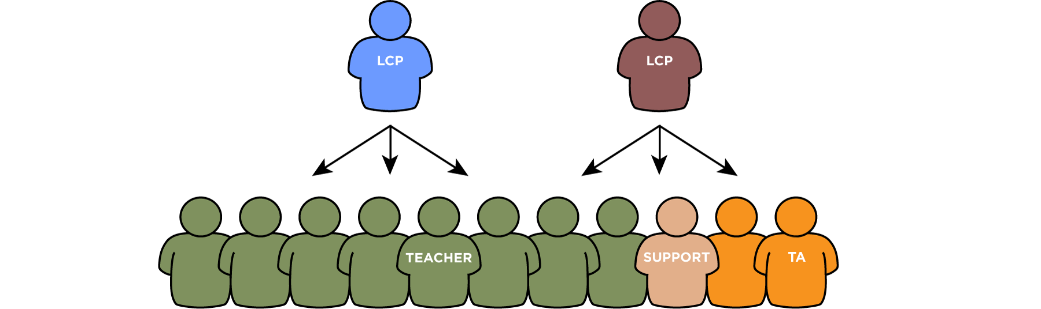2 x LCP Level 4 certificate (6 credits) £130 pp (LCP manual)
Whole school resources pack £240 per school (18 posters, 5 session handouts and 6 x colourful stories)
Cascaded to whole setting by LCP in 5 x 1 hour sessions
LCP attend I day/term to feedback on impact in school
- Audit and Accreditation

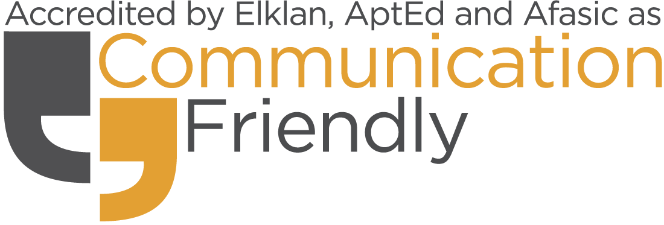£100 per school

1. Training Teaching Assistants

Elklan Speech and Language Support for Under 5s, 5-11s, 11-18s
These are the core Elklan Level 3 Award training courses which have been completed by over 45,000 accredited learners throughout the UK. The courses are taught by Elklan trained Speech and Language tutors in 10 x 2 hour sessions. “Three day intensive” or e-learning options are also available. Participants learn about communication theory and are given a library of practical interventions to use immediately in the classroom. Most importantly they understand how and why to use these strategies appropriately to help any child access the curriculum, become an independent learner and improve their social skills. A portfolio of practical work and interventions with children embeds the teaching and this is assessed and marked by the tutor. Participants often feedback that this is the most useful, enabling and enjoyable course they have attended. There are no entrance requirements for this course and Level 2 and attendance certificates are also available. Courses run with 15 learners and could be arranged to include other setting’s TAs in your area if numbers allow. Settings working together for have an enriched learning experience.
For CFS status this course should be completed at Level 3 by a minimum of 2 of TAs. TAs who have already completed this course within the 2 years prior to commencing the CFS process can be counted. However, training more TAs adds to the setting’s capacity and will help to extend the CFS status after the third year. We encourage settings to consider upskilling all TAs with this accredited training.

2.Training the whole setting staff through Lead Communication Practitioners
In this element the capacity of the setting is increased as Lead Communication Practitioners cascade training to the whole setting staff.

2.1.Training “Lead Communication Practitioners”.
Lead Communication Practitioners (LCPs) are the key resource in each setting. They cascade the Elklan training to their colleagues and then continue to support, develop and encourage the application of the training and communication strategies in their departments.

2.1.1.Elklan Speech and Language Support for Under 5s, 5-11s and 11-18s
This is completed at Level 3 by at least 2 teachers in a primary setting, one of whom will be the SENCO. Teachers who have already completed this course within the 2 years prior to commencing the CFS process can be counted.

2.1.2.Elklan Creating Communication Friendly Settings
This Level 4 Certificate is awarded to Lead Communication Practitioners who provide a rolling programme of training and support to every member of the setting staff. These LCPs (one of whom is the SENCO) are provided with teaching notes, tutoring and resources to facilitate whole setting training using the Elklan Communication Counts course. The Level 4 portfolio involves an analysis by the LCPs of the embedding of the training and an evaluation of the impact in the setting on staff practices and pupil learning.

2.2.Cascading training to the whole setting staff
LCPs cascade training to ALL staff (teaching, non-teaching, support and administrative) in 5x1 hour sessions over 5 half terms to develop and support speech, language and communication throughout the setting. The sessions cover the following:
- What is communication?
- Interaction
- Asking effective questions
- Extending vocabulary
- Developing understanding and ‘Speak Out!’
- Encouraging expressive language and narrative development
The course content has been described by teachers as "high quality teaching in a nutshell". Training ancillary staff in communication strategies enables better behaviour management

3.Gaining Communication Friendly Setting Accreditation
A CFS audit pack is provided which the LCPs use to collect the required data. This includes lists of staff trained, the setting's Communication Policy, and examples of interventions and strategies used and embedded in the setting. The data collected is sent to the tutor for assessment who arranges for another setting to visit to carry out the observations. If this is not possible an alternative arrangement is made.

