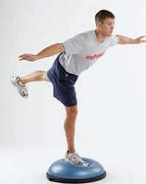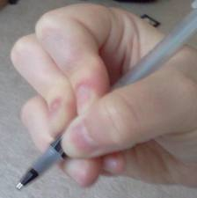The proprioceptive system – awareness of body position
These are receptors in our muscles and joints which react to the amount of contraction or stretching our muscles undergo when we move. Proprioception tells us where our limbs are in space and allows us to move our limbs without looking at them
- The majority of children with coordination difficulties have poor proprioception. They may therefore struggle in any task in which they cannot see their limbs clearly e.g. brushing their hair.

- 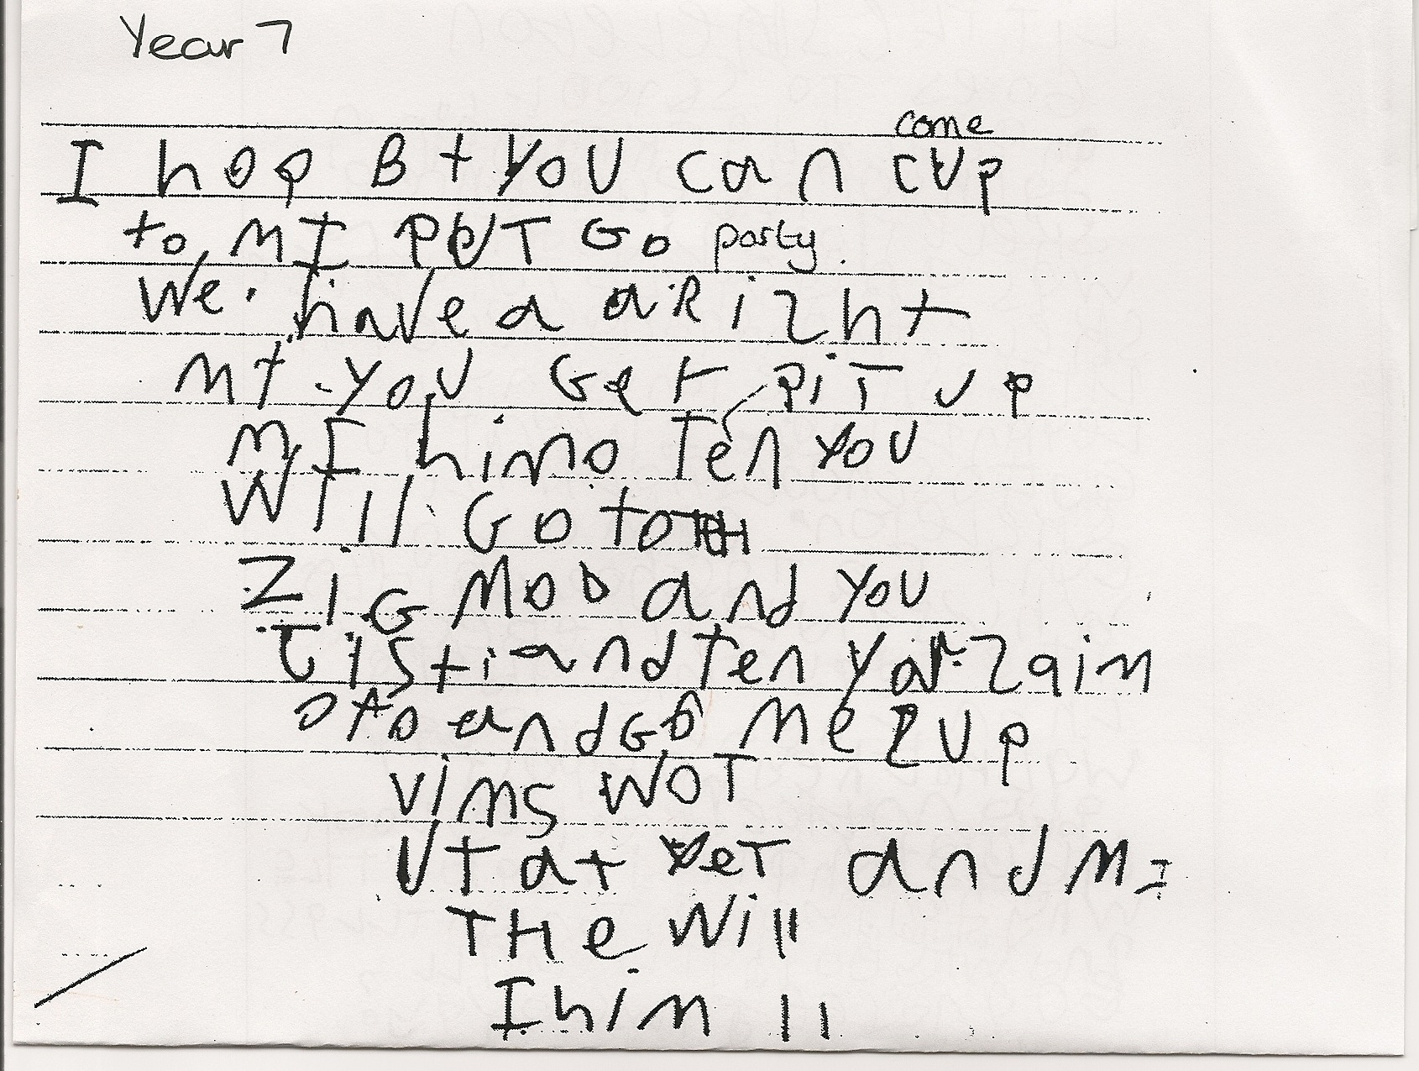The placing of hands and feet is difficult, movements appear heavy and the child appears clumsy. Because of the poor feedback relating to the amount of stretch and relaxation in muscles children have a poor understanding of where their limbs are in space. Their movements appear heavy and the child appears clumsy.

- They may be unaware of the force they are using and break toys and equipment or knock other children flying when hugging or playing. They may use excessive pressure when writing with their work being poorly laid out. They will need to keep shaking their hand when writing to help alleviate the pressure and discomfort.

- They may take longer to get dressed and clothes may be inside out and messy.

- Some children may have a very reduced sense of touch and not register pain e.g. when touching something hot.

- Many of these children will struggle to sit still for long and need to constantly move or fidget to maintain attention.

- Children with motor immaturity have a reduced sense of this and this will have an adverse impact on their movement and how they perform everyday activities. Often they struggle to develop automaticity in their movement and will have to plan and think about their movements e.g. how to walk across the classroom or to form their letters when they write. This will take up capacity in their working memories and may contribute to working memory overload.

- Even when these children learn to carry out some movements tasks well they are slow to react to changes e.g. being able to stop a bike when someone steps in front. If the task becomes too complex the system will overload.

- A child may learn to swim with reasonable confidence but has to think about every movement of each arm and leg. If their concentration is broken they will not automatically keep moving their limbs without this conscious thinking and planning and may sink!

