Immaturity of neurone development in the brain
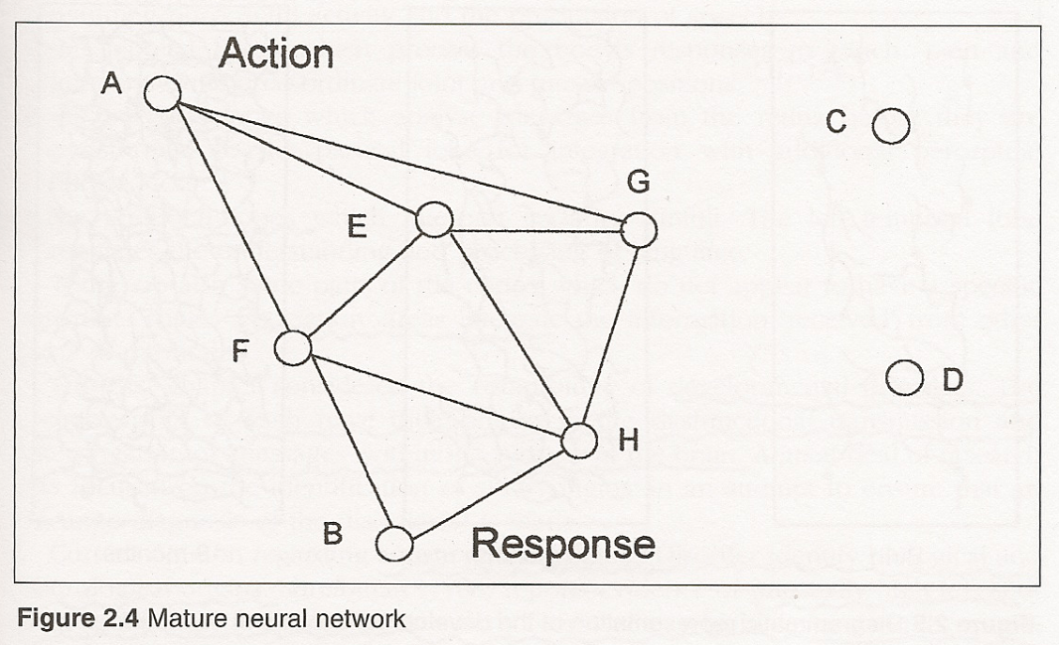
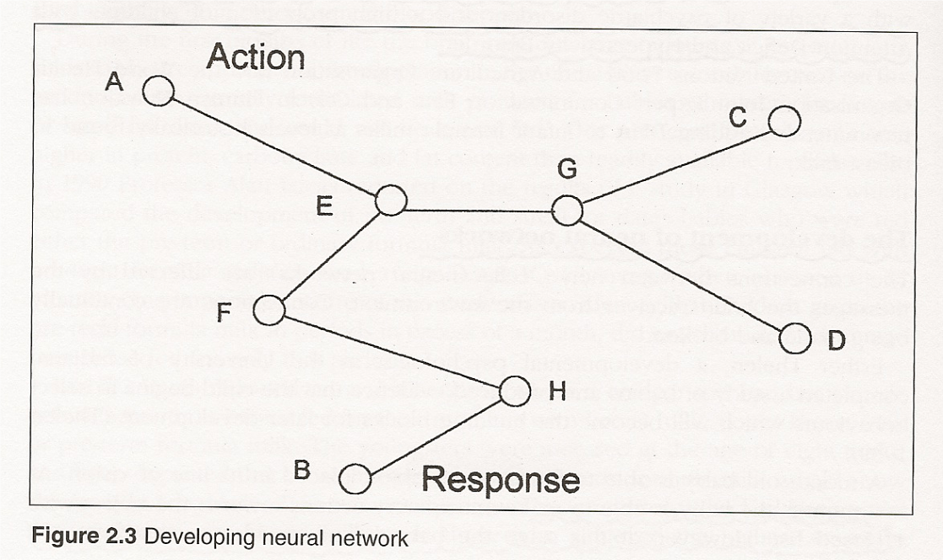
From Madeleine Portwood
‘Developmental Dyspraxia’

A baby’s brain develops through interacting with the environment. In the early stages this will involve a baby reaching out and touching something that they see. For a very young baby this is very much a hit and miss process. Through trial and error a baby is able to refine their movements and make them more precise. Both the arms and legs of a young baby will be moving in response to seeing and trying to touch an object. By about 6 months however they will be able to reach with one hand and touch an object. Each successful action will result in the reinforcement of the relevant pathway in the brain.
The first diagram above shows a very immature brain belonging to a baby aged 6 weeks. The second diagram belongs to the same baby aged 6 months. With lots of opportunities to move and interact with the environment the brain becomes more efficient and the extra hand and foot movements seen in the younger baby disappear as do the useless connections in the brain – shown as C and D in the second diagram.
Thinking and planning become easier. As the brain becomes more efficient it is easier to find information stored in the brain. There are less dead ends to get stuck in. This makes it easier for a child to follow what is happening in the classroom. Their processing of information will be quicker.
Many children do not get enough opportunities for movement and so their brains remain in a state of immaturity. We can observe this when we carry out a motor screening with the children. If an immaturity exists it will show as additional hand movements or tongue thrusts when they carry out the activities on their feet such as walking on their toes, heels and sides of feet.

