Dear colleagues

The Key to Success website has now been updated with the latest pupil numbers from the January 2015 school census.

Schools can obtain information on the pupil numbers used for their 2015-16 Pupil Premium allocation at:

<https://www.keytosuccess.education.gov.uk/cgi-bin/schools/index>

Schools will need to go through the following stages to access the information:

1. They log into secure access
2. Select KtS (Key to Success as the system they wish to access)
3. Click ‘download’ under pupil premium 2015-16 from the menu on the left.

Schools will see the screen below.  All schools should be able to see the pupil premium section and the download and search option.

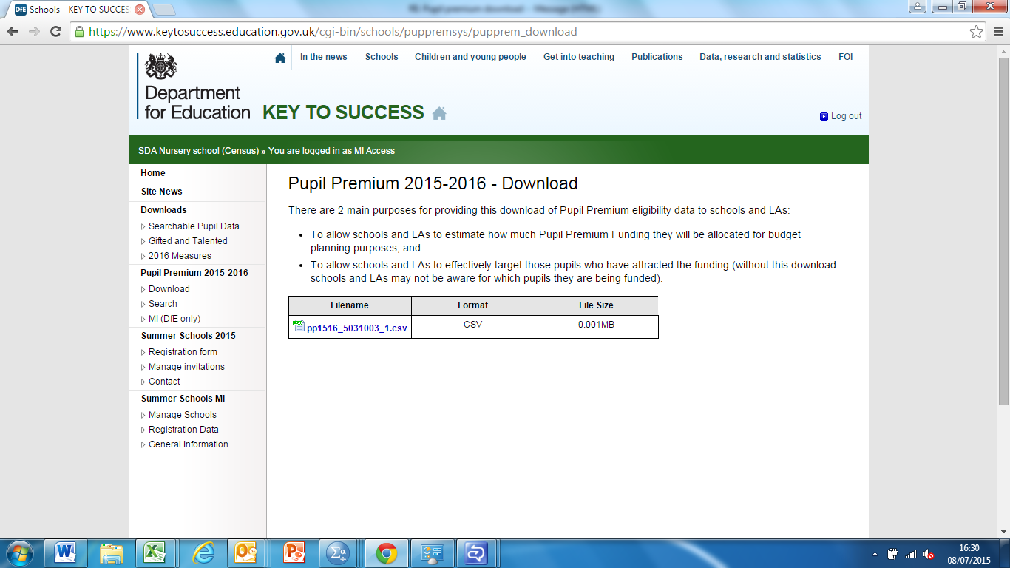

If you have any queries please e-mail: [LAGrantEnquiries.EFA@education.gsi.gov.uk](mailto:LAGrantEnquiries.EFA@education.gsi.gov.uk)