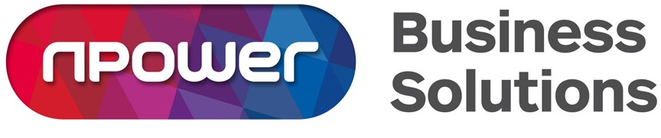

Our letter code: npm 15228
17/09/2019
Your reference: YPO CfD Letter

Important: Your Contracts for Difference charges

Dear Customer

As you may be aware, your energy bills are made up of a combination of the commodity cost (the fuel you consume) and non-commodity costs. Within the non-commodity costs are government originated charges including Contracts for Difference (CfD).
CfD is an Electricity Market Reform (EMR) mechanism to help the UK meet its carbon reduction targets and ensure the security of electricity supply.
The CfD costs vary annually due to wholesale price fluctuations and the amount of CfD generation produced in each year. These costs do not originate from npower and are instead industry-led, met by a levy applied by industry bodies to all energy suppliers. The costs are then passed onto customers and, as your supplier, we are now in a position to invoice for these charges.
As a result, you will shortly receive an invoice for the CfD pass through reconciliation for your energy usage between 1st January 2018 and 30th September 2018. This is to cover retrospective changes to the previous reconciliation charge primarily due to Green Excluded Electricity (GEE) exemptions. GEE is one of the mechanisms which exempts our demand from the CfD Scheme and is designed to not disadvantage imported green energy generation from other European Union countries.
Below is a breakdown of the rates used to calculate the charge, per quarter:
Quarter Commencing | Quarter Ending | Previous Reconciled Rate (p/pKWh) | GEE Impact (P/KWh)
01/01/2018 | 31/03/2018 | 0.251 | 0.0065
01/04/2018 | 30/06/2018 | 0.271 | 0.0101
01/07/2018 | 30/09/2018 | 0.360 | 0.0139

Any questions?

Should you have any questions or concerns regarding the CfD charges, please contact our YPO Team on 0845 672 9209 or email YPO@npower.com

Further information with regards to this charge can be found following the below link.

https://www.npower.com/business-solutions/your-account/billing/charges/

Yours sincerely

YPO Team

