BESD
Team
(Formally SEBD Team)
Your first choice for specialist behaviour support

2014 CONFERENCE
Inspired for the future: Making things better for children

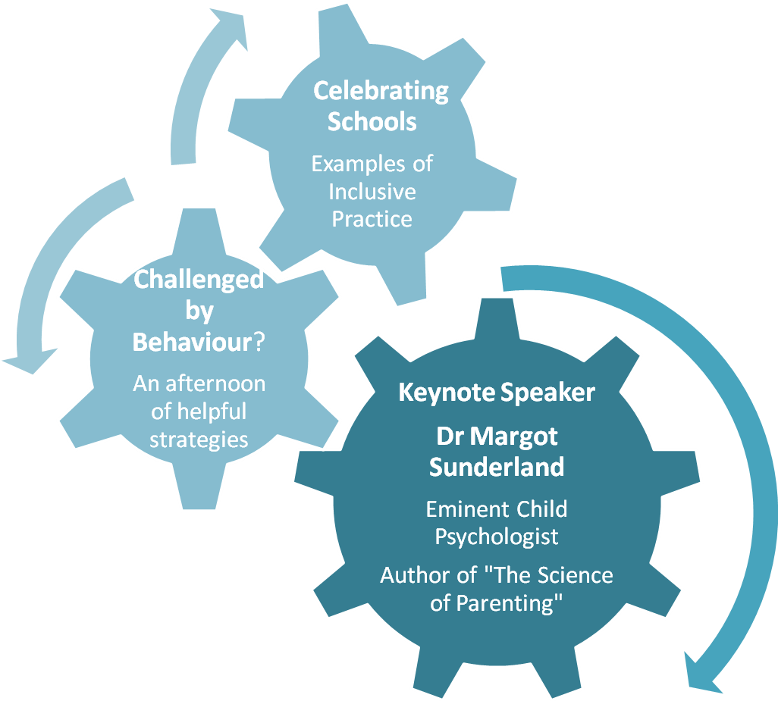

Date - 01.07.14 Venue – Mercure Bingley BD16 1TU

Time – 08.30 –2.30pm Cost - £60 per delegate (lunch included)
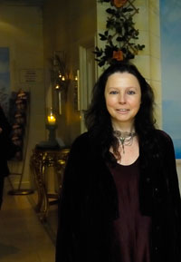
‘Understanding children who present in school with social, emotional and behavioural difficulties and developing practical strategies to support their inclusion’.
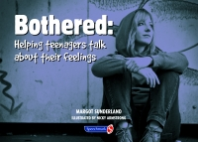

- Director of Education and Training at The Centre for Child Mental Health London

- Honorary Visiting Fellow at London Metropolitan University

- Associate Member of the Royal College of Medicine

- Child Psychotherapist with over thirty years’ experience of working with children and families

- Her internationally acclaimed book, “The Science of Parenting” won First Prize in the British Medical Association Medical Book awards 2007 Popular Medicine section

- The Science of Parenting, endorsed by one of the world’s leading affective neuroscientists Professor Jaak Panksepp, is the result of ten years research on the long-term effects of adult-child interaction on the developing brain

- One of Dr Sunderland’s doctorates is in child psychotherapy; her thesis is entitled “The Application of Art and Science to the Psychological Treatment of Children”

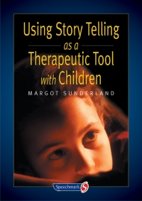

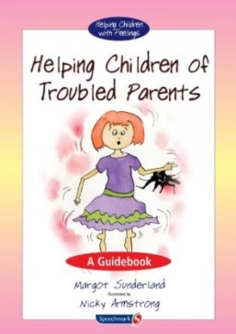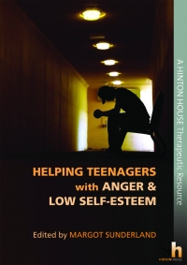

Author of over 20 books on Child Mental Health, translated in to 18 languages & published in 24 Countries

Three Schools share with us:

Celebrating Schools
- Their own experiences & good practice
- How they meet the needs of vulnerable pupils
- Innovative ways they manage challenging behaviour
- How their inclusive practice ensures successful outcomes

National Nurture Group Quality Mark Award

Celebrate the three latest schools to receive the Nurture Group Network, Quality Mark Award (QMA).

This award recognises the incredible work being done in nurture groups
across the district to improve the life chances of our most vulnerable children.

The QMA is a national award which recognises excellent nurture group practice. Nurture groups are proven to change children’s lives and gaining this award is a significant achievement.
BESD Workshops

- Working together around behaviour and safety to prepare for Ofsted
- An essential workshop for school leadership around behaviour planning and managing risk for pupils presenting with BESD in response to the updated Ofsted framework
- This workshop will help you to develop systems in school with greater consistency around the leadership of behaviour and managing interactions with outside agencies. Examples of behaviour plans and risk assessment proformas will be provided to use in your schools.

- Circle Time
- This fun-filled workshop will provide a ‘taster’ of how Circle-Time should be an essential part of the social and emotional developmental provision for all children, especially those who present with BESD.

- Creative Learning
- A creative approach to learning helps develop flexibility, whilst remaining focused on the task in hand.
- This workshop will lead participants through exercises to develop their own creativity, sense of fun and joy in learning. You will learn how to manage pupils with an ease and spontaneity that will delight and enthuse whilst remaining calm, against all the odds!

- Portable Calming Spaces
- In mainstream Primary Schools the provision of a calming/sensory room is a rarity. Space and resourcing may be barriers to providing a much needed ‘place to be’ calming area.
- This workshop will give a taster of ideas for low-cost, pop-up, easily transportable sensory resources to create a calming space anywhere in school.

- 08.30 – 09.00am - Coffee & Registration
- 09.00 – 09.10am – Opening Speech
Michael Jameson Strategic Director for Children’s Services
- 09.10 – 11.10am - Dr Margot Sunderland Keynote Speaker
(To include coffee)
- 11.10 – 12.10pm – Celebrating Schools
- 12.10 - 12.30pm – BESD Support
- 12.30 – 13.30pm - Lunch & Market Place
- 13.30 - 14.10pm – Workshops
- 14.10 - 14.20pm – Celebrating BESD
- 14.20 - 14.30pm – Closing Speech
Timetable for the day
I would like to attend the Inspired for the Future Conference on Tuesday 1st July 2014

Name

School/Organisation

Address

Please tick the workshop that you would be interested in attending:

- Working together around behaviour and safety to prepare for Ofsted

- Circle Time

- Creative Learning

- Portable Calming Spaces

To book a place or for further information please contact Linda Whittingham or Stephanie Walsh on 01274 385913
Or email bssadmin@bradford.gov.uk

