Image | What type of energy store do we have in the images?  How would you describe this type of energy store?  How does this energy store change? (the image might help)  Can you think of another example of something with this type of energy store?
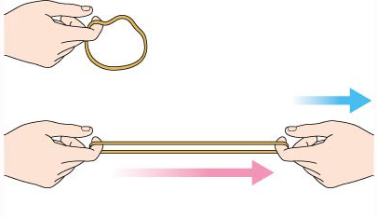  Elastic band | _________________ energy store  This is the energy stored in an object when it is squashed or _________________. As an object becomes more stretched it ________________ its elastic energy store. An example of something with an elastic energy store would be a ________________
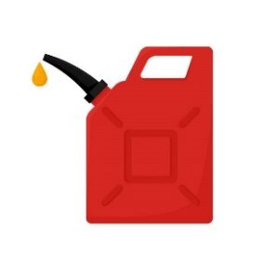  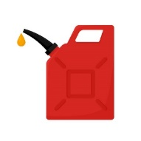  Can of petrol | __________________ energy store  This is the energy stored in batteries, food or __________________. As the battery, food or fuel gets bigger, it ____________________ it’s chemical energy store. An example of something with a chemical energy store would be a ____________________________
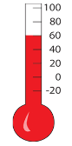  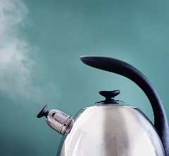  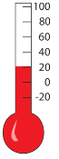    A kettle full of cold water and a kettle full of hot water | ________________________________  This is the energy stored in an object because of its temperature. As an object gets hotter, it _________________________________________________________  ___________________________________________________________  ___________________________________________________________
    Person on diving board | ________________________________  This is the energy stored when an object has been raised above the ___________________. __________________________________________________________  __________________________________________________________  ___________________________________________________________  ___________________________________________________________
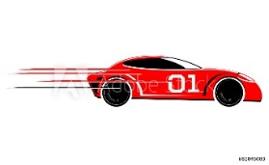
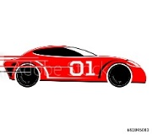
A car speeding up

