Flexible Grouping Prompts
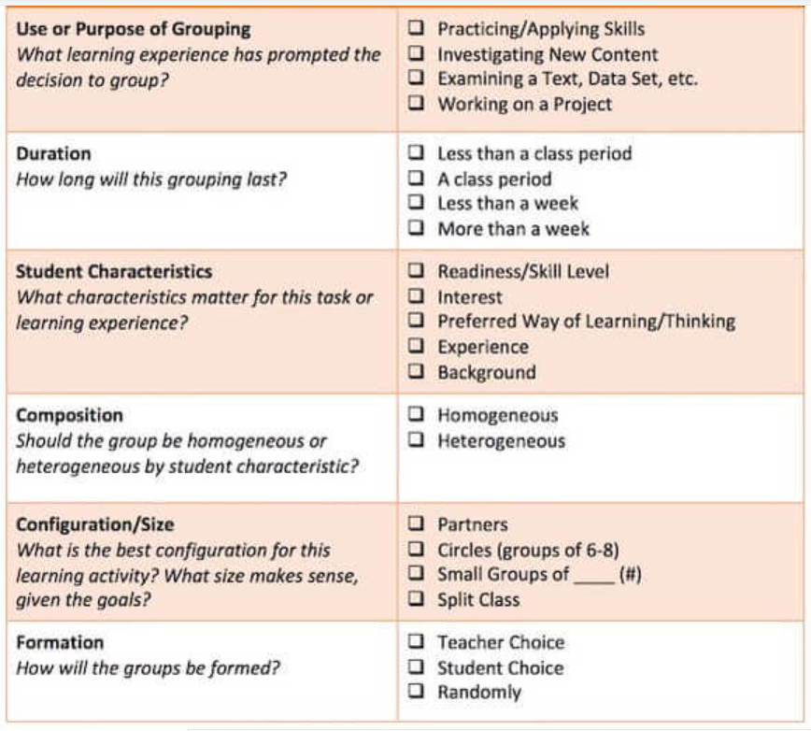
Source: How To Use Flexible Grouping In The Classroom - (teachthought.com) (2017)

