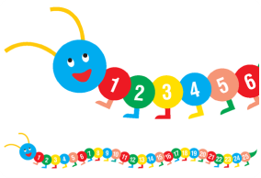
Ideas to teach Early Maths skills
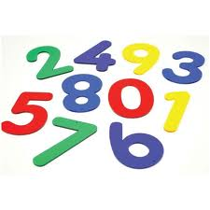
Objectives:
- To be able to count numbers 1 – 10
- Be able to counts objects 1- 10
- Be able to say which is more or less
- To be able to complete addtion and subtraction calculations using objects
Activities
  - Make a number 1 book, number 2 book etc. Use objects, pictures of numicon and numbers.
  - You could also make a 1 feely bag, 2 feely bag etc. Get her to put her hand in the bag and guess what the objects are and count them out. Alternatively, use the feely bag to go on a 1 walk, 2 walk/treasure hunt. Provide her with a picture task plan showing pictures of objects she has to find, e.g. 1 pencil, 1 cube etc. For two she would have to find 2 pencils, two cubes etc… (include numicon pieces)
  - Again using feeling bag, mix up all the number cards (have at least 3 of each number) – get her to put all the 1’s in the one bag, 2’s in the two bag. You could also make post boxes for this activity.
  - Jump on 1-10 roll the ball to number 1-10 etc…
  - Go outside and play hopscotch – instead of throwing a stone, she has to find a matching number card and place it on the corresponding number on the hopscotch to have a turn– she can then jump on the numbers rather than hop. Alternatively, you could get her to place a numicon piece or the correct number of objects on a number.
  - Use instruments and count the beat.
  - Threading numbers of objects.
  - Take pictures of Sophie holding numbers to sequence. Extend this to Sophie holding number 1 and then Sophie and one other child holding number 2 etc.
  - When baking, take a picture of 1 cake, 2 etc. for her to sequence. How many buns do we need to make for…
  - Trace and copy numbers on white board, make numbers with playdough, plastercine, clay, write outside with a chalk, squeezy bottle, march in the shape of number etc…
Ideas for using counting resources enc.
- Match numbers to numbers
  - Simply match cards
  - Play lotto – use a sheet as a board and another to make the lotto cards
  - Match the numbers of the same colour/different colours
  - Play number snap, pairs
  - Put the numbers around the room for the child to find and put them in the correct place on her number lotto board.

- Match number of dots to number of dots, number of elephants to elephants etc…
  - Simply match the cards
  - Play lotto, snap, pairs
  - Put the cards with either the dots, elephants, leopards, flowers or princess around the room – she has to find them and match them to the corresponding quantity on her lotto board.
  - Match number of dots to elephants, elephants to leopards.

Always talk about how many, when working with the dots or pictures help her count them, count both of the cards she is matching so she can hear and see they are the same.

- Match dots or pictures to their corresponding number using the variety of games above. Use a model for her to copy at first (enc). When matching dots to numbers always count up to the number and then count the objects on the corresponding picture. Incorporate Numicon so she can also match Numicon shapes to numbers.
Extend these activities to more or less. For example, find a picture with one more dot, elephant etc…? Which number is one more?

