User Guide – Using Perspective Lite

Version 1.0 – Utilising the functionality of Perspective Lite
Date: June 2016

Link:
Perspective Lite can be accessed at: https://perspective.angelsolutions.co.uk/perspective/login.aspx

Logging In:
Input the username and password you have been given. .

First log in:

- The first time that you log in you will be given the name and email address of the ‘named user’ who was created when all the accounts were set up. For most schools this defaults to the head teacher, but can be any appropriate member of staff if we were advised otherwise.
- Please update these details if necessary. If you forget the password the email address entered here will be used to send a new password to. You therefore need to make sure it’s someone still at the school and that the address is still active.
- You will not be asked to confirm these details again but can update them yourself at a later date if they change (see below).
- Remember that there is only one log in per school, but you can share the account within the school and multiple users can log in at the same time with the same account.

Password changes:

- You will be asked to change your password at least every 60 days. This may happen the first time you log in depending when that is. Set the password to one of your choice and keep a note of it as there is only one account per school. You may also reset the password at any other time if necessary.
- If you are sharing access to the system with other staff in the school, you should ensure that there is a process in place for when someone changes the password to let other authorised members of staff know.

Navigating the system

Reports Menu:

There is only one option in this menu:

Realtime Data Trends Dashboard:

- The Realtime Data Trends Dashboard will show you the high level summary results for your school, contextually similar schools, the local authority and early national figures.
- The graphs are available for each Key Stage. You can switch between Key Stages by clicking and also display the graphs as lines or bars. Your selection can be printed with the ‘print’ button.
- You can use this area to check that the results you have submitted are within expectations (submitted data should be available on the 4th working day after submission, if not sooner). Sense checking will also use this facility. Schools are encouraged to check their data here as early as possible, and re-submit if necessary to avoid problems. Some schools have encountered problems where results ultimately aren’t available in RAISE due to late or erroneous submission.

CAUTION – the vertical scales are not the same on all the graphs. The scale adjusts automatically to make each graph as clear as possible. It is therefore very important to check the scales before making any comparisons. Otherwise the relative differences between the scores may be misleading. (We have already requested that the supplier considers changing this.)

- Contextually similar – Schools across England that are similar to yours in terms of their size, SEN and FSM profiles.
- Early National – this is where you can view the emerging picture during the summer term while data submitted by schools is being loaded by each LA. All LAs in the country use this system and therefore it provides a very complete and accurate early indication. Scores will change daily during submission periods, as more are loaded, however the DFE concede that this is a very accurate guide to the final overall results.

Watchsted

Watchsted is an area where you can see information about school inspections within the LA and across the country under the current framework.

- After selecting Watchsted in the main menu another menu will be shown:

- Map – A map of the local area with coloured pins reflecting the grades achieved by schools that have been inspected.
- Inspectors (not available in this version of Perspective)
- Analysis – The spread of judgements for the last 50 inspections. This allows you to compare one authority to another by using the drop downs. Please note that ‘Primary School’ here includes Junior and Infant schools.
- Search – Allows you to search for words or phrases that appear in the findings or recommendations of OFSTED reports. For example, you can use this to look at findings for outstanding schools around the word ‘Progress’ and see what the inspectors are putting. Use the drop downs to pick finding/recommendation, school type, measure and judgement.

- Wordcloud – Probably less useful than the ‘search’, Wordcloud pulls together the keywords in findings and recommendations of inspections under the latest framework. Again you can use the drop downs to set some parameters for this.
- You can also access Watchsted over the internet without a login at http://www.watchsted.com/analysis

Tools
The tools menu is the new home of Infographics for census visualisation. Other items in the tools menu may be of interest to schools but are not supported by this guide.

Infographics

You can upload a copy of your census data into the system at any time in order to have a quick, visual summary of the profile of your school. Please note that this data is not saved in the system. This is strictly a visualisation tool which can be used to support governor meetings or OFSTED visits and does not change any other requirements of the Census. To illustrate changes in your school over time you may want to load and print two years of data.
Feedback from schools has suggested that the most powerful way to make use of this option is to load the census file as a matter of routine after it has been submitted and save/print the output created by the system. This will allow you to quickly illustrate changes over time as each census passes.

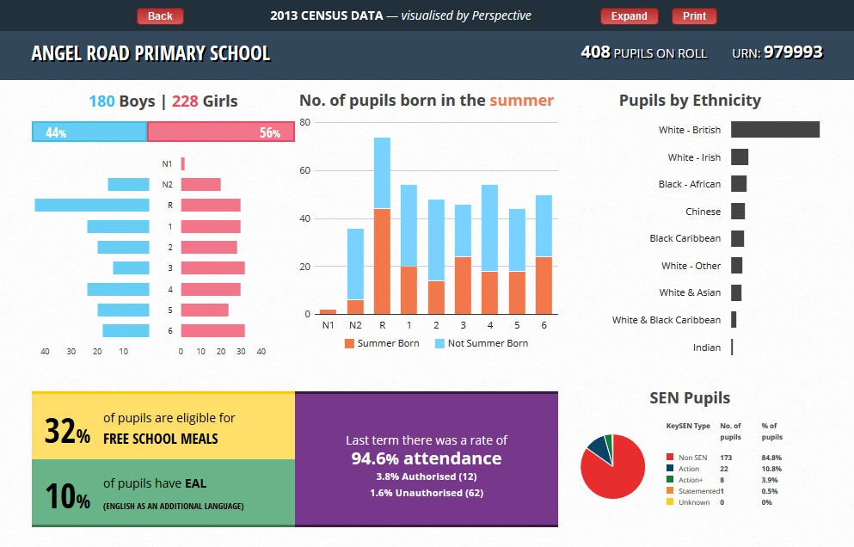

Updating named user details:

In the top right of the screen, next to ‘log out’ is an ‘head and shoulders’ icon that lets you view and then update the named user details for your school. You can use this to make a change to this user (and importantly their email) in the event of staff/email changes.

Help

If you need help, or are unsure what to do, you can click the red ‘help button’. This provides contextual help that changes on each screen including short video clips on what to do and what the screen tells you.

You can also contact the supplier directly through the help button. Please note, however, that the supplier can only assist with the functioning of the system itself.

Other tabs in Perspective Lite

Under the ‘Upgrade’ tab there are many other options for Perspective Lite that are enabled if the school chooses to upgrade the system to full Perspective. That does come at a cost and should be discussed with the supplier if interested. It offers several different functions around retention of evidence, self-evaluation etc. It also gives you more user accounts for the system. Brief summaries of those capabilities are displayed when you click on the upgrade tab. The LA has no position and does not benefit in any way from the decisions schools may take in this area.
Other options in the ‘Tools’ menu (apart from Infographics) are offered services from the supplier that schools can consider if they wish to do so.

Local Authority Assistance

As noted above, the supplier can be contacted through the red ‘help’ button if you have any problems with the system. However, you may still want to contact the LA about other matters. If so, please contact: imtdatateam@bradford.gov.uk and we will respond as soon as possible. You can also send other questions or comments about the system to the same address. Please mark any emails ‘Perspective Lite’.

Please note that the LA cannot reset your password for you. This must be done through the ‘forgotten password’ dialogue box when logging in and the new password will be sent to the email address of the named user. This means it is important to make sure the system is updated if the named contact and/or their email changes.

If you find that you need additional data to assist with work that you are undertaking in the school or across a cluster, please let us know and we will be happy to see if any ad-hoc reports will be able to support this work. It may be that these will become routine for all schools where there’s a wider value.

