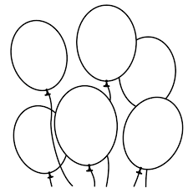I am amazing because:-

I am thoughtful

I am polite

I am helpful

I am a good at

I am a good friend

I am kind