


Horton Grange Primary School
New to English Hub

Supporting new arrivals and their families.

HORTON GRANGE PRIMARY SCHOOL
Celebrating Success Together
Spencer Road, Bradford, BD7 2EU.
Tel: 01274 573287

Welcome to Horton Grange!

About Us:
We are a diverse, three form entry primary school based in the centre of Bradford. Our students are from various backgrounds with the majority of children beginning school with English as an Additional Language. We often welcome children arriving from various countries including different Eastern European Countries, Somalia and Afghanistan. We have developed a successful, clear welcome procedure to ensure each family is fully supported upon arrival and to make the transition to a new school as positive an experience as possible.
Following on from the introduction to school we engage the children with a creative, supportive curriculum which is provided through intervention sessions with our Language Support Unit and supported within the classroom environment. Our children often make accelerated progress which we monitor carefully.

Our staff:
At Horton Grange we work as a team with the classroom teachers to ensure all areas of support for New to English children and their families are covered.

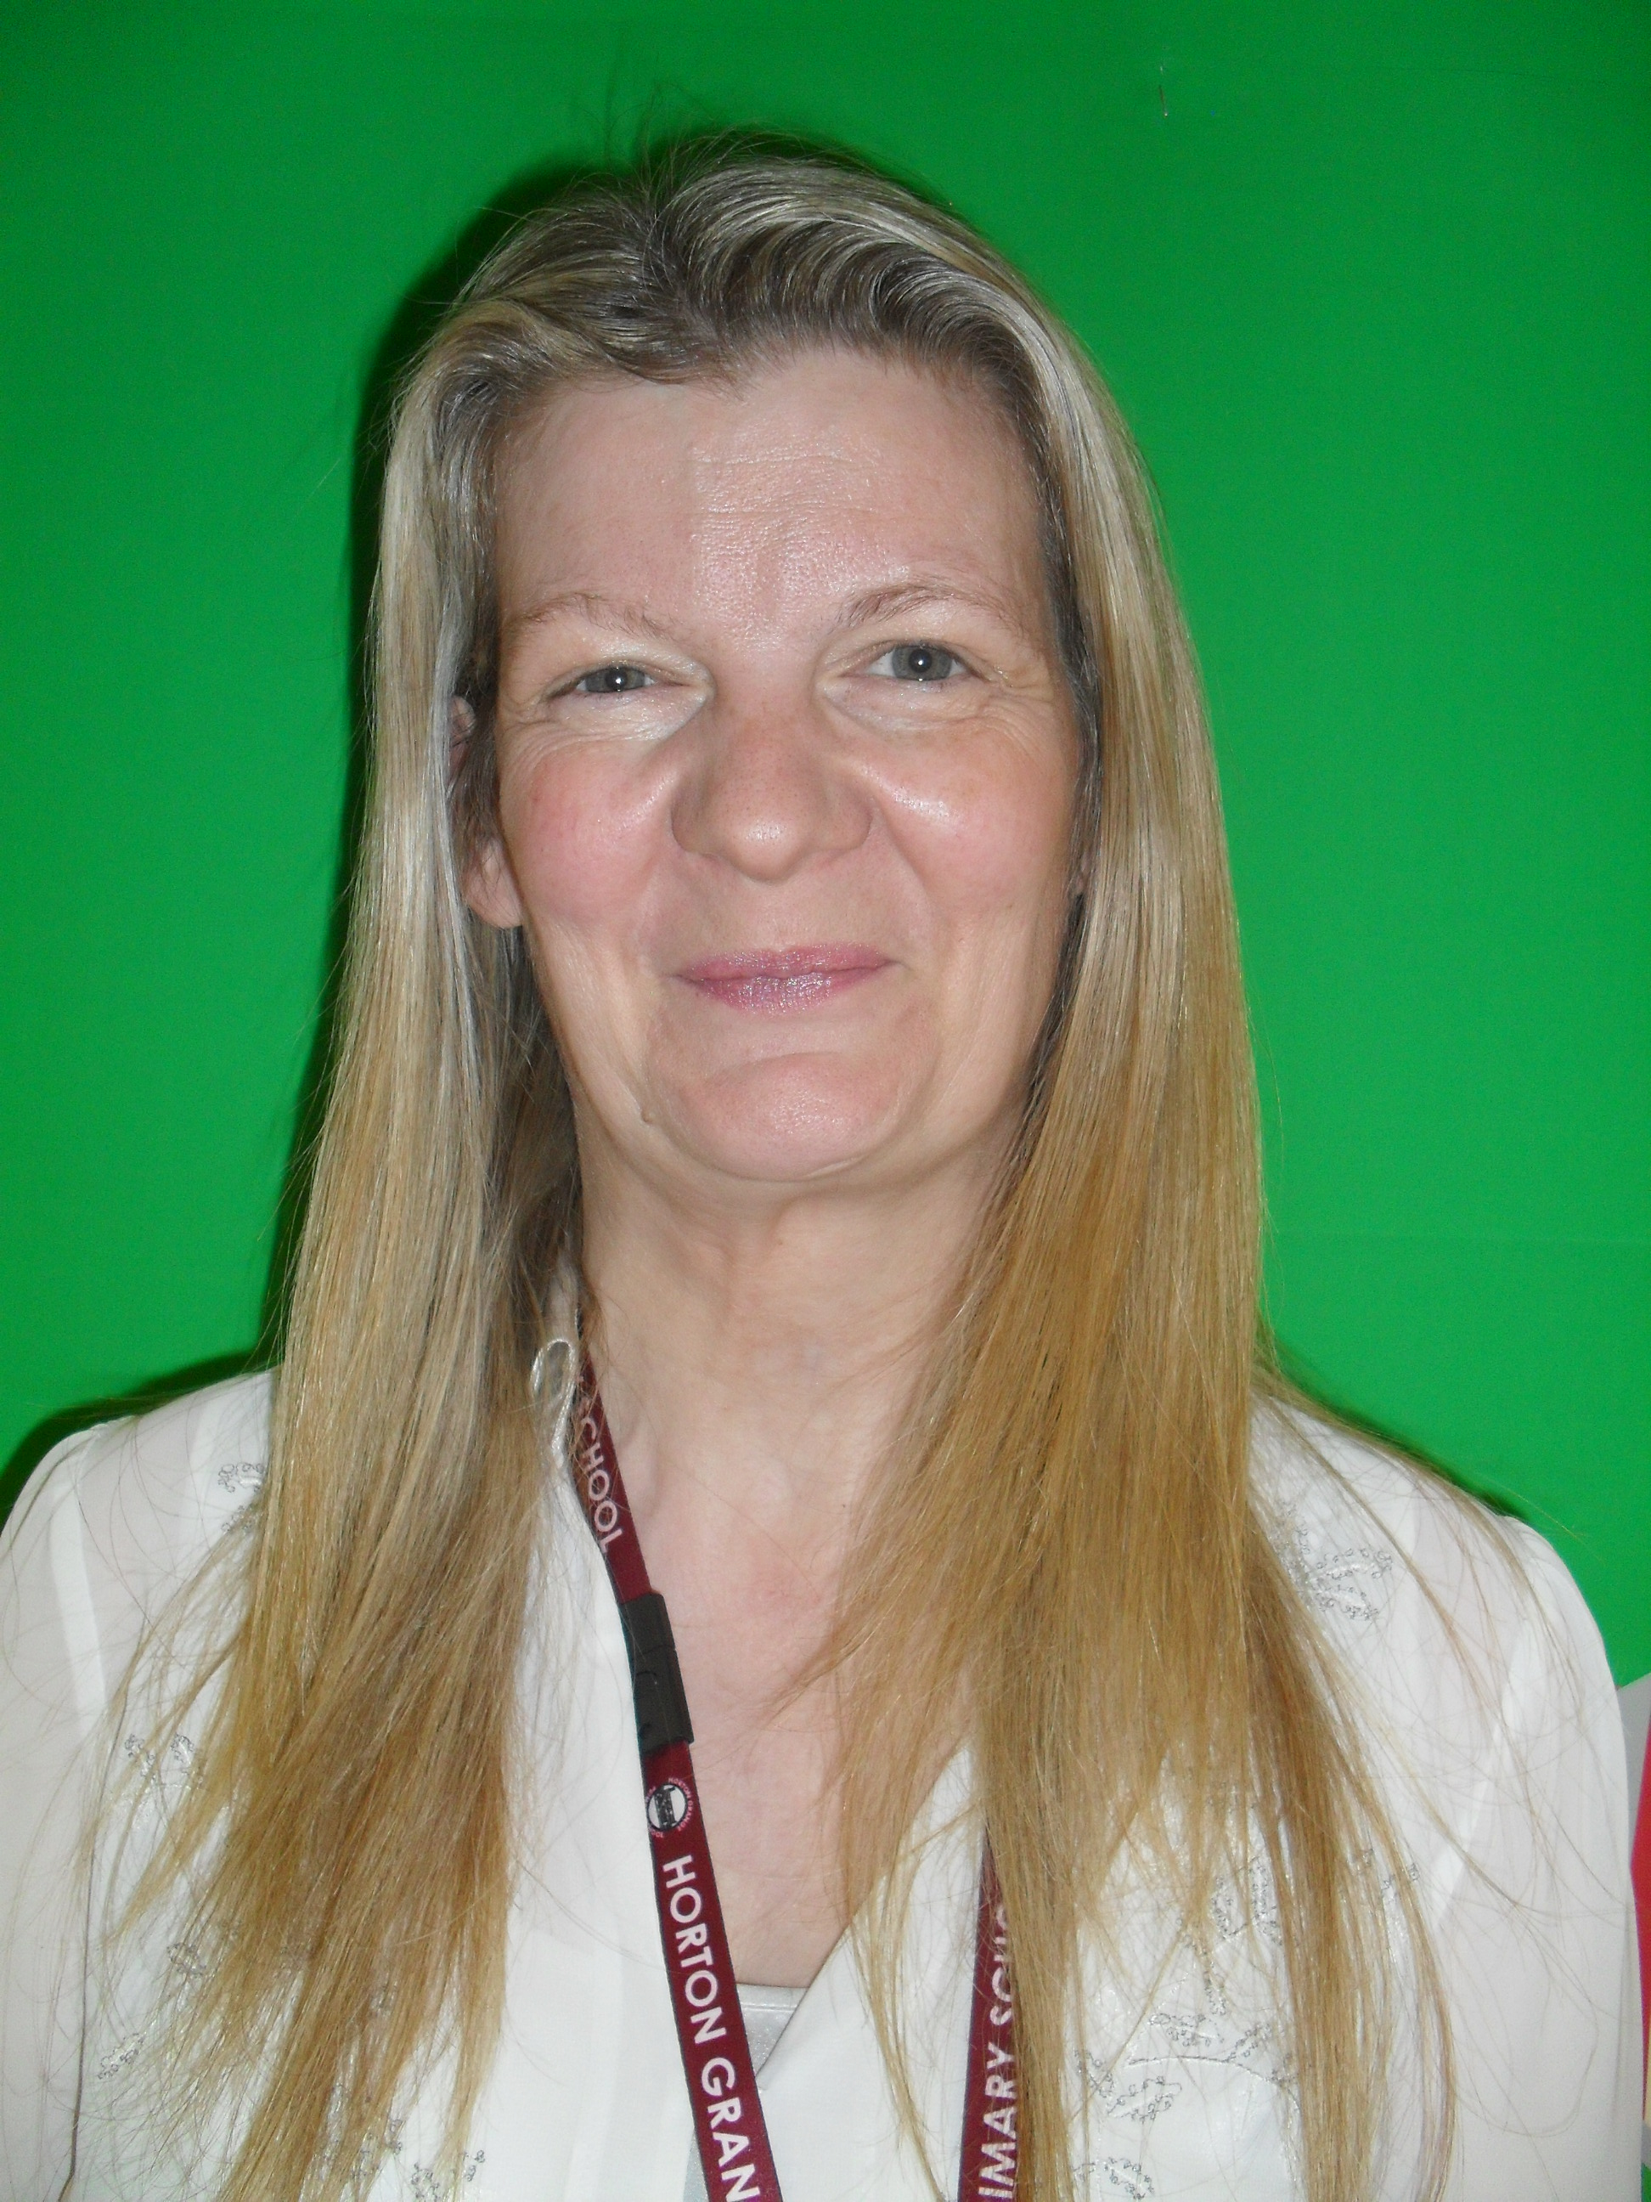
Lynda Salthouse – EAL/NTE Co-ordinator
Lynda has worked at Horton Grange for the past 5 years. As a classroom teacher she has welcomed many New to English children into her classroom. As part of her role, she monitors and evaluates the outstanding work carried out within a class setting and the Language Support Team.
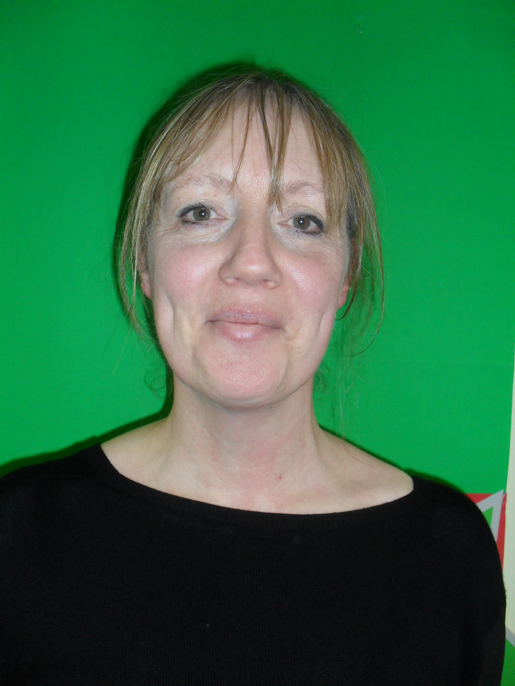
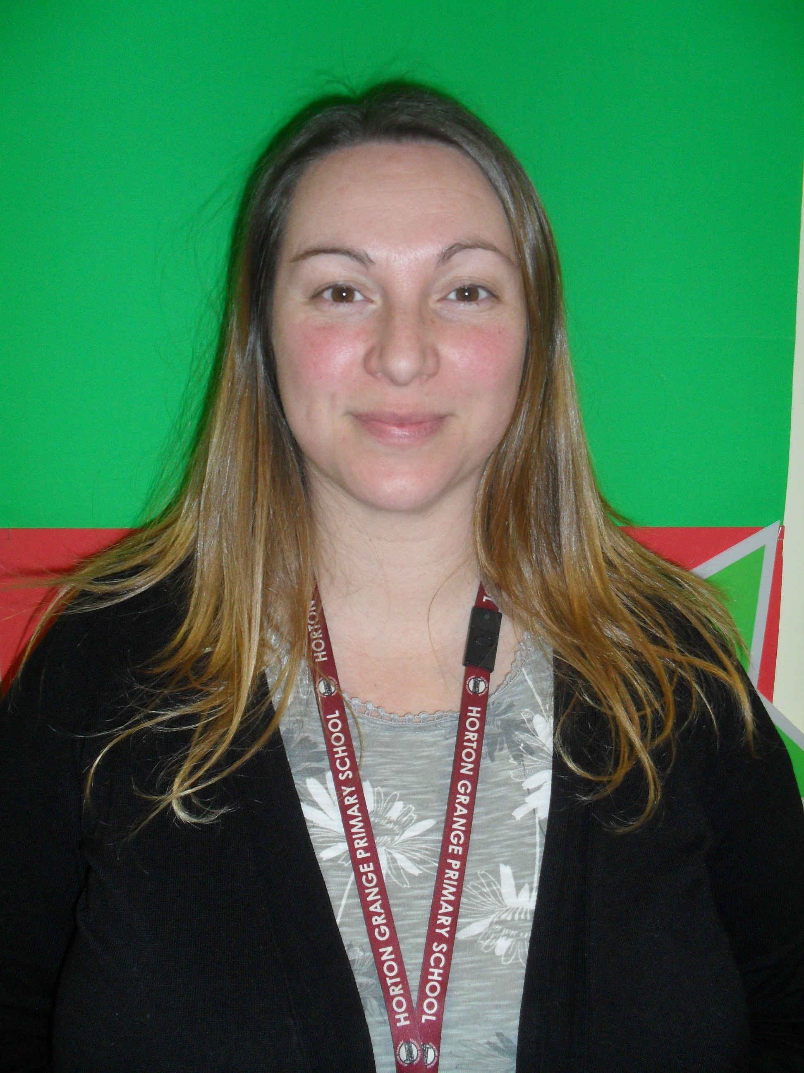
Tracey Dawson and Janette Young – Language Support Team

Tracey and Janette are experienced practitioners who have supported new arrivals for several years at Horton Grange. They work closely with the Class Teachers to ensure the children are receiving the exact level of support either in class or in the Language Support Unit where they provide lessons in English and Maths to accelerate the children’s progress. The children are assessed within the unit upon arrival and targets set. The children then follow a programme which is assessed at the end of each half term to monitor progress.

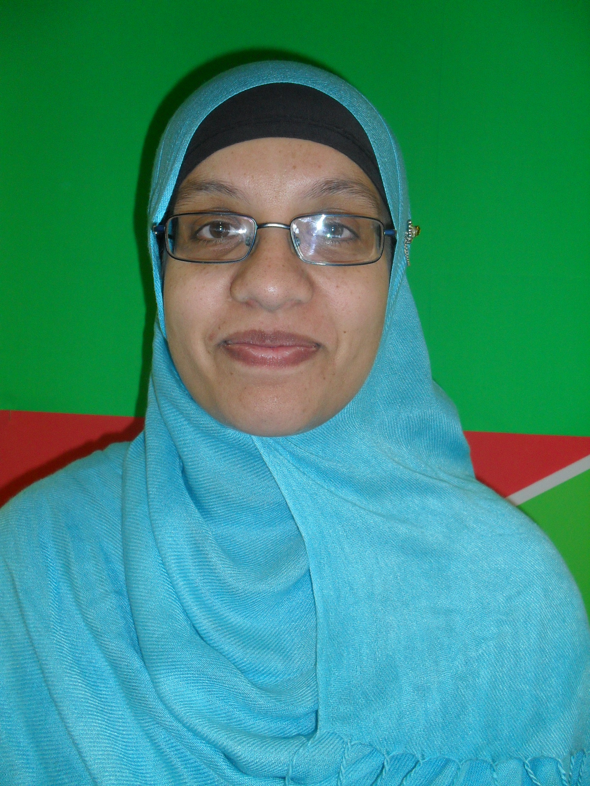
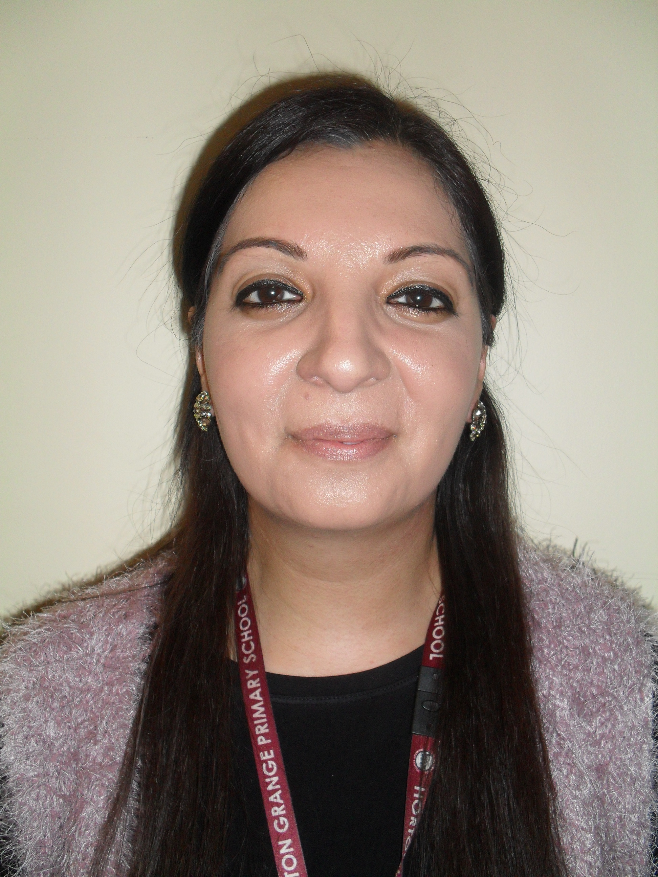
Zakia Bano – Office Administrator and Attendance Officer

Yasmin Akhtar – Parental Involvement Worker
Zakia and Yasmin are our first points of contact for new arrivals. They work closely with each new family and ensure all the relevant paperwork is completed and the class teachers and the Language Support Unit are ready for the child upon entry. The support continues throughout the time the children remain at Horton Grange and includes additional support with transition to High School.

Due to our experience in this area, we feel we can offer our support to other schools and practitioners with new arrivals. If you feel you would benefit from visiting our school, would like us to visit you or have some questions regarding the progression of the children, processes or engaging with the families then we would be pleased to hear from you.
Sharing good practice is something we feel very passionate about at Horton Grange and we look forward to discussing how we can work together.
In the first instance please contact Lynda Salthouse by email:
lynda.salthouse@hortongrange.bradford.sch.uk

