Department of Children’s Services

Aiming High for Children

FAO The PSHE Co-ordinator  All Primary Schools | Access & Inclusion  Health & Well-being Team  Future House  Bolling Road  Bradford, BD4 7EB  Tel: 01274 385946  Fax: 01274 385943  Mobile: 07852109151  E-Mail: Millie.Clare@bradford.gov.uk

3 April 2014

Dear Colleague,

PSHCE education Course REPEAT

Hope you are all well and keeping up to date with the DfE/PSHE Association guidance. I would like to draw your attention to a forthcoming repeat course. This course on 31 March was very successful and oversubscribed, so we would like to run it again for those who missed out.

This course is currently advertised on Bradford Schools Online, application through courses desk, reference number PSH13P/31. This course is entitled ‘PSHE education NEW Programme of Study and Government Expectations’. The content of the course will address DfE expectations that ‘All schools should make provision for Personal, Social, Health and Economic education (PSHEe), drawing on good practice’ (DfE) 2013.

‘From Spring Term 2014 all schools must publish their curriculum by subject and academic year including Personal, Social, Health and Economic education’. This course will discuss the Government’s Children and Families Bill and it’s position on PSHE education, Ofsted and the new Programme of Study’. This has been developed into a new updated spiral curriculum for Primary Schools in Bradford and will be disseminated at the course.

Title  PSHE education NEW Programme of Study and Government expectations |  |  |  |  |  | Course number  PSH13P/31
Intended Participants |  |  | PSHE co-ordinators  Subject Leaders
Phase of education: |  |  | If ‘other’ please specify: Primary
Target audience and prior experience:
Date/s | 16.5.14 | Times | 09.00 – 3.30 | Venue | Future House |  | No of sessions | 1
Cost | per person |  |  | Tutor | Millie Clare  - Internal Tutor Gail Sudall  - External Tutor Jan Lever

Hope to see you all soon.

Yours faithfully
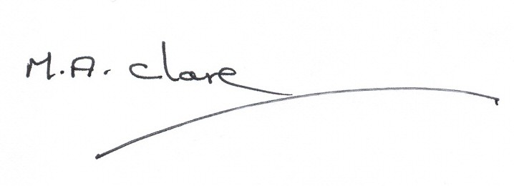
Millie Clare
PSHCE Consultant

