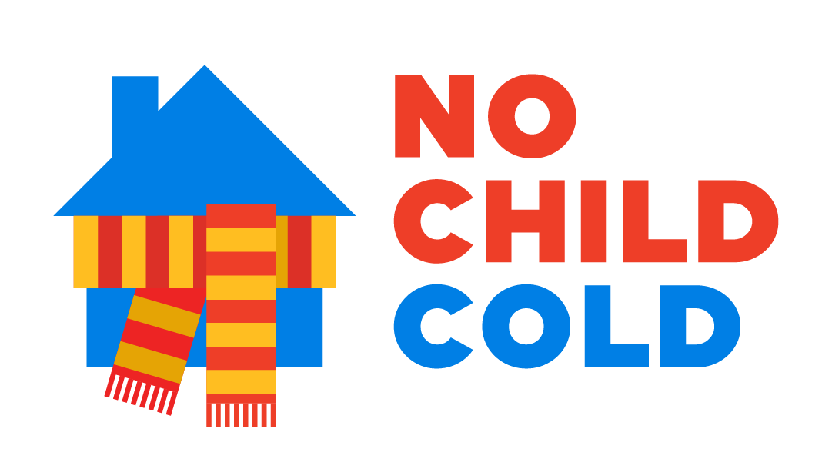
Dear colleagues
No Child Cold Grant Scheme
There are now approximately 75,000 children in Bradford accessing education by remote learning during a period when temperatures have reached -4 in the district. We know that for many families the additional heating costs are challenging. An estimate of children who are living in households who are in poverty suggests that as many as 21,000 children in our district are remote learning in homes which will be cold.
Bradford partners from the VCS, business and faith groups have come together at pace to put in place a one off short term scheme to make sure that no child in the district is cold as a result of the recent lockdown. It brings together winter warmth money with individual, philanthropic and business giving into a scheme that will meet the needs of a wider group of children than existing arrangements which focus on those on benefit. This is a direct response to the impact of the pandemic and on home schooling in the winter period for children in the Bradford District.
We are asking schools to support families by making referrals. Schools know their families better than any other agency and can identify families who are in need.
This scheme is designed to help families where
- household income, of those responsible for bills, has fallen due to a reduction in wages, either because of a reduction in working hours, a loss of regular overtime or a member of the household has been furloughed.
- The family is a low income household (defined as being in receipt of UC, tax credits or other income related DWP / local authority benefit) and fuel costs have increased as a result of children being at home because of school closures.
- The family live in a household where the child would be entitled to free school meals and fuel costs have increased because the children have had to stay at home because of school closures.
“No Child Cold” is administered through Citizens Advice and will pay out grants of £80 to household which will be made directly to energy suppliers on behalf of the family
Families need to access the scheme via trusted partner in the district. Referrals can be made using the referral form by:
- Schools
- Food banks
- Voluntary sector advice agencies

There is a list to these on the website web/charity/displayCharityCampaignPage.action?charityCampaignUrl=NoChildCold#supporterList
If you are able to make a donation to support the scheme, please go to
https://uk.virginmoneygiving.com/charity
Thank you for your support. Together we can make sure that no child is cold in our district as a result of this lockdown.

Jenny Cryer
Assistant Director
Office of the Chief Executive Bradford Council

