HCSS Budget Modelling Software – HCSS Budgeting 2017

Additional Guidance Notes for Schools – Teachers Main Scale

We have been advised that within Bradford, teachers move from scale point 5 directly to scale point 6b, bypassing scale point 6.

The automatic incremental process within HCSS will not account for this and will only move a teacher from scale point 5 to scale point 6.

A manual adjustment will need to be applied where you have a teacher(s) paid at scale point 5 during 2016-17 moving up to scale point 6b in 2017-18.

To do this, identify the teacher from the staff list and open (load) the contract.

Go to the salary details table towards the foot of the page.

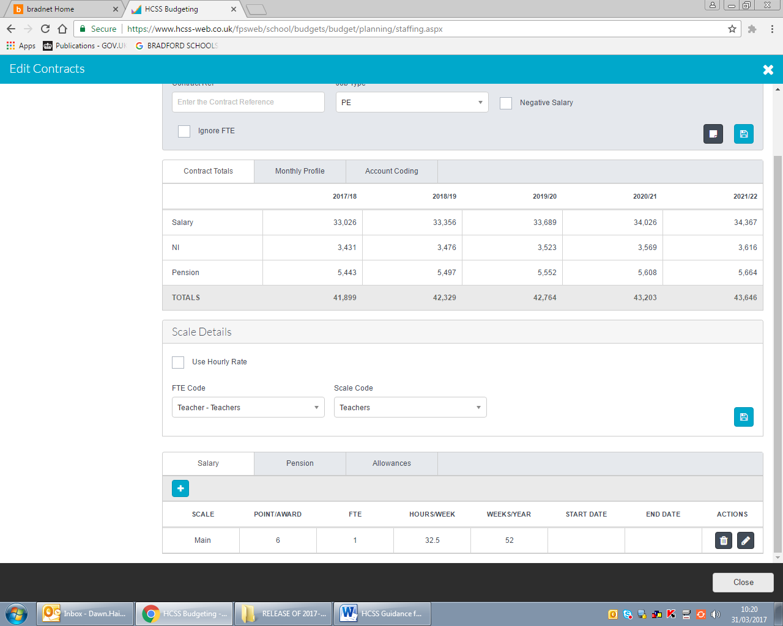

Click the edit button on the right

The scale point box will open up. Change the scale point from 6 to 6b and save the changes.

Complete this process for every teacher moving from 5 to 6b where the scale point on HCSS is shown as point 6.

