**Access Group (HCSS) Budget Modelling Software 2018**   **(March 2018 VERSION 2)**

**Additional Guidance Notes for Schools**

These guidance notes provide a little more information on how to set up and use the Bradford customised version of the Access Group (HCSS) Budget Modelling Software and to point out some specific details on S251 funding forecasts. **This guidance sets out some manual adjustments to funding and Pay Related Factors that are required in setting up your scenarios.**

Please contact a member of the HCSS Helpdesk with any technical queries that are not resolved by these guidance notes **0845 340 4546.** Schools should contact a member of School Funding Team with more general budget or formula funding related queries.

**Primary schools** should read sections **A**, **B**, **C**, **E and F** below

**Secondary schools** should read sections **A**, **B**, **E and F** below

**Nursery schools** should read section **A**, **C**, **E and F** below

**Special schools** and **PRUs** should read sections **A**, **D**, **E and F** below

**A. All Schools**

1. Once the 2018/19 financial year is ‘live’, the 2018/19 financial year will be the default view when you log in to the Software. The list of scenarios initially will be blank. You can either begin a new scenario or transfer an existing scenario from 2017/18.

You can create a blank scenario by clicking on the blue **‘+’.**

To ‘transfer’ a scenario from 2017/18 click on ‘**Upgrade Scenario**’ (whilst you are in 2018/19). You will be able to select a scenario from the drop-down list. Click on ‘**Submit**’ and you should see a pop-up message confirming the upgrade has been successful. Repeat this step for each scenario you wish to transfer. All transferred scenarios will still exist in the (closed) 2017/18 year.

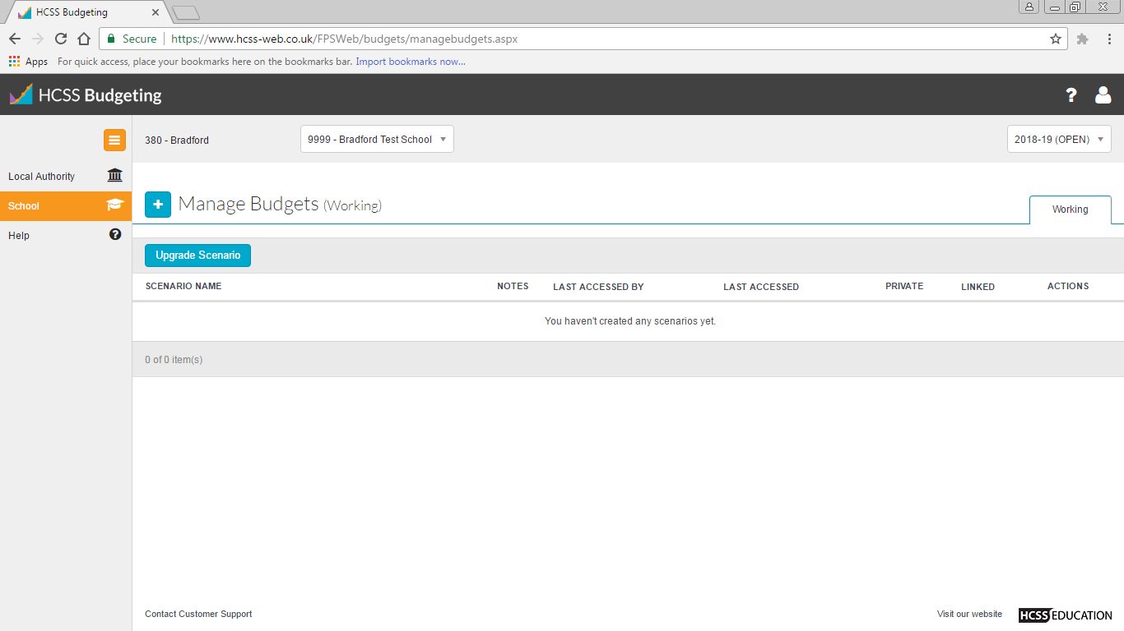

To change the financial year back to 2017/18, choose 2017-18 (CLOSED) from the top right drop-down menu.

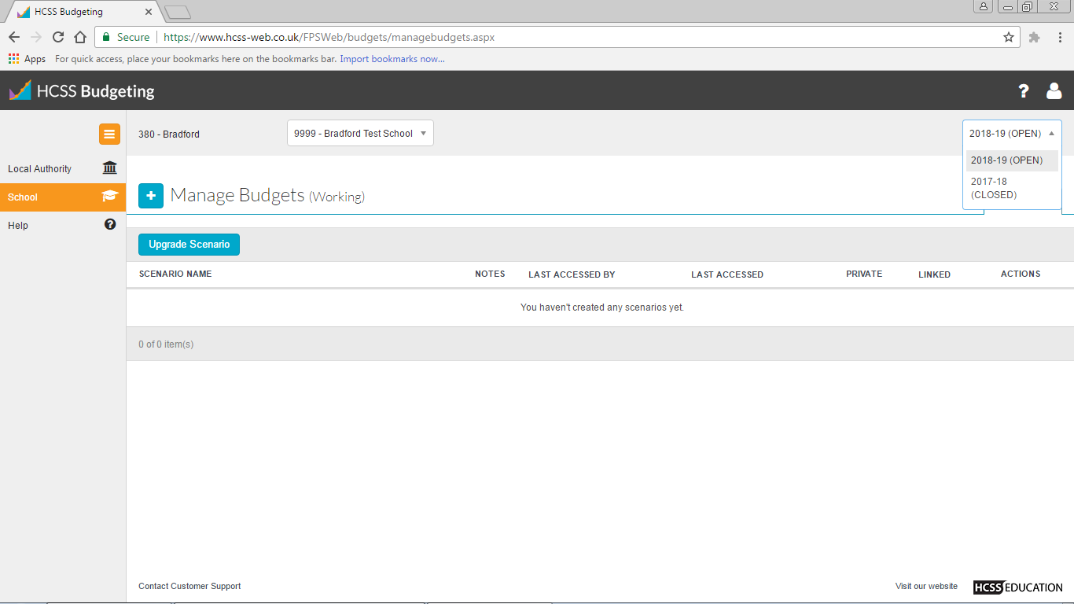

You can choose from various actions under the Actions heading, at the right of each scenario line. To edit the scenario name, for example, you would choose Edit and then rename the scenario.

1. To load your chosen scenario click on the scenario name (in blue text). When your scenario has loaded you will be presented with a ‘Budget Dashboard’ screen. This displays a series of graphs depicting the data within the scenario. This can be printed by right clicking on the screen and choosing Print.
2. To access the data within your scenario, click on the **Scenario** heading on the left hand side. You will be presented with the screen below:

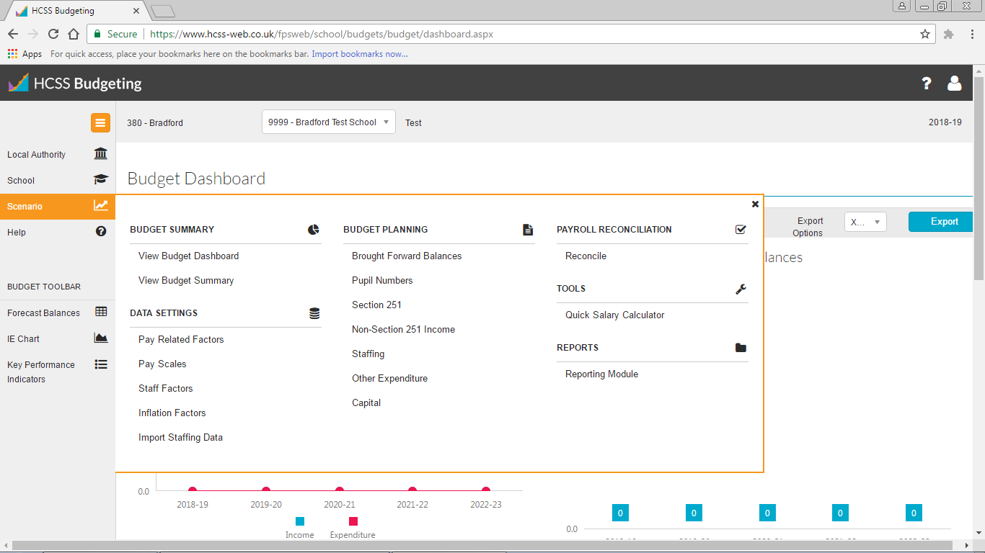

The majority of the work you will undertake will be within the **Budget Planning** menu.

You can view a summary CFR report by selecting **View Budget Summary** from the Budget Summary menu

You can navigate to different areas by clicking on the **Scenario** heading from any screen within your scenario.

**B. Primary and Secondary Schools**

1. Navigate to the **Pupil Numbers** page (Budget Planning submenu) using the Scenario heading menu, as above.

The October 2017 Census pupil numbers will be displayed (excluding 3&4 year old nursery numbers; so for nursery schools the Pupil Numbers page will be blank; it will also be blank for special schools and PRUs). Numbers for future years are partially pre-populated. **You need to manually input your estimate of Reception (primary) and Year 7 (secondary) numbers in each future year.** You may also wish to review pupil number estimates for future years in other year groups; amend by overtyping. You should ensure that pupil numbers for all year groups (reception to year 6 primary; year 7 to year 11 secondary) in all 5 years are populated. Sense check the pupil numbers total shown at the bottom of the page.

**You must not change your October 2017 numbers** from those pre-populated. This will change your 2018/19 Section 251 funding. As your main 2018/19 Section 251 formula funding is now set and will not change, your software would be calculating a level of funding in 2018/19 that is not accurate and this will be a reason why your software does not match your Section 251 Budget Statement.

**Schools with DSPs and ARCs:** please note that the adjustment to pupil numbers and / or AWPU funding in ‘show factors’ in the S251 page that has been needed previously, to remove those pupils funded on a place-led basis, is no longer required. You should not reduce your pupil numbers or AWPU funding in any year for this reason. This is because DSP and ARC place-led funding is now set at a reduced value of £6,000 rather than £10,000 but pupils placed in these provisions now attract full formula funding and are not deducted from October Census numbers.

Other pupil number adjustments for information: You may find that the total of your pupil numbers shown in the Pupil Numbers page for October 2017 is slightly higher than the total of funded numbers shown in your 2018/19 Section 251 Budget Statement. This difference is the result of data cleansing at national level, which has removed children that are identified as being on the roll of more than one school.

1. See section C below for guidance on altering / inputting **early years 2, 3&4 year old nursery numbers** and for correcting slight differences in 2018/19 pre-populated EYSFF values due to the rounding of 3&4 year old headcount numbers. You may wish to add your 3&4 year old numbers into the Pupil Numbers page. However, this is not necessary and will not have an impact on the funding calculations (EYSFF allocations are calculated within the Section 251 page). The Year 12 and Year 13 numbers in the Pupil Numbers page also do not link to any funding calculations.
2. Navigate to the **Section 251** page using the Scenario heading menu.

Your I01, I02 and I03 funding will be displayed by factor. The figures in the 2018/19 column should ultimately match the figures shown on your 2018/19 Section 251 Budget Statement by factor.

You can drill down into each factor by choosing ‘Edit’ or ‘Show Factors’ from the drop-down box under Actions at the right hand side of the page:

* *Clicking ‘Edit’ allows you to change the funding value, which is recommended for adjusting I03 funding.*
* *Clicking ‘Show Factors’ will allow you to view the data behind the funding calculations e.g. if you forecast that your Ever 6 FSM% will increase in future years, you could adjust the % here. Please be careful to ensure that changes to data are realistic, as if these changes do not materialise in future October Censuses you could be overestimating your funding. Schools are generally advised not to amend any of the data behind the formula funding calculations; certainly not to amend to increase funding allocations in future years.*

Please note that, as in previous years, the Software does not pre-populate **Pupil Premium** (I05) and **Post-16 ESFA Bursary** funding (I02). You will need to enter these allocations manually in the relevant **Non-Section 251 Income** pages. However, unlike in previous years, for primary schools only, estimated **2 year old EYSFF allocations** (I01) are pre-populated albeit simply within the EYSFF total in the Section 251 page. You can see a breakdown of the EYSFF calculations via the ‘Show Factors’ sub-menu on the EYSFF line. 2 year old allocations are included as an annual cash amount at the bottom of the ‘Show Factors’ page. This value can be edited and will feed through to the Section 251 page funding totals.

*Nursery schools please note that your 2 year old allocations, as in previous years, are not pre-populated and can be entered manually either in the I01 Non-Section 251 Income page (as you would have done in previous years) or as a cash value by year at the bottom of the ‘Show Factors’ page.*

We recommend that schools calculate their own estimate of Pupil Premium funding for 2018/19 using their pupil data from Key To Success alongside their January 2018 Census return (this is because the S251 estimate is calculated using the previous years Ever 6 FSM % data). Please ensure that your scenario includes an estimate of Pupil Premium funding in every year, based on the information you have available at the moment. Please note however, that *the Government has currently committed to continue Pupil Premium funding until the end of the current spending period (2020).*

**Secondary schools with DSPs and ARCs that have post 16 places will need to manually move** in the Software the element of place-led funding for post 16 places from I01 to I02 so that the CFR totals match the Section 251 Budget Statements. Post 16 places are worth £6,000. So the place-led funding (no. of places x £6,000) should be removed from I01 funding (enter a negative) and added to I02 funding (enter a positive) in the relevant I01 and I02 Non-Section 251 Income pages.

1. You are reminded that you need to **manually enter into the Software as expenditure your school’s contributions to de-delegated items**. You should enter the same figures as shown in the CFR Funding Breakdown of your S251 Budget Statement for 2018/19. To enter these figures:
   1. Navigate to the **Other Expenditure** page using the Scenario heading menu as before.
   2. You can then either click on the blue ‘**+**’ button to add the item as a new budget line, or amend the figure brought into 2018/19 from your 2017/18 scenario
   3. Choose the relevant CFR code by clicking in the Section box and choosing from the drop-down menu.
   4. Enter a relevant description along with the expenditure values and any further information helpful to you in your budget setting. *Once you enter a figure for 2018/19, the figures for 2019/20 – 2022/23 will be automatically generated based on 3% inflation in each year. You can overtype these figures to match 2018/19 (assuming no inflation), or keep the inflated figures, should you wish.*
   5. Click on the blue ‘Save’ button at the bottom right of the page.
2. Once you have completed these initial adjustments and inputs, please **check** your totals of formula funding and de-delegated funds expenditure in the **CFR Report** for 2018/19. You can navigate to your CFR report by clicking the Scenario heading menu and choosing **Reporting Module** from the Reports submenu. Click on the CFR report under the Bradford Reports tab and click on the blue ‘Print to Excel’ button; you should then be asked to open or save the report in Excel. If you have simply tried to replicate your Section 251 Budget Statement and have not deliberately and knowingly made any changes e.g. for I03 SEN funding, or to use different estimates for I05 Pupil Premium, I01 Early Years, I02 Post-16 funding, then the funding totals by CFR code for 2018/19 in the CFR Report should match (allowing for roundings) the totals shown on your 2018/19 Section 251 Budget Statement.

There will be a difference where schools have adjusted their estimates of 2, 3&4 year old nursery numbers following the publication of the 1st Draft Indicative EYSFF allocations – please see paragraph C for how to manage these. There may also be some small differences that are due to roundings in the Software, including for the rounding of EYSFF headcount numbers. If this is this case, please make manual adjustments as necessary in the relevant **Non Section 251 Income** pages.

1. Once you are clear about your ‘starting’ funding position you should then enter **additional funding allocations** that you estimate / expect to receive for items that have not been included in the 2018/19 Section 251 Budget Statements. These should all be entered in the relevant Non-Section 251 Income pages. Please see the [budget guidance notes](https://bso.bradford.gov.uk/Secure/CMSPage.aspx?mid=229) on BSO for further information on what is not included in the Section 251 Budget Statements. You should also take note of the risks and changes to funding that are highlighted in these guidance notes.

**C. Funding for Nursery Provision (EYSFF) – Nursery Schools & Classes in Primary Schools**

1. The Software has been pre-populated to include the Early Years Single Funding Formula (EYSFF) totals, and estimated numbers, for 3 and 4-year-old free entitlement delivery that were shown in the 1st Draft Indicative EYSFF Budgets published on 23 February 2018.

Please note that the pre-population of the 2 year old EYSFF funding for primary schools only is treated simply; pre-populated only with an annual cash amount within the ‘Show Factor’ page on the EYSFF line of the Section 251 Page. 2 year old allocations for nursery schools, as in previous years, are not pre-populated and can be entered manually either in the I01 Non-Section 251 Income page (as you would have done in previous years) or as a cash value by year at the bottom of the ‘Show Factors’ page.

Please note that the estimated headcount numbers for 3&4 year olds by term pre-populated in the ‘Show Factors’ page may be rounded to whole numbers. This may explain small variances between the EYSFF funding figures in the Software vs. the 1st Draft Indicative Budgets for 2018/19 for some schools where the Indicative Budgets included partial headcount numbers (due to arithmetic estimates of extended hours provision for the summer term). If you wish to adjust for this – so that your EYSFF 3&4 year old funding 100% matches the 1st Draft Indicative Budget - you will need to enter a balancing correction in the I01 Non Section 251 Income page (please see step d below). However, we would advise that such a correction is not really necessary.

Please note that, where schools have asked for estimates of 3&4 year old numbers to be adjusted for 2018/19 following the publication of the 1st Draft Indicative Budgets, although these changes will be reflected in the Confirmed Indicative Budgets (published mid-March), they are not reflected in the Software. Schools that have adjusted their estimates will need to manually adjust their scenarios, using the process described below.

Please also note that the headcounts pre-populated for 3&4 year olds are not split between the universal and extended entitlements; a single headcount total is given by term in the rows marked ‘universal’ (where 1 headcount = 15 hours so a child taking 30 hours = 2 headcounts). However, if schools wish to, they can split the numbers between the universal and extended entitlements by amending how the information is populated in the ‘show factors’ page. There are rows clearly marked ‘universal’ or ‘uni’ (for the universal 15 hours entitlement) and ‘extended’ or ‘ext’ (for the extended 30 hours entitlement). For example, a school that has a headcount of 50 children in total each term, with 20 of these accessing the full extended 30 hours, would populate a headcount of 30 in the universal rows and 20 in the extended rows. *There is another way in the Software of counting ‘headcount’, by amending the default extended hours from 30 to 15; so in the same example the school would record 50 in the universal headcount rows and 20 in the extended headcount rows.*

Schools are advised always to sense check their HCSS Software estimates with the ready reckoner that is provided (do you get the same funding result when you use the same estimates of numbers and is this funding in line with what you would expect / manually calculate / currently receive?). There is opportunity for error when making amendments and splitting the headcount numbers. A simple sense check of the EYSFF funding totals in the Software will help ensure that significant errors (especially with double counting) are not made.

Please note that the sustainability lump sum for nursery schools is not dynamic i.e. it does not re-calculate for changes in numbers. Nursery schools should just watch for this and should use the ready reckoner to forecast the impact of numbers changes on this value. This is not a significant issue unless estimated numbers in 2018/19 and in future years are significantly different from 1st Draft Indicative Budget estimates.

1. A school’s early years funding will be adjusted during 2018/19 to take account of the difference between estimated and actual numbers of funded hours counted in the termly censuses in May 2018, October 2018 and January 2019. *You can alter EYSFF funding in the Software throughout the year if you wish (once you know the actual numbers of eligible children in the termly censuses for example) by using the process described in step 13 below.*
2. By default, the Software assumes the same termly hours and the same level of basic funding as 2018/19 for the 4 remaining years of the 5 year forecast. *You can alter EYSFF funding estimates for future years using the process described in the next step.*
3. Navigate to the **Section 251** page by clicking on the **Scenario** heading on the left hand side. Scroll down to the Early Years Funding section and you will see your total EYSFF in a separate line. Nursery schools will also see the Sustainability factor as a lump sum.
   1. Scroll down and choose ‘Show Factors’ from the Actions drop down box at the right hand side of the **EYSFF Funding** factor line.
   2. Overtype the headcount numbers by term to reflect either your actuals or your revised estimates in the relevant columns and rows. To do this, choose ‘Edit’ from the Actions drop down box at the right hand side of each row and then overtype the termly headcount figure as necessary. Click the Save button for each row once you have made changes. Once you have entered all adjustments, click to close the screen. The Software will then recalculate the EYSFF funding total for 3 and 4 year olds in the Section 251 page. You should sense check the total for each year. The Software assumes by default that 1 headcount entered in the universal rows is worth 15 hours a week; 1 headcount in the extended rows is worth 30 hours, so it simply takes the headcount you have entered x weekly hours (15 or 30) x pre-populated weeks per term (12 summer; 14 autumn; 12 spring).
   3. For monitoring and recording changes in EYSFF funding during 2018/19, in all cases, we advise schools to use the Ready Reckoner to re-calculate estimates of funding allocations during 2018/19 and to sense check the results. The EYSFF ready reckoner will be published late March and will be available on [BSO here](https://bso.bradford.gov.uk/Secure/CMSPage.aspx?mid=1904).
   4. As an alternative to the process described in a. and b. above, it is possible for a school simply to add the funding adjustment shown in the ready reckoner into their I01 funding by entering a value in the **Non-Section 251 Income** page. To enter the funding values:
      1. Navigate to the **Non-Section 251 Income** page by clicking on the **Scenario** heading on the left hand side
      2. Click on the blue ‘**+**’ at the top of the page.
      3. Choose I01 from the Section dropdown list and enter a relevant description along with the necessary funding adjustment and any further information.
   5. You can use the process in d. above to manually enter / amend funding estimates for **2-year-old nursery funding**.
   6. For forecasting early years funding for future years, again, schools can adjust the termly headcounts by drilling down in the Section 251 page as described above, or by using the ready reckoner to calculate an estimated adjustment and manually entering this in to the Non-Section 251 Income I01 page in future years.
4. **Nursery schools**, before making any changes, should check that the formula funding totals in their HCSS CFR Report for 2018/19 match the total of EYSFF for 3 and 4 year olds shown in their 1st Draft Indicative EYSFF Budgets, published on 23 February 2018. You can navigate to your CFR report by clicking the Scenario heading menu and choosing **Reporting Module** from the Reports submenu. Click on the CFR report under the Bradford Reports tab and click on the blue ‘Print to Excel’ button; you should then be asked to open or save the report in Excel. As a reminder, where a nursery school has requested adjustments to estimated numbers for their Confirmed Indicative EYSFF Budgets, these adjustments will not be included and the numbers in the Software will need to be manually adjusted to match. There may also be slight differences due to the rounding of headcount numbers.

**D. Special Schools and Pupil Referral Units**

1. The funding sections in the Software for Special Schools and PRUs are blank. This is because of the timing of publication of the first High Needs Monthly Funding Statements for 2018/19. You should initially construct your budget in HCSS with reference to the [High Needs Monthly Funding Statements](https://bso.bradford.gov.uk/Secure/CMSPage.aspx?mid=3225) that are published on Bradford Schools Online on a monthly basis. A summary statement showing the 2018/19 Delegated Budget Shares for stand-alone High Needs providers was added to the [High Needs Funding Statements page](https://bso.bradford.gov.uk/Secure/CMSPage.aspx?mid=3225) on 23 February 2018 and the first Monthly Adjustment Statement will be available mid-April. A ready reckoner for 2018/19 will also be made available for schools to use to estimate their funding allocations throughout the year (available via the link above).
2. You will need to manually enter your estimated budget information using the **Non-Section 251 Income** page. To enter the funding values:
   1. Navigate to the **Non-Section 251 Income** page by clicking on the **Scenario** heading on the left hand side
   2. Click on the blue ‘**+**’ at the top of the page.
   3. Choose the relevant CFR code from the **Section** dropdown list:
      1. I01 funding = Place funding for pre-16 pupils
      2. I02 funding = Place funding for post-16 pupils
      3. I03 funding = Plus elements of funding for all pupils
      4. I05 funding = Estimated Pupil Premium funding
   4. Enter a relevant description along with the funding values and any further information.
3. Once you have initially entered your first draft of funding for 2018/19 you should sense check that the Place-Plus totals shown in your CFR Report in your HCSS scenario are as you would expect. You can navigate to your CFR report by clicking the Scenario heading menu and choosing **Reporting Module** from the Reports submenu. Click on the CFR report under the Bradford Reports tab and click on the blue ‘Print to Excel’ button; you should then be asked to open or save the report in Excel.
4. The ‘**Plus’ elements** **(I03)** of funding will change during 2018/19 according to the population of pupils recorded on the roll of the school at the 10th of each month. You should therefore, adjust your budget on a monthly basis in HCSS to reflect any changes in I03 funding. You should also check for changes to any of the other funding elements that these statements may identify*.* The High Needs Funding Statements will be updated and published on [this page](https://bso.bradford.gov.uk/Secure/CMSPage.aspx?mid=3225) on BSO.
5. **For Future Years**: The Software assumes no changes in per pupil / place funding values in future years and we would suggest that schools work on the same factor values as for 2018/19. You will be able to use the ready reckoner (click [here](https://bso.bradford.gov.uk/Secure/CMSPage.aspx?mid=3225) to access this on BSO) to estimate adjusted funding for 2018/19 as well as for future years on this basis.

**E. Primary & Secondary Formula Funding – Basic Assumptions for April 2019 onwards**

1. **I01 funding**
2. The Software is set up to assume that primary and secondary formula funding from April 2019 will continue to be constructed as it has been in 2018/19 – using National Funding Formula and the 2018/19 formula variables and data for individual schools (FSM, EAL etc).
3. The Software assumes that the **Minimum Funding Guarantee** (MFG) continues at 0% per pupil in 2019/20 onwards. This is a dynamic formula, which will take account of changes in pupil number estimates.
4. The Software assumes that, from April 2019, all schools will be off the **Transitional Ceiling** (all values in 2019/20 onwards are £0). Only a small number of schools are affected by this ceiling in 2018/19 and our modelling currently suggests that, where individual school data measures such as FSM do not increase substantially, the ceiling will not be a significant factor in 2019/20. Schools are advised not to alter the data behind their Section 251 formula funding calculations and certainly not to alter with the purpose of increasing formula allocations in future years.
5. The Software currently assumes that the cash values of the new **Per Pupil Minimum** factor (£3,500 primary; £4,800 secondary) for 2018/19 repeat unchanged in 2019/20 onwards. However, the actual allocations from April 2019 will change for pupil numbers and other data. We are working with HCSS on a dynamic calculation of this factor and an update to the Software will be released in due course.
6. Funding for **expanding schools** and for **bulge classes,** as well as for **safeguarded salaries,** is pre-populated to match S251 Budget Statements for 2018/19 only. Applicable schools need to review whether this funding will continue from April 2019 and manually adjust funding either by drilling down in the Section 251 page or by adding a new budget line in the Non Section 251 Income page, where it is appropriate to do so.
7. The value of funding for the **BSF affordability gap (PFI funding)** is pre-populated from the 2018/19 value across all 5 years. We would expect this to increase in line with inflation. However, this will not have an impact on the net budget of the school and therefore, for simplicity, we suggest that this is kept at the 2018/19 value. **This funding is not physically allocated to schools and BSF schools should either remove this from their I01 funding for budgeting purposes, or add a corresponding value of expenditure into E28**.
8. **I02 Post-16 ESFA funding**
9. I02 **ESFA Main funding** for 2018/19 is pre-populated to match the estimate in your Section 251 Budget Statement.
10. The estimated **ESFA Post-16 Bursary** funding shown in Section 251 Budget Statements is not pre-populated and you will need to enter this funding manually into the Non-Section 251 Income page of the Software.
11. The total I02 funding shown in the CFR breakdown in your Section 251 Budget Statement includes the post 16 element of the High Needs Place funding. This is not pre-populated in the Software and so you will need to enter this funding manually into I02 funding in the Non-Section 251 Income page. As the total High Needs place funding is included in HCSS in I01 funding, a corresponding adjustment to remove this funding from I01 funding will be needed (see the note under step 6).
12. We expect that the ESFA will notify the Authority of final allocations for 2018/19 by mid-April and therefore, any adjustment to funding will be shown on the Advances Schedule for this either April or May. Schools will need to manually adjust their allocations in the Software.
13. The Software assumes the continuation of Post-16 funding in future years at the same cash value as 2018/19. The software does not automatically re-calculate I02 allocations where schools change their post 16 pupil numbers in the Pupil Numbers page. This leaves schools to make their own estimates of funding, using their own predictions of funded growth and retention rates.
14. **I03 funding (SEND)**
15. I03 funding for primary and secondary schools is pre-populated to match the 2018/19 Section 251 Budget Statements. This reflects the funding position recorded in February 2018. I03 funding figures will change on a monthly basis, from April, to reflect the movement of pupils on roll with EHCPs. Schools can estimate their own I03 funding by taking into account any known leavers or starters throughout the financial year. Schools should therefore, adjust their budgets on a monthly basis in the Software to reflect any changes in I03 funding. Schools should also check for changes to any of the other funding elements. The [High Needs Funding Statements](https://bso.bradford.gov.uk/Secure/CMSPage.aspx?mid=3225) and the main [Advances Schedules](https://bso.bradford.gov.uk/Secure/CMSPage.aspx?mid=312), which show these funding adjustments, will be updated and published on BSO. It is reasonable for schools, in the absence of any further more specific information, to assume the same value of I03 funding in future years as in 2018/19, provided that the specific expenditure associated with their current number of children with EHCPs is also included on the same basis.
16. **I05 Pupil Premium funding**
17. Schools need to manually input their estimated I05 Pupil Premium allocations into the Non-Section 251 Income page.
18. The value of Pupil Premium funding in future years will be mostly influenced by a) the number of children on roll in the January Censuses who have registered for free school meals at any stage in the last 6 years and b) the value of funding per pupil, which will be set by the Government. It is reasonable for schools to estimate at this stage the continuation of this grant in future years using the same unit values.
19. Schools can also enter into their scenarios expected allocations for children who are Looked After. This will be paid in 2018/19 retrospectively on a termly basis.

The [budget guidance notes](https://bso.bradford.gov.uk/Secure/CMSPage.aspx?mid=229) give further information on Pupil Premium funding.

**F. Teacher and Support Staff Pay Assumptions**

1. The Software has been set up on default pay-scales and other inflation assumptions listed below. A number of these are somewhat estimated at this time however and **some manual adjustment is also required before you progress with your scenario modelling.** Schools are advised to fully read the Authority’s budget setting guidance notes for the warnings given about expenditure pressures, uncertainties and actions to take during budget setting for 2018/19. These guidance notes can be found [here](https://bso.bradford.gov.uk/Secure/CMSPage.aspx?mid=236).

The Authority leans towards recommending that schools plan towards a ‘worst case scenario’. However, the Authority has made ‘educated guesses’ around what this constitutes, which may not turn out to be accurate! Schools must regularly check the status of key decisions and must regularly review the impact of these on planned spending.

Schools will be aware that they can amend the inflation and pay related factors assumptions, and the values of pay-scales, in their software. Schools should seek further guidance from the HCSS helpdesk if they are unclear about how to do this. School Funding Team will ask for the Software to be updated to take account of significant changes and confirmations that apply to all schools where required during the year.

The table below shows how we aimed to set up the default ‘Pay Related Factors’ within the Software. Unfortunately, we are unable to set some of these defaults due to the way the Software is set up nationally (the Software cannot be changed just for Bradford, but will be changed once confirmed for all users of the Software).

**Therefore, at this time schools are recommended to open the ‘Pay Related Factors’ page within each of their scenarios and amend to match this table:**



**Schools will need to adjust the teacher’s superannuation employer’s contribution at 2019/20 onwards. Please see more guidance below.**

* 1. **Teachers Pay** **Award:** the Software assumes by default a blanket 2% uplift applied at September 2018 on all points, across all scales and allowances. All points, scales and allowances are then uplifted again by 2% each September in future years.

The 2017 Teachers Pay & Conditions document is available for reference [here](https://www.gov.uk/government/publications/school-teachers-pay-and-conditions).

Schools are reminded on a specific point, that in Bradford, teachers move from scale point 5 directly to point 6b, bypassing scale point 6. The automatic incremental rise within the Software will not account for this. Please read the guidance notes on the[HCSS page](https://bso.bradford.gov.uk/Schools/CMSPage.aspx?mid=199) on BSO on how to edit those contracts showing as scale point 6 instead of scale point 6b. If you have specific questions on terms and conditions or specific teacher contracts within your school please contact your HR officer.

* 1. **Support Staff Pay:** the Software by default assumesthat the Local Government Employer’s current 2 year offer is accepted. From April 2020, the Software then assumes that all scale points will increase by 2% a year.

The offer for 2018-2020 incorporates the increase in the national living wage and also supersedes the specific Bradford living wage, so no additional adjustments are needed for these factors when using this assumption.

The position for 2018/19 on this basis is straightforward within the Software.Scale Points on the existing SCP framework have been adjusted to match those offered by the Local Government Employers. Schools will be able to cross check the values for each SCP in the Software against the employer’s offer letter embedded here:



However, the position for 2019/20 onwards is complicated because the employer’s offer includes the introduction, at April 2019, of a new national pay scale, which renumbers and merges existing SCPs and also adds new ones. In its current format, the Software cannot manage 2 different NJC scale point frameworks within the same 5 year period for the same staff. This is a national issue. HCSS are currently working on a holistic software solution, but this will take time to develop.

Outside the Software, where the new national scale is introduced at April 2019, schools will need to assimilate their support staff onto this and amend contracts.

Within the Software, as an interim measure, we have kept the existing SCP framework for the full 5 year period but have ‘back-referenced’ the values of points under the new national scale onto the existing scale. For example (see the embedded document), current SCP 18 under the new scale becomes SCP 7 at April 2019. The value of SCP 7 at April 2019 is £19,554. We have therefore, adjusted the value of SCP 18 at April 2019 to be £19,554. On this basis, for the purposes of constructing their budget forecasts at this time, schools would assume that support staff will continue to progress on the existing SCP framework.

* 1. Teacher Pension Scheme: Prior to making the adjustment set out in the table at the top of the previous page, the Software currently by default assumes that the employer’s contribution to teacher’s pensions remains at 16.48% across the 5 year period. As we have set out in other guidance, we expect this % to increase at April 2019; we have indicatively suggested that the % may be 19% from this point. **This is subject to confirmation**. Unfortunately, an upgrade to the Software is needed to amend the default settings a) to increase the % to 19% and b) to bring this in at April 2019. HCSS is currently working on a national software adjustment for this (it is a big job to enable the Software to amend teacher costs at April rather than September) and an update will be released in due course.

Schools are recommended to do 2 things now within their Software:

Firstly, as set out of the previous page, to manually adjust in ‘Pay Related Factors’ the ‘Teacher’s Superannuation Employer’s Contribution’ from 16.48% to 19.00% at September 2019. Apply this “only to pensionable contracts”.

Secondly, to add into their Software under E01 expenditure a manually calculated 5/12ths value lump sum for the period April-August 2019 for increased pension costs. This can be calculated based on total E01 expenditure and can be ‘rough’. A lump sum is necessary as adjusting the Pay Related Factors will only bring the increase in at September 2019 (so only part year in 2019/20).

* 1. Local Government (West Yorkshire) Pension Scheme: the Software assumes that the employer’s contribution to the local government pension scheme will increase from 17.5% to 20.0% from April 2020.
  2. Inflation – the Software assumes that prices for goods and services will increase by 3% annually at April each year.

**G. Additional Notes and Feedback from Schools**

1. Please note that School Funding Team is able to access the data for Bradford schools directly online but will only do so if this is requested by the school and with the school’s permission. Only School Funding Team has access rights within the Local Authority. Routine checks of the Software are not carried out by SFT. SFT will only access the scenarios for an individual school where the school has requested and authorised SFT to do so.
2. We will shortly ask for your feedback on the 2018 Software. We value your feedback so please look out for the questionnaire on BSO.

**H. Contact Details**

1. Schools should contact **HCSS Customer Support** for guidance with technical issues or general user advice, such as how to enter staffing adjustments into the Software. **Please call HCSS directly on 0845 340 4546.**
2. Schools should contact a member of School Funding Team with any more general budget or formula funding related queries.

**Appendix 1 – Bradford Support Staffing: Term Time Only Factors**

|  |  |  |  |  |  |  |  |  |
| --- | --- | --- | --- | --- | --- | --- | --- | --- |
|  | **Actual** | **Weeks** | **Under 5** | **Over 5** | **Under 5** | **Over 5** | **Under 5** | **Over 5** |
|  | **days** |  | **Years** | **Years** | **Years** | **Years** | **Years** | **Years** |
|  | **worked p.a** |  | **scale 1-4** | **scale 1-4** | **scale 5-6** | **scale 5-6** | **scale SO1-PO6** | **scale SO1-PO6** |
|  |  |  | (pt 4-21) | (pt 4-21) | (pt 22-28) | (pt 22-28) | (pt 29 & over) | (pt 29 & over) |
| **TERM TIME** | 190 | 38 | 0.831 | 0.849 | 0.838 | 0.849 | 0.846 | 0.857 |
| **TERM TIME + 1 WK** | 195 | 39 | 0.853 | 0.872 | 0.860 | 0.872 | 0.868 | 0.880 |
| **TERM TIME + 2 WK** | 200 | 40 | 0.874 | 0.894 | 0.882 | 0.894 | 0.890 | 0.902 |
| **TERM TIME + 3 WK** | 205 | 41 | 0.896 | 0.916 | 0.904 | 0.916 | 0.912 | 0.925 |
| **TERM TIME + 4 WK** | 210 | 42 | 0.918 | 0.939 | 0.926 | 0.939 | 0.935 | 0.947 |