General ideas for phonics and whole word teaching

Suggestions for resources:
- Wooden & magnetic letters
- Picture cards, objects for alliteration
- See and Learn Playing with Sounds (from Downs Ed)
- Choose-it literacy app
- Jolly phonics

Teaching letter and sounds knowledge:

Make it multi-sensory

- Hear and say the phoneme.
- Hear and say the phoneme and use a sign.
- See the grapheme and say it.
- Say the phoneme and write it.

Sequence to introduce letter
Follow the sequence of letters and sounds. Start with SATPIN.
Start with two letters and when secure with one add another. Place letter she is secure with on the letters I know board.
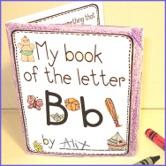
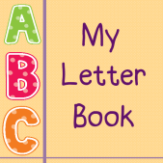
Activities:

- Create a letter book. You can create one book and add a page
at a time or create a small book per letter. Stick in pictures or objects
beginning with the letter. Use pictures of the child going on a treasure hunt for
objects beginning with that letter (showing what she found), a photo of models of the letter she has made using playdough/clay). You could stick pipe cleaner models of the letter in the actual book. You could also make letter books around topics, class stories.
- Have treasure boxes for each letter as they are introduced that she can add to, spend time decorating them and making them together. Make a clay model of the letter to add to the box and decorate.
- Play matching games, lotto, pairs etc.
  - Match letter to letter (play lotto, snap, games e.g. find as many letter a’s… etc. as she can around the room, use letter cards, wooden letter etc.
  - Match letter to picture cards which include the letter
  - Match letter to picture cars without the letter (she has to say the word and hear/identify the initial sound to match it to the letter)
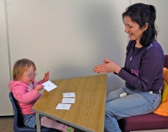
Introducing whole words

Make large flash cards of the words. Make sure the print is large. Create a words I am learning/have learnt wall/box

Activities:
- Match word to word, use a lotto board or simply have pairs of cards. Always say & (sign) the word together as he/she picks it up.
- Turn the cards over and play pairs.
- Have several copies of each word, group the words which are the same together. Every time he/she picks up a word say it together/also make the sign.
- Hold up a flash card whilst saying the word and ask him/her to find a matching word from his/her set.
- Say a word and he/she selects it from his/her words – only have about 4 words in front of him/her at any one time, if this is too much just have two words or one word and his/her name.
- Make the words using wooden/magnetic letters. Only give him/her the letters he/she needs to make the word – jumble them up, provide him/her with a model to copy. Also do this every day with his/her name. Have his/her name (a model) and a photo on magnetic whiteboard with letters jumbled up underneath and get him/her to put them in the right order every morning. When he/she is ready you can remove the model
Use words that can make simple sentences, e.g. This is a, Here is a.
Make simple books using the vocabulary that link to topics, class books, hobbies, likes, family etc… For example: This is me. This is mummy. This is a dog, fish etc…
You can also use early readers with two or three word sentences that incorporate the words he/she can read or you are teaching.

