Consultation and Information Event

Bradford Local Authority Commissioned

Social Emotional Mental Health (SEMH) Free School

Date: 12 July 2018

Time: 1:00pm – 3:00pm
(Refreshments available from 12:30pm)

Location: Ernest Saville Room, City Hall,
Centenary Square, Bradford, BD1 1HY

Bradford is the UK’s youngest city with well over 150,000 children & young people. This includes an increasing and complex Special Educational Needs and Disabilities population

Bradford has high aspirations for the District’s children and young people. Resources invested here will directly impact the educational outcomes and lives of children and young people with SEND and their families.

Bradford has a rising number of children and young people with complex SEMH and/or Autism with associated challenging behaviour needs, placed out of authority. We are excited to be able to potentially provide local provision and educate children and young people close to their families and communities.
Bradford is excited to develop a new Special (SEMH) Free School

The Local Authority has organised a Consultation and Information event in Bradford to share our vision.

Social Care, CAMHS, Health colleagues and neighbouring authorities are invited to take part in the event.

You will also have the opportunity to meet key personnel.

A presentation will be given on the Bradford context, the type of school Bradford Local Authority is looking for and our expectations.

Detailed information will also be provided about the potential site.

For further information on our vision of the potential new Social Emotional Mental Health Free School and to book your place at the Consultation and Information Event please contact: SEN-FreeSchool@bradford.gov.uk
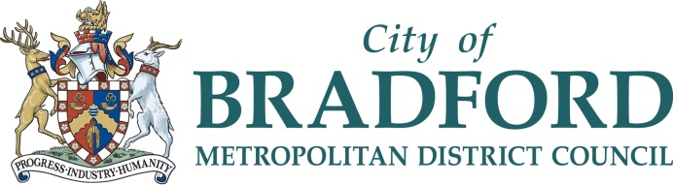

#BradfordSEMH

