FAQ Working Families Entitlement
- How do I keep up to date with all the changes?
Regular updates have been sent from the Early Education Funding team. If you have misplaced or not received them, these can be found on BSO

Key updates can be found EARLY EDUCATION DOCUMENTS | Bradford Schools Online

- Who is eligible for the 2 year old working families entitlement from April 2024?
This is the same criteria as 30 hours for 3&4 year olds and they become eligible the term after their 2nd Birthday

- both parents are working (or the sole parent is working in a lone parent family)
- each parent earns on average a weekly minimum equivalent to 16 hours at the National Minimum wage or 16 hours at National Living Wage.
- neither parent has an income of more than £100,000 per year
- both parents are employed but one or both parents is temporarily away from the workplace on parental, maternity or paternity leave, adoption leave or get statutory sick pay
- one parent is employed, and one parent has substantial caring roles based on specific benefits received for caring, or is disabled/incapacitated based on receipt of specific benefits

- What evidence of eligibility are parents of 2 year olds expected to give?
- Complete the updated parent agreement. EARLY EDUCATION DOCUMENTS | Bradford Schools Online
- Proof of Date of Birth
- HMRC Eligibility code
- Two year old working families eligibility is from the start of the term after the child’s 2nd birthday.
HMRC will determine if parents are eligible not the childcare provider or Local Authority.

- When will each of the new working families entitlements start?
This table shows the entitlements by age and date.
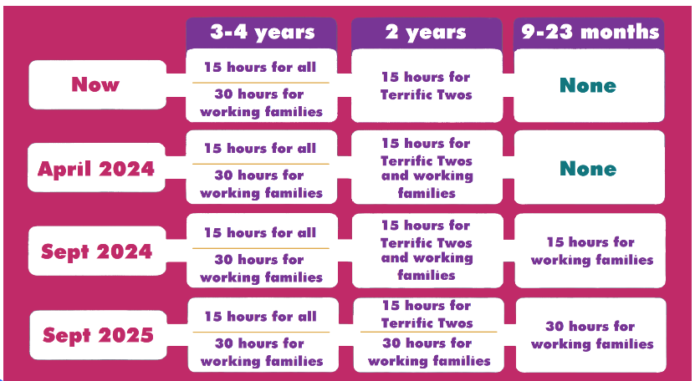

- How do I make a claim?
Early Education and childcare providers can check a working parents eligibility code using the Working Parents Entitlement checking system in the Bradford Early Years Provider Portal. The codes are checked in the same way the “30 hour codes” are checked.

- As with the current 30 hours for 3 and 4 year olds, providers will need to check the date of birth of the child and code dates before confirming eligibility for the relevant term.

- How do working parents receive their entitlement code?
- All codes for working parent entitlements will now be known as the ‘eligibility code’
- Parents will be able to begin applying for codes for the two year old working entitlement from 2 January 2024 for children eligible from 1st April.
- The application process and eligibility criteria will be the same process as the current 30 hours for 3 and 4 year olds, with HMRC continuing to determine eligibility via the Childcare Service.
- Eligible working parents of two-year-olds will be able to access 15 hours entitlement from April 2024. Please signpost parents to the Childcare Choices website for them to apply: https://www.childcarechoices.gov.uk/
- The deadline for parents to receive a Working Entitlement Code for the Summer term is 31st March.
- Updated Funded Hours Parent Agreement Form released to use.
- The Early Years Provider Portal will be upgraded to allow code checks to be carried out. Recorded training will be made available for checking codes.

- How much will I be paid?
- Each provider is given a universal base rate per hour per child
- Unlike the Universal Base Rate, which is the same value for all providers, Deprivation and SEND rates vary between providers according to the measured level of deprivation of children attending each provider. (see the technical statement for rates)
- Use the ready reckoner to assess what you will be paid.
DRAFT Ready Reckoner 2024/25 - draft document published for Consultation - to forecast your funding for the year.
NOTE: Change of date of the publication of formula funding and budget information for 2024/25 - Following the change of date of the Council’s annual budget setting meeting (from 22 February to 7 March) the confirmed budget and formula funding information for 2024/25 will be published two weeks later than planned, on Friday 8 March.
- Can providers charge extra charges for meals, etc.?
- Government funding is intended to deliver 15 or 30 hours a week of funded, high quality, flexible childcare. It is not intended to cover the costs of meals, other consumables, additional hours or additional services.
- Providers can charge for meals and snacks as part of a funded entitlement place and that they can also charge for consumables, such as nappies or sun cream, and for services such as trips and specialist tuition.
- Providers need to be mindful of the impact of additional charges on parents, especially the most disadvantaged.
- Providers, who choose to offer the funded entitlements, are responsible for setting their own policy on providing parents with options for alternatives to additional charges, including allowing parents to supply their own meals or nappies, or waiving or reducing the cost of meals and snacks.
- Providers must be completely transparent about any additional charges
- Can providers advertise places now?
- You can advertise places now for April 2024 if you are a funded provider for 2 year olds.
- Bradford Council will share with providers the Childcare Choices media pack, which includes leaflets and posters.
- Bradford Council will still be advertising ‘Terrific Twos’ as we want to ensure the take up of these places remains high.
- Why is funding not paid equally when a child attends two settings?
It is up to the parent where they take up their funded hours and how these hours are split between the providers.
- Will I be able to claim EYIF for a 2 year old?
Yes, EYIF will be expanded to cover funded hours for 2 year olds
- Will I be able to claim Disability Access Funding for eligible 2 year olds?
Yes, DAF will be expanded to cover funded hours for 2 year olds from April 2024.
- Will The Early Years Pupil Premium (EYPP) be paid for 2 year olds?
Yes, EYPP will be expanded to cover funded hours for 2 year olds from April 2024.
- Is there any sufficiency information you can share with us to see if I need to expand my business?
- For April 2024 our information does not show a need for places
- We will be sharing sufficiency information with the DFE at the end of March, we will then release this to all providers.
- There is lots of talk around a recruitment crisis what support is there?
- The government are having a recruitment campaign (link below)

Early Years Recruitment Campaign: https://earlyyearscareers.campaign.gov.uk/
- Look at growing your own staff, link with schools and collages and apprenticeship schemes.
- Bradford Council website has lots of useful information and guidance for employing apprentices.
  - https://www.bradford.gov.uk/jobs/apprenticeships/apprenticeship-guidance-for-employers/

- Will there be any changes to the funding compliance process? If so can this be shared?
There will be no changes to the funding compliance process. Checks are made against all funded children, so the process will just expand to cover the new younger entitlements.

- In the past we have only offered places to disadvantaged 2’s how will I prioritise who I offer a place to if a working family approaches my setting for a place?
It is up to individual providers to set a policy on how and who they offer places to, you should look at the community your setting serves.
- Grace Periods – how will these work?
The code dates and grace periods for the 2 year olds will work in the same way as the existing 30 hour eligibility for 3-4yr olds. Codes must be reconfirmed with HMRC every 3 months. If a code is not renewed, or a parent no longer meets the eligibility criteria when they reconfirm their code, the code will enter a grace period. The grace period will allow a child to continue accessing the hours with the same provider until the Grace Period end date. Children cannot begin hours with a provider if the code is already in a grace period.

- Can children be eligible for both a working family place and a disadvantaged place? If so, which do I claim for?
Yes, some parents will be eligible under both the disadvantaged and the working families. More guidance will be provided.
Useful Links
Childcare Choices HERE or copy and paste the full link
https://www.childcarechoices.gov.uk/?utm_source=Search+&utm_medium=RSA&utm_campaign=CC&gad_source=1&gclid=EAIaIQobChMIx4Lm_MmvhAMV6olQBh1A4QxgEAAYASAAEgJhkvD_BwE&gclsrc=aw.ds
Bradford Schools online Here or copy and paste the full link (you will need to sign into your account)
https://bso.bradford.gov.uk/Secure/CMSPage.aspx?mid=3346
Families and Young Persons Information (FYI) Here or copy and paste the full link
https://fyi.bradford.gov.uk/
(this takes you directly to the Early education and childcare page) https://fyi.bradford.gov.uk/information-advice/childcare-free-funding/early-education-and-childcare/

Early Years Recruitment Campaign: https://earlyyearscareers.campaign.gov.uk/

Training for the portal is available on: https://skills4bradford.co.uk/Services/7034

