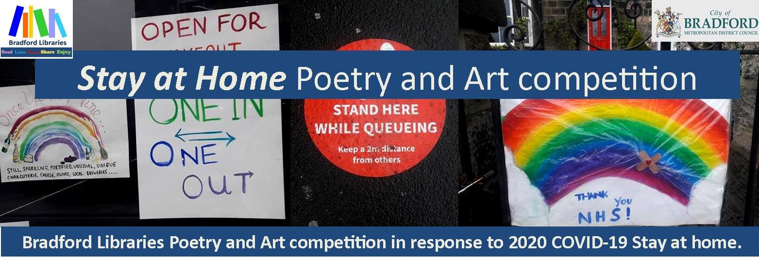
Entry Form and Conditions of Entry.
At Bradford Libraries we believe Poetry and Creativity can be a great way of engaging our minds to explore what, how and why we feel a certain way. Now that we are relaxing Lockdown and we are starting to adapt to change in our daily lives, we wanted to reflect on our experiences living through these unusual times. We want to think about things to celebrate; things that have made us sad or things that we have learnt, felt or seen for the first time. We are inviting the people of Bradford of all ages to submit their poetry or artwork for inclusion in one of two books.
The poems and artwork will be selected by a panel of judges.
We will produce two books - one book will feature poems and artwork by children & young people under 18 and one book will feature artwork and poems by adults (over 18).
For both there will an overall art winner which will feature on the cover of the book.
Name
Address
Phone
Email
Age category | 4 to 11 □ 12 to 18 □ Adult □
What you are entering | Poetry □ Artwork □ Both □
 | If handing your work into a library please let us know which library you wish to collect your artwork from once photographed.

See overleaf for conditions of entry.
CONDITIONS OF ENTRY: Poems
- The competition is in three categories, Adult, Children 4 to 11 years (Reception to Y6); Children 12 to 18 years (Y7 – Y13).
- Poems must not have been published either in print or on a website, nor be currently submitted or accepted for future publication. They must not have been awarded a prize in any other competition.
- Poems must be your own original work and must be on a subject relevant to, or inspired by, the coronavirus lockdown of 2020. Our judges will read ALL poems entered. The decision taken by the judge is final.
- Poems must be typed and no longer than 40 lines. We are happy to receive all forms of poetry.
- If sending poems by post, each poem must be on a separate sheet of paper, which must bear your name accompanied by the entry form.
- If sending poems by email, each poem should be in a separate Word document, which must bear your name and accompanied by the entry form.
- A maximum of two poems may be submitted per entrant.
- We regret that we are unable to return poems, or amend them after entry.
- The closing date is Monday 21st September. Results will be announced on National Poetry Day 1st October. Winners will be notified in advance of that date and invited to the National Poetry Day announcement event (if possible).
- Copyright remains with the authors, but Bradford Libraries reserves the right to publish winning and commended poems in the aforementioned book which will be produced as a direct result of this competition.
- Entries by post: Poetry and Art Competition, Bradford Libraries, Keighley Library, North Street, BD21 3SX
- Entries by email should be sent to Library.Events@bradford.gov.uk
- Names and contact details of entrants will be stored only for the duration of the competition and will only be used for communications relating to this competition. They will not be passed to any third parties.
CONDITIONS OF ENTRY: Artwork/images
- The competition is in three categories, Adults; Children 4 to 11 years (Reception to Y6); Children 12 – 18 years (Y7 Y13.
- Artwork must be your own original work and must on a subject relevant to, or inspired by, the coronavirus lockdown of 2020. Artwork can be in any medium – painting, collage, photography, drawing as long as it can be photographed and reproduced to be included in the book.
- Entries can be submitted in three ways –
Entries by post: Poetry and Art Competition, Bradford Libraries, Keighley Library, North Street, Keighley BD21 3SX.
Entries can also be handed in at your local library. Artwork not emailed must be accompanied by competition form and must bear your name on the reverse. The artwork must be no bigger than A4. The artwork will be photographed returned to your nearest library for you to collect.
Entries can be emailed to Library.Events@bradford.gov.uk Artwork must be accompanied by entry form and must be in jpeg format.
4. A maximum of two images/artworks may be submitted per entrant.
5. The closing date is Monday 21st September. Results will be announced on National Poetry Day 1st October
Winners will be notified in advance of that date and invited to the National Poetry Day announcement event (if
possible).
6. Copyright remains with the artists, but Bradford Libraries reserves the right to publish images of the winning
artworks in the aforementioned book which will be produced as a direct result of this competition.
7. Names and contact details of entrants will be stored only for the duration of the competition and will be only used
for communications relating to this competition. They will not be passed to any third parties.

For more information please email Library.Events@bradford.gov.uk

