Social, Communication, Interaction

and Learning (SCIL) Team
End of Academic Year Surveys

We’ve reached that time of year where we seek feedback from all our stakeholders to reflect on what we are doing well and what we could improve on next year.
- SCIL Team End of Year Schools and Settings Survey

https://online1.snapsurveys.com/icj7ay
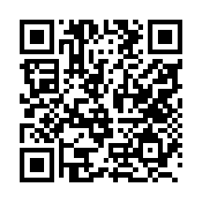
- SCIL Team End of Year Young Person’s Survey
https://online1.snapsurveys.com/m708lf
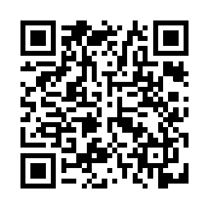
- SCIL End of Year Parent Carer Survey
https://online1.snapsurveys.com/dldiaz
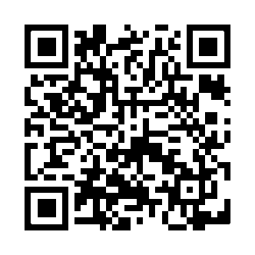

Please can you:
Take a up to 10 minutes to complete the school/setting survey (link 1).
Where appropriate, share the young person (link 2) and parent / carer survey (link 3) if they have been supported by the SCIL Team.
Your feedback is very important to us to help inform any changes for next academic year.
We politely ask that replies are received by the Friday 8th May

