




Guidance for Schools

FPN Portal Guide
Copyright
© 2025 MRI Software LLC - All Rights Reserved. It is confidential and commercially sensitive and must not be distributed in any form without prior permission of a manager from MRI Software. If you do not have authorisation to receive this document, please return it to the author as soon as possible.

Content
Content 3
Introduction – What is the FPN Portal? 4
Before You Start 5
Accessing the FPN Portal 6
First-Time Login 6
Logging In 6
Finding a Pupil 7
Search Options 7
Filter Options 7
Creating a new FPN Request 8
Start a New Request 8
Step 1 – Select the Request Reason 9
What is a Notice to Improve? 9
Step 2 – Add Parent/Carer Details 10
Step 3 – Record Absence Dates 12
Step 4 – Upload Evidence 13
Step 5 – Additional Information 14
Step 6 – Review and Submit 15
Why Can’t I Start a New Request? 16
Editing a Request 17
Subsequent Requests for a Pupil 18
Request and Action Statuses 19
Responding to an Action Needed Request 20
Requesting a Withdrawal 21
Common Reasons Why a Request is Declined 23
Viewing Previous Cases 24
Adding or Disabling Users 26
Create User 26
Good Practice Tips 28

Introduction – What is the FPN Portal?
The FPN Portal allows schools to submit attendance-related cases to their Local Authority for consideration.
Using the portal, schools can:
- Submit Fixed Penalty Notice (FPN) requests
- Request a Notice to Improve (NTI)
- Upload attendance evidence
- Respond to requests for additional information
- Track progress of submitted cases
- View issued, withdrawn and declined notices
- Request the withdrawal of a case

Before You Start
Before creating a request, ensure you have the following information available:
✅ Correct pupil details
✅ Parent/carer contact details
✅ Dates of unauthorised absence
✅ Attendance reports
✅ Copies of letters, emails or communications sent to parents/carers
✅ Records of attendance meetings or interventions
✅ Any supporting evidence required by your Local Authority
Providing complete and accurate information will help avoid delays in processing your request.

Accessing the FPN Portal

First-Time Login
When your account is created, you will receive an activation email.
- Select the activation link.
- Create a password.
- Complete any security checks.
- Sign in to the portal.

Logging In
Navigate to the FPN Portal https://education.cloud.mrisoftware.com/
- Enter your username.
- Enter your password.
- Select Sign In.
You will only be able to view pupils and requests associated with your school.

Finding a Pupil

Search Options

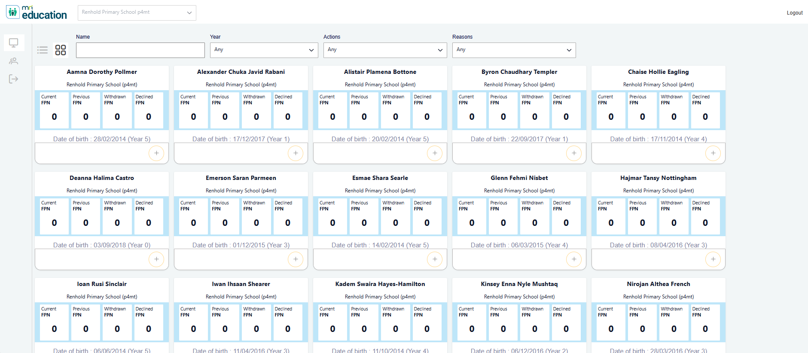
Use the search box to locate the pupil by:
- First Name
- Last Name
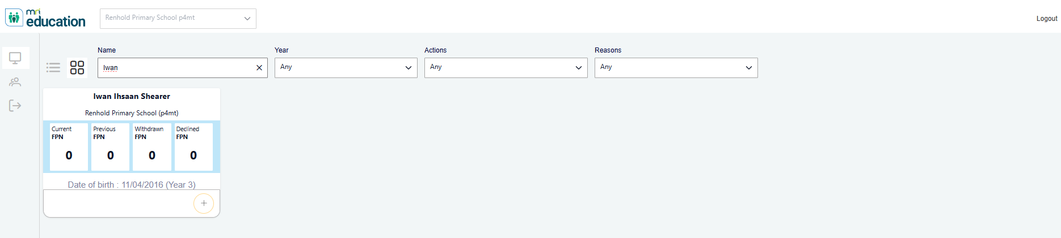

Filter Options
You can also use filters including:
- Year Group
- Action
- Request Reason

Creating a new FPN Request
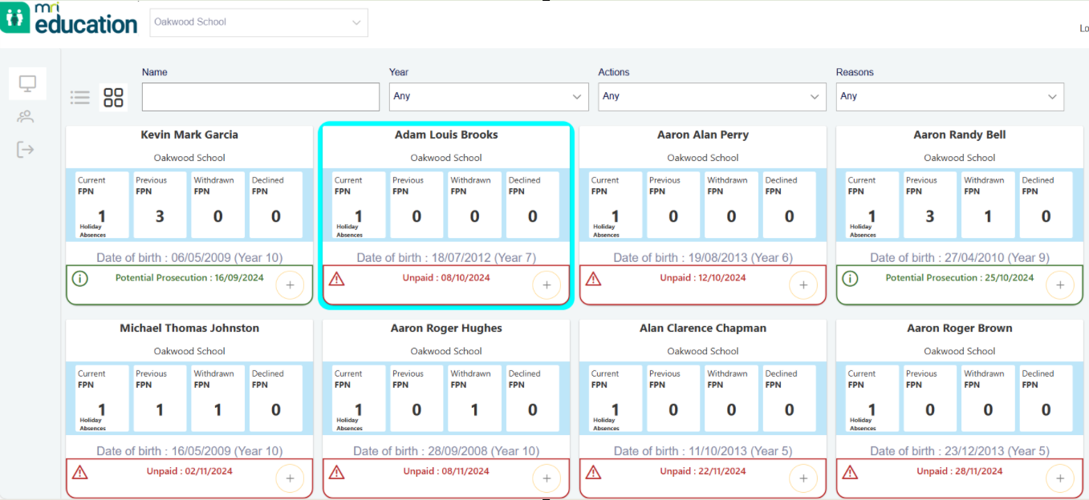
Search for the pupil the FPN request is for and click on the card once. This will make the plus button in the bottom right of the card available to select.
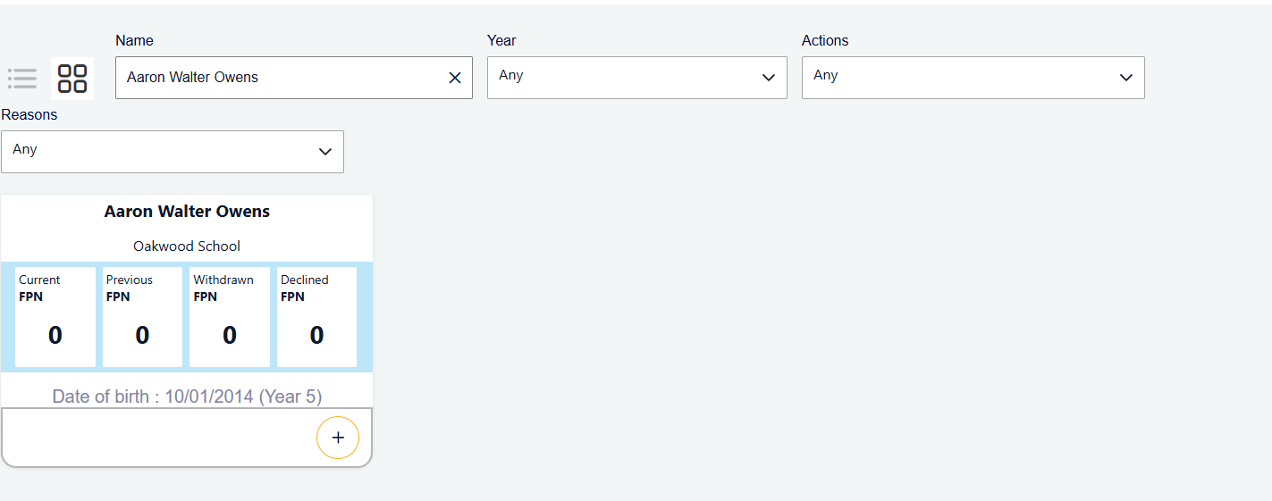

Start a New Request
Click on the “Start new request” icon in the bottom right of the card.
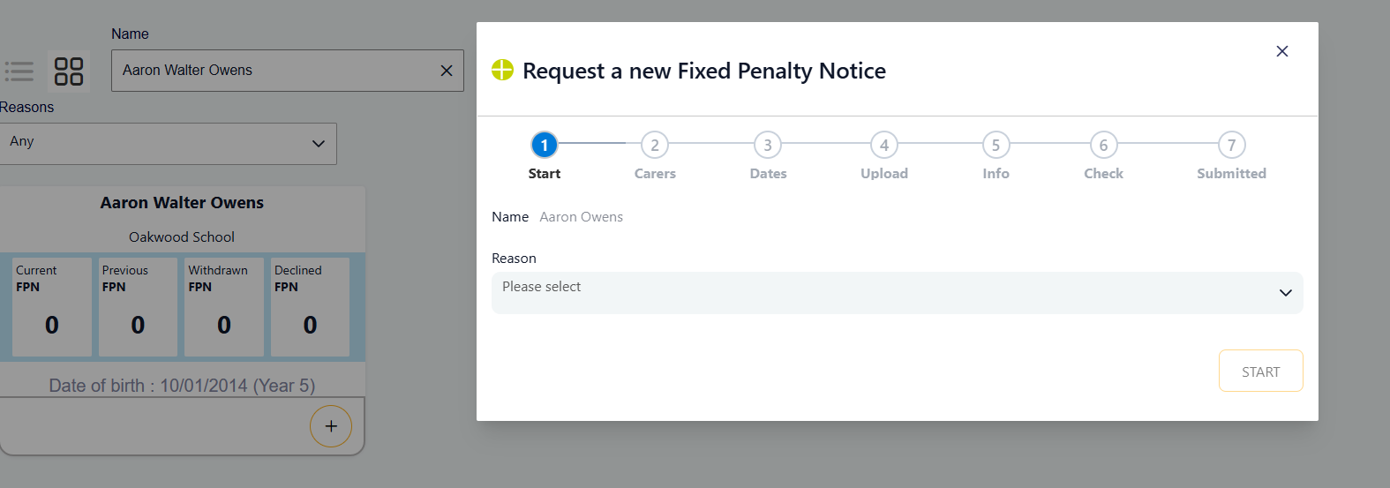

Step 1 – Select the Request Reason
Choose the reason for the request, such as:
- Unauthorised Absence
- Holiday Absence
- Persistent Lateness
- Combination Absence
Depending on your Local Authority's policy, you may also be able to request a Notice to Improve (NTI).

What is a Notice to Improve?
- A Notice to Improve gives families an opportunity to improve attendance before a Fixed Penalty Notice is considered.

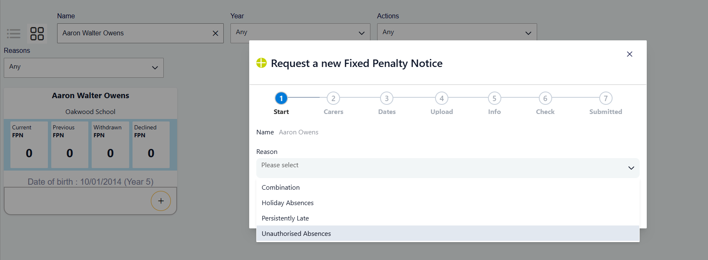
If you select Combination, Persistently Late or Unauthorised Absences an additional option will be displayed ‘Request a notice to improve’. This defaults to No.
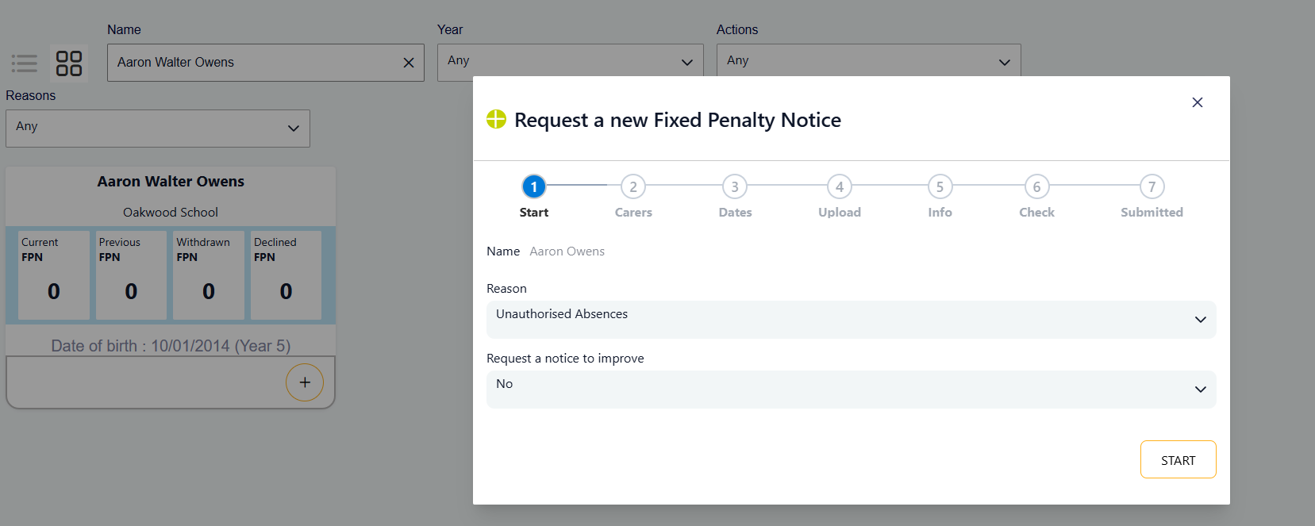
If you select Yes instead you will see a new option ‘Notice to improve period (weeks)’. This defaults to a value set by your Local Authority but cannot be changed.
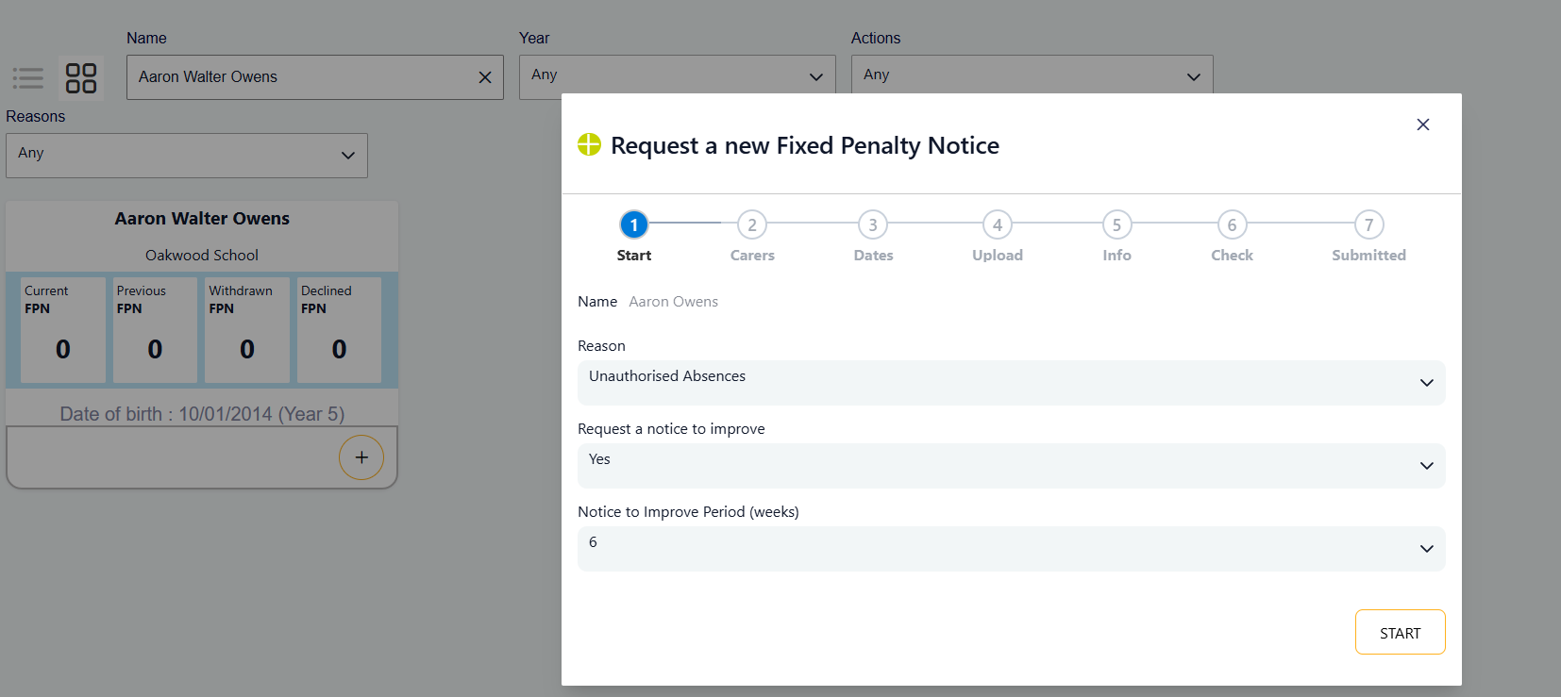
If you select Holiday Absences you won’t see the Notice to Improve options.
Click Start to take you to the next step.

Step 2 – Add Parent/Carer Details
Add one or more parents and carers.
Relationship and Name:
You must select a Relationship, enter a First Name and Last Name

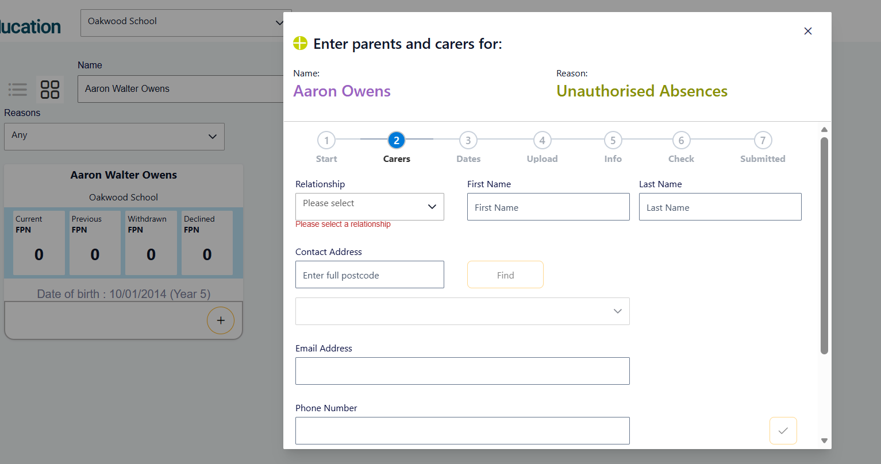
Contact Address:
Enter the full postcode (with a space e.g. MK41 6DZ) and click Find. Select the address from the dropdown list.
If no addresses are found for the postcode you search by you can enter a new address.
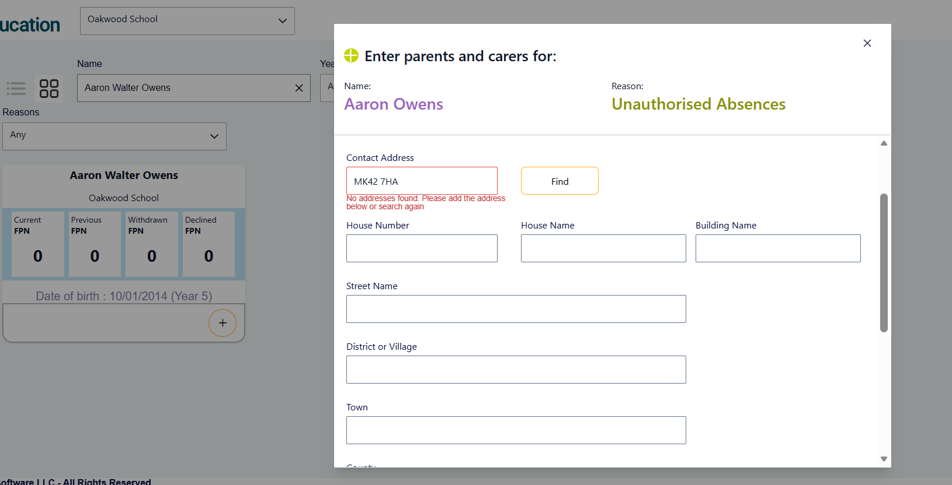
If the postcode search returns a list of addresses but the parents address is not displayed, please contact your Local Authority to get this added.
Email Address / Mobile Phone Number:
Enter the email address and mobile number of the parent. If you are creating a Notice to Improve request and your Local Authority sends these via email – then entering an email is required.
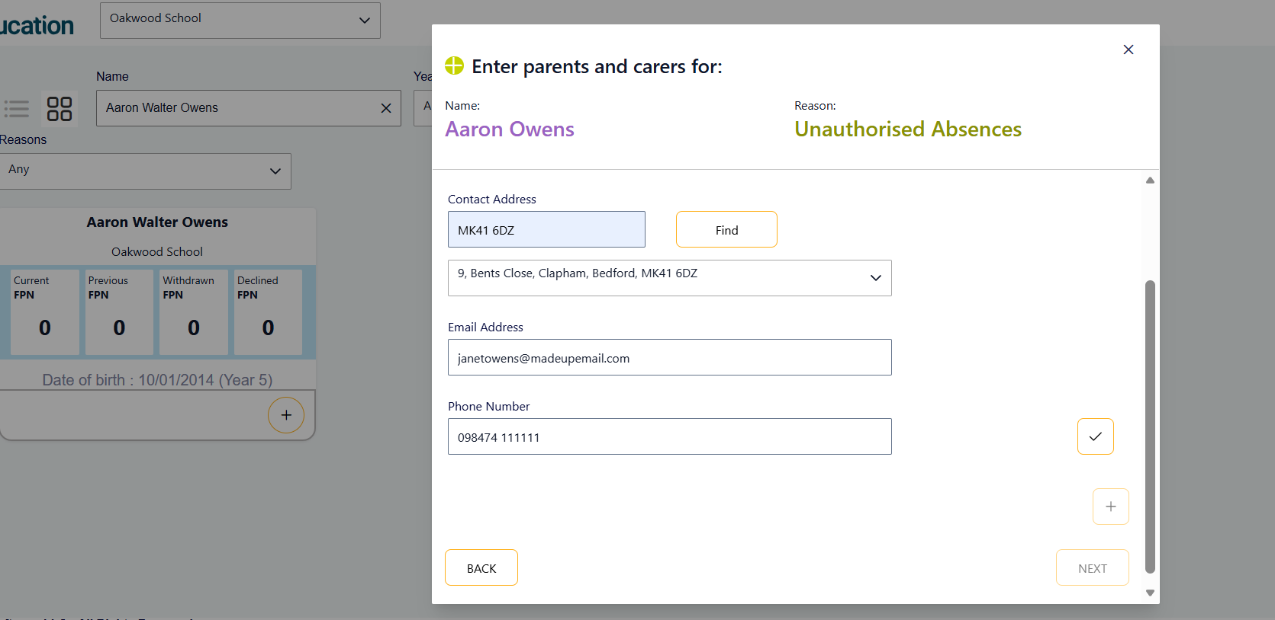
Save:
Click the Tick icon (Save) once all parent information has been entered.
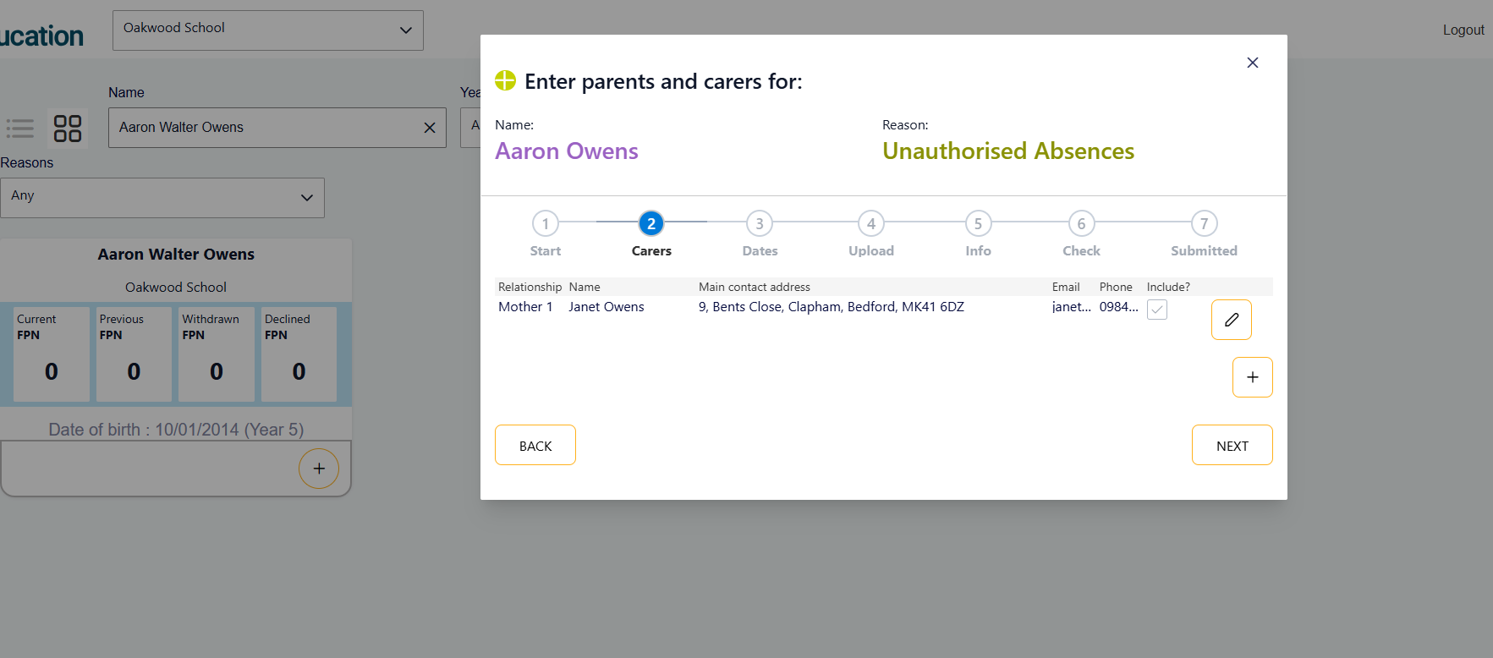
At this stage you can either Edit (pencil icon) parent information or Add another parent.
Once you have entered all parents, click Next to take you to the next step

Step 3 – Record Absence Dates
Add:
- Individual absence dates, or
- A date range
Where appropriate, record the total number of sessions missed.
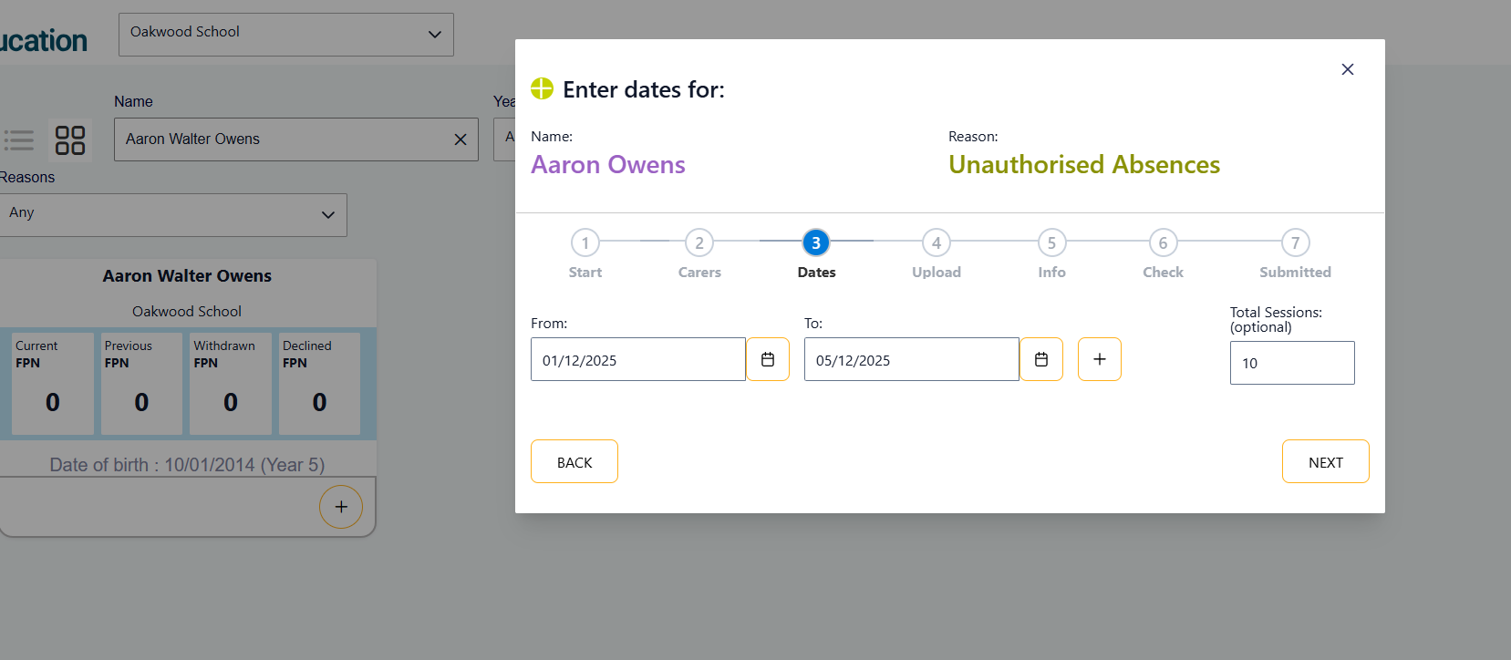
Click Next to take you to the next step

Step 4 – Upload Evidence
Upload all evidence required by your Local Authority.
Evidence Best Practice
The strongest requests typically include:
- Registration certificates or attendance extracts
- Attendance history reports
- Warning letters
- Meeting records
- Copies of email correspondence
- Notes of telephone conversations
- Attendance support plans
- Relevant safeguarding considerations (where appropriate)
Providing complete evidence at initial submission can reduce delays and requests for further information.
Text will be displayed above a Choose button that is defined by your Local Authority. This provides you with details of what files the Local Authority needs you to upload as part of the request.
Here is an example of what a Local Authority might have set up in the Evidence Required Text.
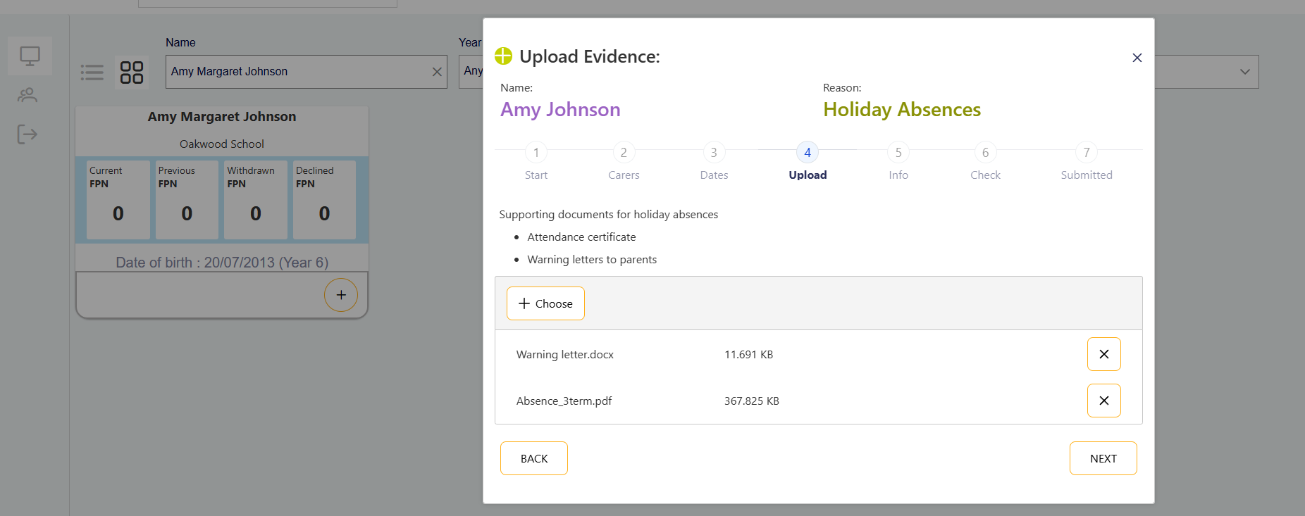
Click Choose, browse for and select the files to be uploaded for this request.
You can click Choose multiple times to ensure you have selected all the required files.
If you choose a file by mistake simply click on the ‘x’ icon next to the file in question.
Once all files have been selected click next to take you to the next step.

Step 5 – Additional Information
Use this section to provide any information that may support the request, for example:
- Previous school interventions
- Attendance support offered
- Welfare concerns
- Other relevant background information
This section is optional but can assist the Local Authority when reviewing the case.

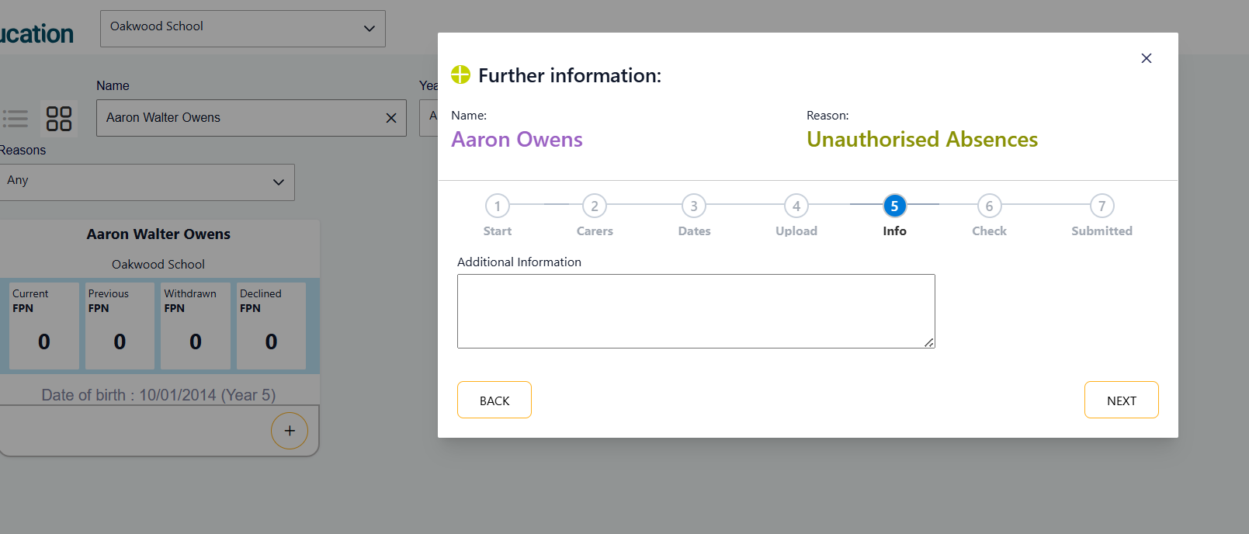
Click Next to take you to the next step.

Step 6 – Review and Submit
Check all information carefully before submission.
You must:
- Review the details entered
- Read the Local Authority terms and conditions
- Tick the declaration box
- Select Submit to send the request.
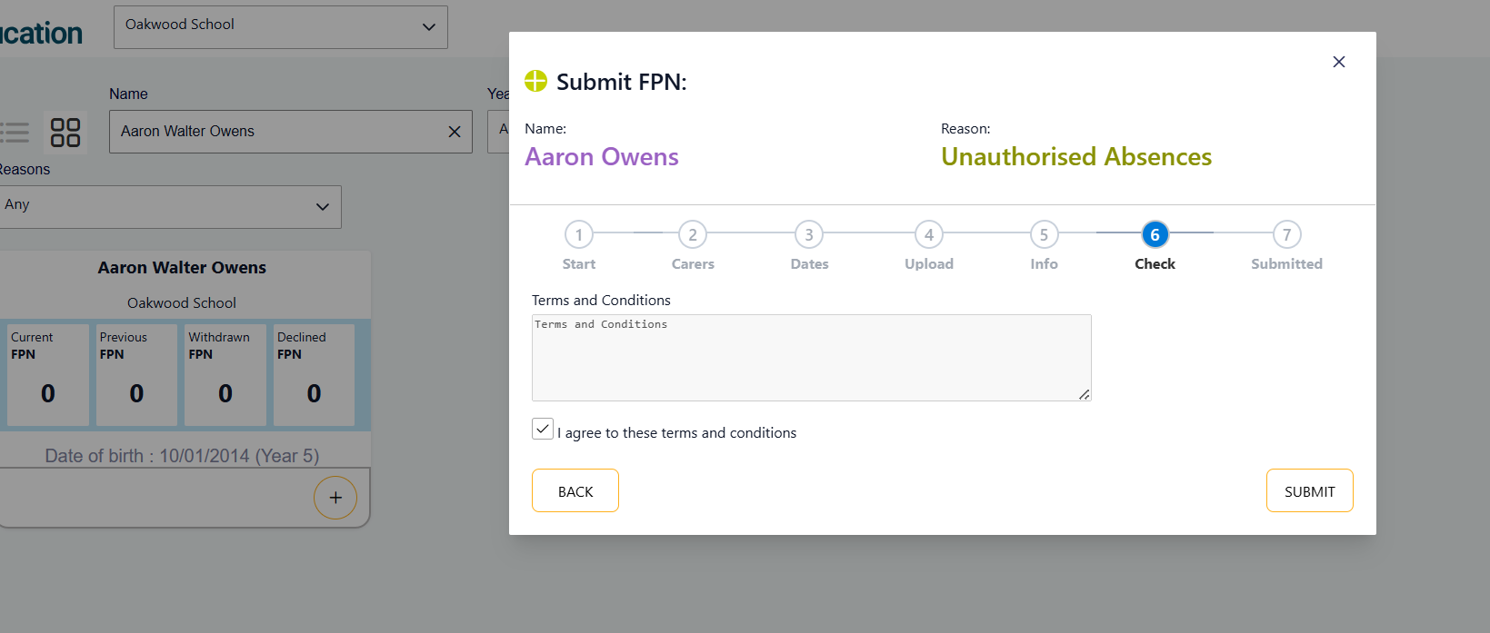
Once you have ticked the agreement box the Submit button will be available to you.
Select the Submit button.

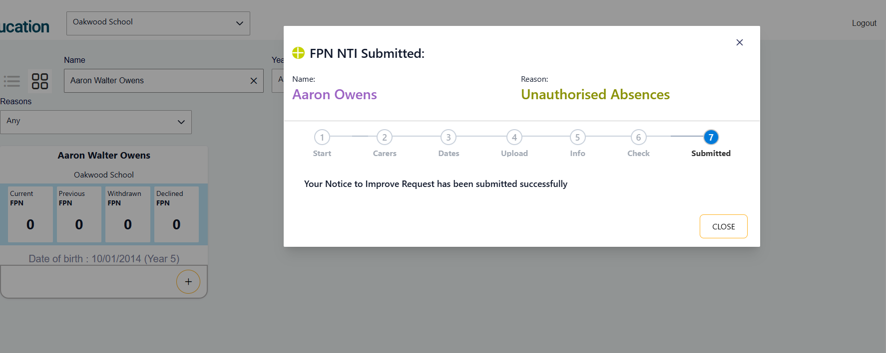

Why Can’t I Start a New Request?
At present only one Current FPN/NTI can be ongoing for a pupil at any one time.
If the Current FPN shows 1 the Start New Request button is greyed out and cannot be selected.
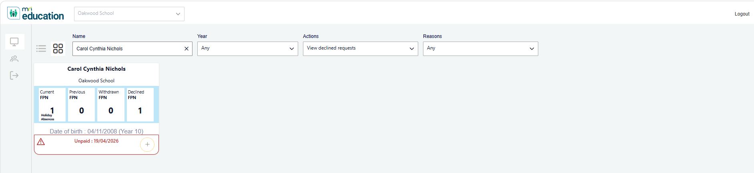

Editing a Request
Where a request has not yet reached the point at which a Penalty Notice (PN) or Notice to Improve (NTI) has been issued, you can:
- Open the request.
- Select Edit.
- Amend the required information.
- Save your changes.
- Examples may include:
- Incorrect absence dates
- Missing evidence
- Incorrect parent/carer information
- Typographical errors
- Additional information becoming available
Important
- Once a Notice to Improve or Penalty Notice has been issued, the request may no longer be editable.
- If further changes are required after issuance, contact your Local Authority for advice.

Subsequent Requests for a Pupil
If previous requests have already been submitted for the pupil, you may notice that parent/carer records already exist.
Rather than creating duplicate records:
- ✅ Select the existing parent/carer(s) who are relevant to the current request.
- ✅ Review their details before continuing.
- ✅ Update the existing parent/carer record if information has changed.
Examples may include:
- Change of address
- Change of surname
- Updated email address
- Updated telephone number
Important
- Where a parent/carer's details have changed, edit the existing record rather than creating a new parent/carer entry.
- This helps maintain an accurate and complete history for the pupil and parent/carer.
Adding New Parent/Carers
- If a new parent/carer has become involved since the previous request, you can add a new parent/carer record as appropriate.
Examples may include:
- New legal guardian
- New foster carer
- Parent newly identified as having parental responsibility
- Updated family arrangements
Always ensure that only relevant parent/carers are included within the request.

Request and Action Statuses
The portal will display the current status of each request.
You can also select to view your pupils by action status using the Actions filter.
Status | Description
Any | View all your pupils irrespective of status
Action Needed | Additional information is required from the school
Request to Withdraw | Request has been submitted by the school to withdraw the request
Unpaid | Fixed Penalty Notice has not been paid in the required timeframe
Issued | Fixed Penalty Notice has been issued
Submitted | Request has been submitted and is awaiting review
Resubmitted | Updated information has been provided and returned for review
Withdrawn | Request or notice has been withdrawn
Declined | Request did not meet the criteria for issue
Potential Prosecution | Request is a 3rd offence for the parent in a 3 year rolling period
Referred for Prosecution | Case has progressed beyond the Penalty Notice stage
Paid | Penalty Notice payment has been received
Partially Paid | Penalty Notice partial payment has been received
NTI Requested | Notice to Improve request submitted
NTI Issued | Notice to Improve has been issued
NTI Past Monitoring | Notice to Improve has passed its monitoring date

Responding to an Action Needed Request
If the Local Authority requires further information you will receive an email. In addition when you next log on, it will default you to see any requests requiring your input.
The Actions filter box will show ‘Actions needed’ and the pupil cards will show Action needed with the date of the request.
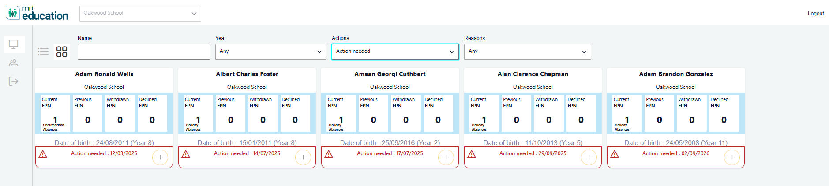
Click on a child that has actions required to see what is being requested.
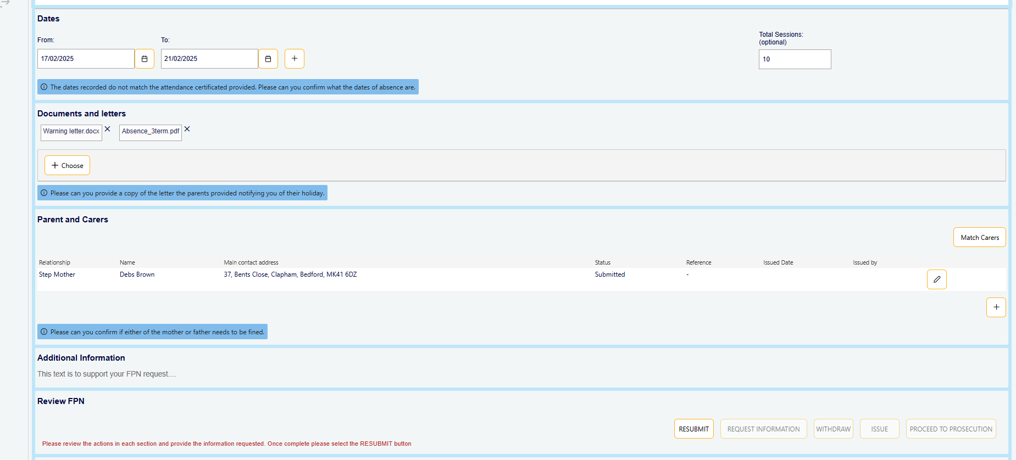
Action items are shown in blue highlight, and that section will be editable.
Once required information has been entered or uploaded click on the Resubmit button.
Providing information promptly will help avoid delays.
To view the resubmitted requests, change the actions dropdown view to Review resubmitted requests.

Requesting a Withdrawal
Schools may identify circumstances where a request should no longer proceed.
Examples may include:
- Information submitted in error
- Incorrect attendance data identified
- Additional evidence changes the circumstances
- Duplicate request identified
To request a withdrawal:
- Open the relevant request.
- Select Request Withdrawal.
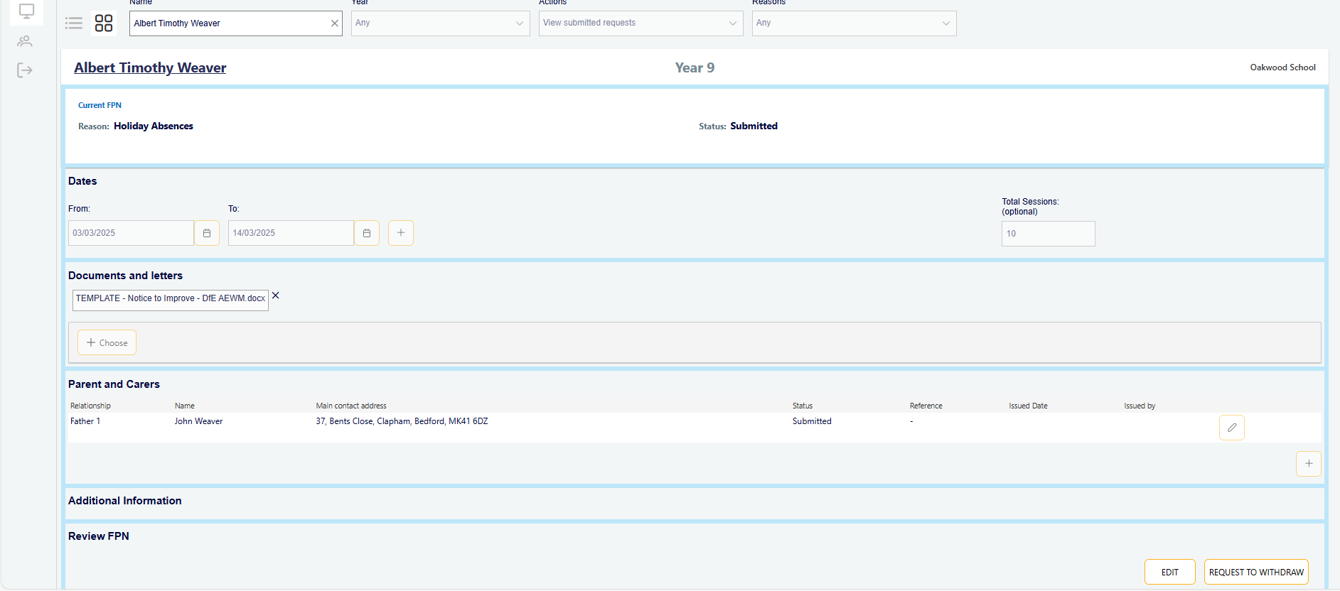
- Enter the reason for withdrawal.
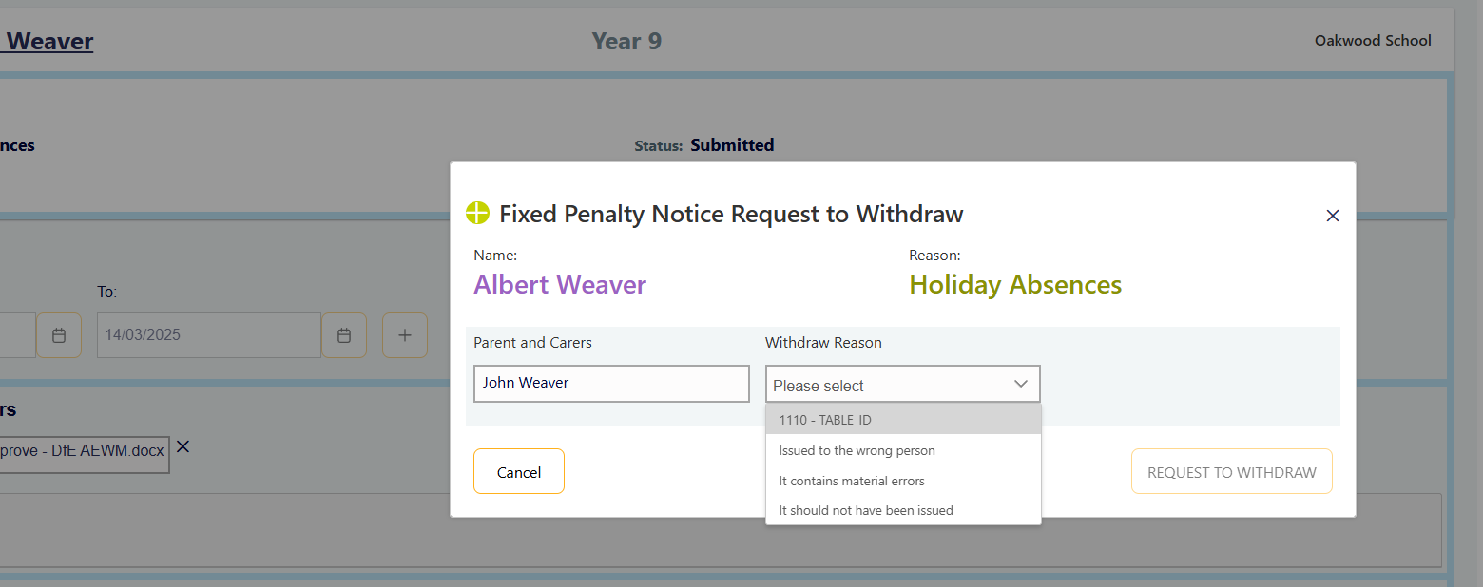
- Submit the request.
The Local Authority will review the request and determine whether withdrawal is appropriate.

Common Reasons Why a Request is Declined
Requests may be declined where:
- Attendance thresholds have not been met.
- Evidence is missing or insufficient.
- Parent/carer details are incomplete.
- The absence is authorised.
- Duplicate requests have been submitted.
- Local Authority policy criteria have not been met.
Please refer to your Local Authority attendance policy for specific criteria.

Viewing Previous Cases
The portal maintains a history of attendance enforcement activity for each pupil.
Depending on your permissions, you may be able to view:
- Current requests
- Previous FPN requests
- Previous NTIs
- Issued notices
- Withdrawn requests
- Declined requests
- Case outcomes
This information can help schools understand previous attendance enforcement activity and ensure future requests are submitted accurately.
Search for a pupil or view using a dropdown filter such as Actions.
You can see if there are any Previous, Withdrawn or Declined requests.
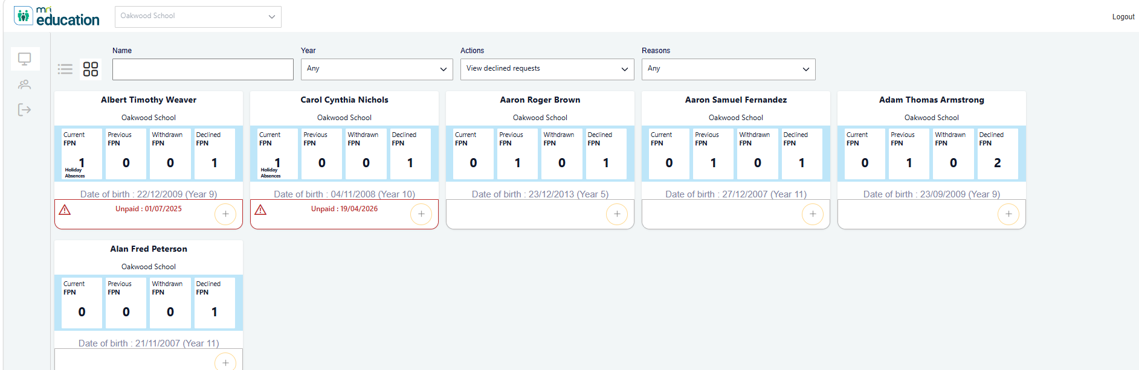
Click on the child’s card to open the details.
Navigate to the Previous, Withdrawn and Declined FPNs section.
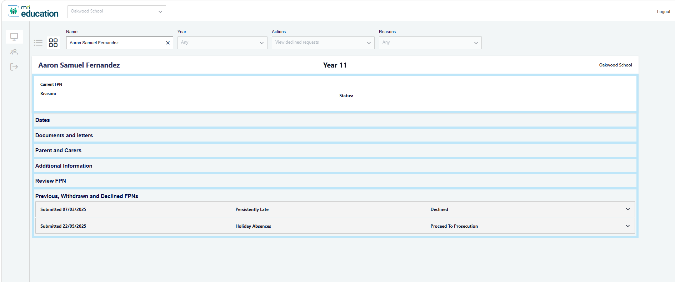
From here you can expand the section to view more information such as the reason the request was Declined.
You can also Download any Documents and Letters.
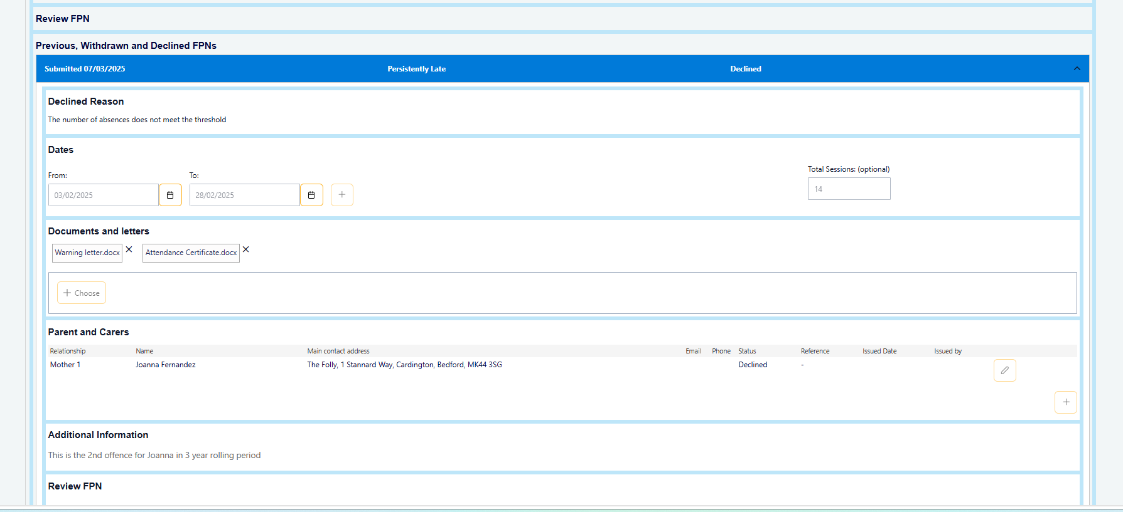

Adding or Disabling Users
If another user needs access to the FPN portal at your school you can navigate to the User Management area.
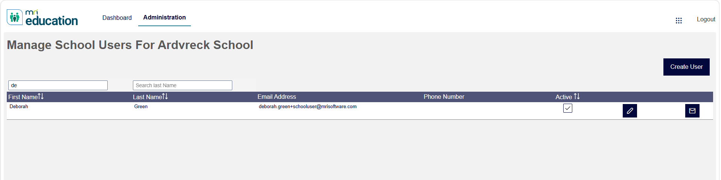
From here you can see the current list of users that can access the FPN portal at your school.
If a user has left your school you can untick the Active box.
You can Edit the details of existing users.

Create User
Click ‘Create User’ to add a new user to your school.
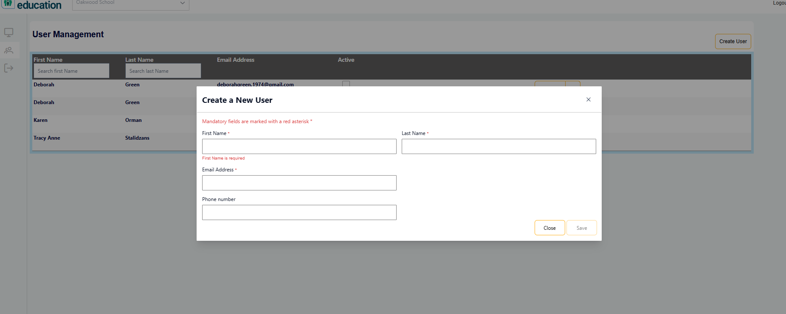

Enter First Name, Last Name and Email Address and optionally Phone Number.

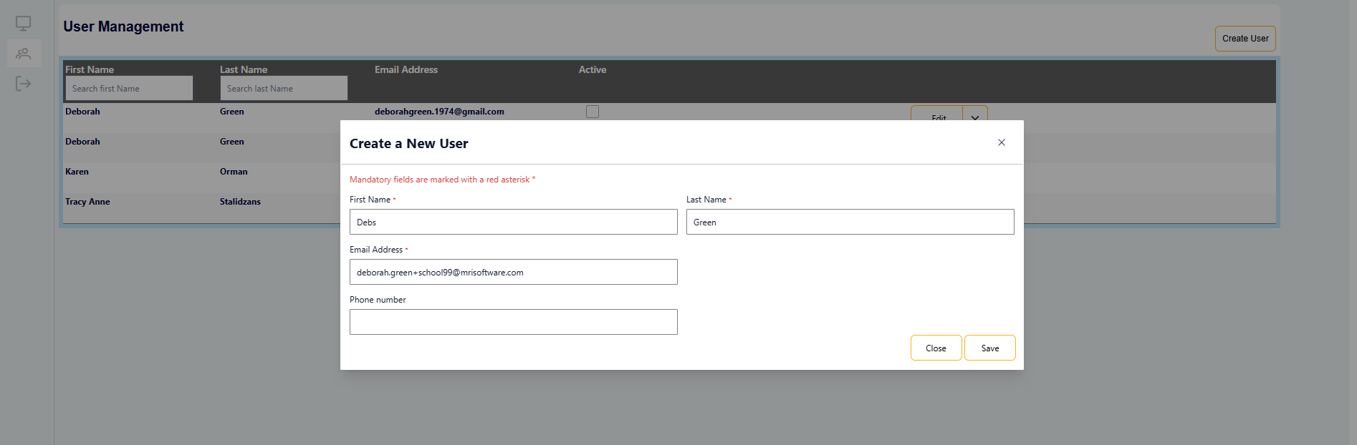

Clicking Save will send an email to the user to register their account.

Good Practice Tips
✓ Always check whether parent/carer records already exist before creating new ones.
✓ Update existing parent/carer details rather than creating duplicates.
✓ Ensure attendance dates are accurate before submission.
✓ Upload all supporting evidence at the point of submission whenever possible.
✓ Review requests carefully before submitting.
✓ If a mistake is identified before an NTI or FPN is issued, use the Edit function to correct the information.
✓ Respond promptly to any requests for additional information from the Local Authority.
✓ Keep parent/carer information up to date to ensure notices are issued correctly.

