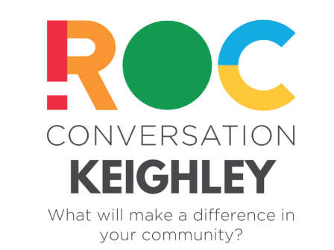

**Do you live, work, socialise or have an interest in Keighley.  If so, read on…**

On Tuesday 3rd March 2020, ROC are coming to Keighley and **you** are invited to join the ROC conversation which will be taking place at Victoria Hall, Hard Ings Road, Keighley.  BD21 3JN  7pm – 9pm

**Who are ROC?**

Redeeming Our Communities is a national charity founded in 2004 with over 150 projects throughout the UK. The charity’s main aim is to bring about community transformation by creating strategic partnerships which open up opportunities for crime and disorder reduction and improved community cohesion. This partnership approach has seen crime and anti-social behaviour fall and fresh hope brought to some of the most deprived and challenging areas of the UK, urban and rural alike.  
  
ROC brings together community groups, churches, the police, the fire service, local authorities and voluntary agencies to encourage them to work together in positive partnerships for practical ‘on the ground’ change. As a result, statutory agencies have improved access to the support of community/church groups, and thousands of volunteers are enabled to better serve the needs of their community. This idea is proving to be even more valuable in the light of the current economic climate and the Big Society.

**What is a ROC Conversation?**

A ROC Conversation is a structured community engagement event that brings together local people to celebrate all the good things happening in the community and explore practical ways of doing more.  A ROC Conversation is a 2 hour structured community engagement event that invites members of the community to gather and discuss the specific needs of their community, and explore practical ways of meeting those needs. We invite:

* Residents
* Businesses
* School and Youth representatives
* Volunteer groups
* Police & Fire Services
* Faith groups
* Councillors and MPs

**Safer, Kinder Communities**

ROC’s mission is to increase community resilience by inspiring and supporting groups to work together.

**A ROC Conversation achieves this by:**

* Connecting local community members, volunteers & statutory agencies
* Celebrating all the good things taking place in your community
* Raising awareness of the current needs of your community
* Exploring potential solutions and resources required to meet current needs
* Creating a network of people passionate about improving your community
* Identifying & utilising existing skillsets and resources in your community
* Kick-starting new projects in your community

**Who can attend?**

The simple answer to this is **ANYONE** can attend.

ROC works with many difference agencies including public services, statutory authorities, schools, businesses, community organisations and churches. People who agree that communities are important and that we can all play our part. People from different backgrounds, with different beliefs and different cultural influences who all share a common vision: to make their community stronger.  The common vision enables them to look beyond their differences and pool their energies and resources.

If you have already booked your free place, we look forward to welcoming you to the ROC Conversation.

If you would like to register for your free place please go to [ROC Conversation Keighley](https://www.eventbrite.co.uk/e/roc-conversation-keighley-tickets-76422913993)

cid:image001.png@01D58054.18FD9DA0

Debra Green OBE  
Executive Director  
Redeeming Our Communities (ROC).

People of goodwill working together towards safer, kinder communities.

The Fuse, Warburton Lane, Trafford, Manchester M31 4BU

[@debrajgreen](http://twitter.com/debrajgreen)

[www.roc.uk.com](http://www.roc.uk.com/)  
[debragreen@roc.uk.com](mailto:debragreen@roc.uk.com)

0161 393 4511

Charity - 1139817 Reg com 7327258

Scotland - SC044606