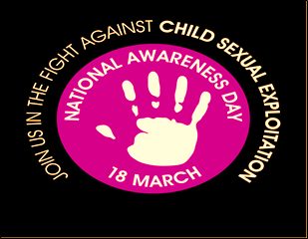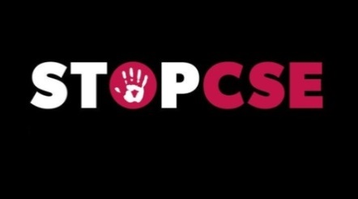CBMDC-colour-RGB - smaller

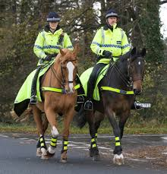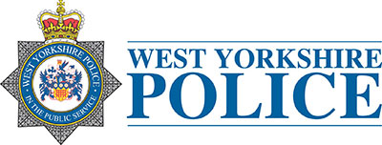

**Event being covered by Pulse Radio**

Barnardos Turnaround and Trusted Relationships

**Human Trafficking Info**

***Smoothie Bike***

***Safety Quiz***

***Face Painting*** 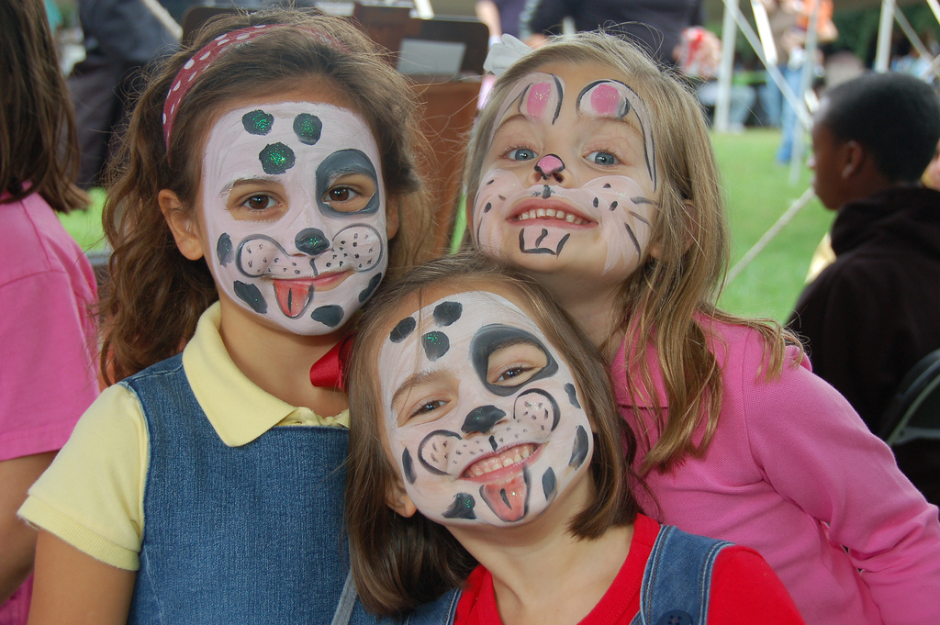

***Information Services***

***Cake Cutting between***

***3.30 – 4.30pm***

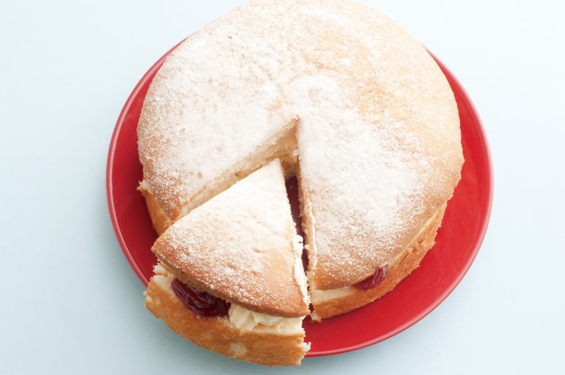

**(Kindly baked & donated by free cakes for kids - Bradford)**

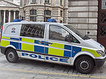 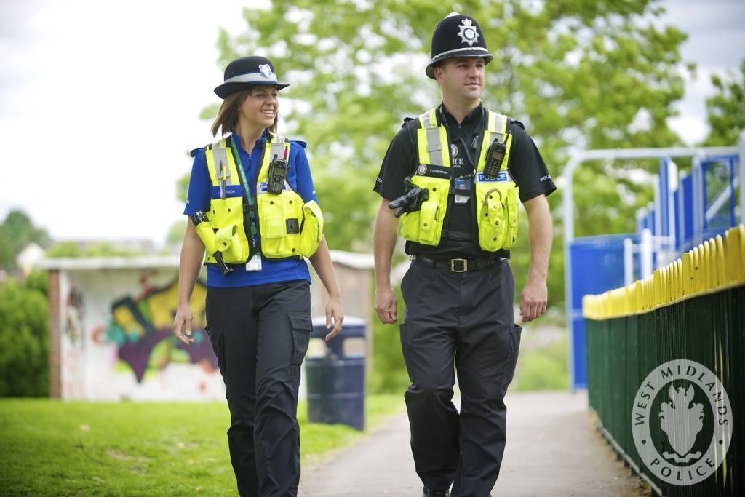

**Police**

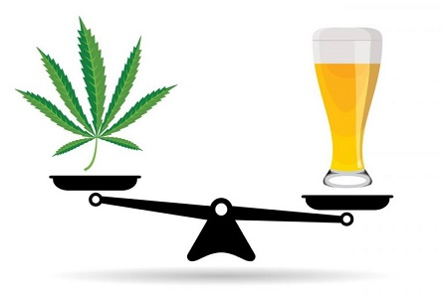 **Drug’s & Alcohol Info**

**Domestic abuse Info**

**Specialist Support services Info**

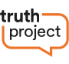 **Truth Project**

**Police Horses**

**Health Bus & Sexual Health Service Outreach**

**Screening of the latest Barnardos Film**

**/**

**10AM – 5PM**

**Join us**

**Bradford Broadway Centre**

**Bradford**

**CE & Missing**

**Team**

**Design a poster competition for schools to raise awareness of CSE**

