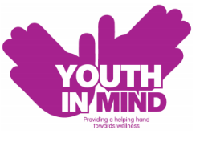
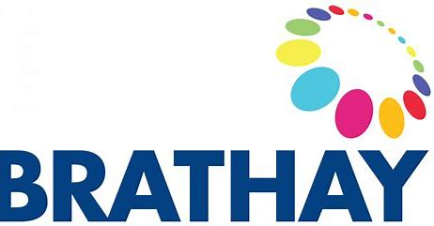

Peer Mentoring Newsletter
***** Digital Training Date 30th November 2020*****

We hope you are well, safe, and coping with the vast changes of Covid-19.
To get this exciting project to as many schools as possible to support our young people in theses challenging times, the training day with be held digitally.
With this in mind we are excited to be collaborating with the Youth in Mind Transformation Apprentices aged 16-24, this team have created a new resource called Peer Hero which aims to support young people to discover the positive impact Peer Mentoring can have across schools and communities in Bradford.
The apprentices will be taking part in the training and following on the apprentices will deliver a Peer Mentoring webinar in schools to act as a catalyst to promote the project and inspire engagement from young people.

This is an exciting programme for schools to be involved with and we hope you are as excited as us!
Do not forget this a free program for all secondary schools!

Please the attached flyer for more information about the peer mentoring programme.

Contact, Catherine Askham on 07739646175 or Catherine.Askham@Brathay.org.uk

I am writing to introduce you to an exciting new initiative being delivered by The Brathay Trust in partnership with Youth in Mind and the Youth In Mind Transformation Apprentices.

Brathay Trust are providing a free Peer Mentoring programme for the Bradford District and Craven to deliver a school-based, person-centred, and integrated approach to improving mental health and emotional wellbeing of children and young people.

We will do this by offering advice, guidance, resources/toolkits, and training to school staff chosen by school to enhance your mental health champions work and ethos.

The aim is for children and young people to design, implement and manage a one to one peer mentoring service within their schools.

We aim to do this by:

- Enabling students to support each other to improve their mental health and emotional wellbeing and build resilience, confidence, and self-esteem
- Reduce the stigma of mental health in schools
- Provide schools with training, advice, guidance, and resources which will enable them to deliver accessible and tailored peer support services to their students
- Help schools improve their students’ experience of assessing mental and emotional wellbeing and resilience
- Build a legacy of mental health awareness and peer support within schools

Have that go to person they would not normally have to talk through things with around settling in at school/bullying/identity/feeling and emotions.

In the wake of COVID-19 we all recognise there is likely to be:
- An increase in anxiety for young people transitioning to secondary school.
- By not attending school their learning may have been impacted upon.
- Feeling less effective academically could impede self-confidence, wellbeing, and resilience.
- Family relationship issues due to lockdown

Identifying and supporting these young people will be of the upmost importance, and peer mentoring can be a great tool to ensure this occurs. It instils a culture of mutual support and the less formal setting gets pupils talking more, with trained and supervised peers able to relate to mentees lived experiences. (All training to be provided free and at a convenient time to the school).

Brathay will ensure the school champion/peer co-ordinator allocated is fully trained and has all the resources and support required throughout the process, thus enabling the school to embed the peer mentoring programme for the long-term future.

We hope this will become a legacy project for Bradford. The peer mentors chosen by school will also benefit from the journey, with training and resources provided to them and will work closely with the peer mentors in other schools and will have the opportunity to gain qualifications/attend a residential all funded through the peer mentoring programme.

For more information please contact myself Catherine Askham on 07739646175 or email Catherine.Askham@Brathay.org.uk

