Ten Top Tips for pupils with Motor Skills Difficulties

- Give constant reminders and simple, clear instructions, this should be both spoken (oral) and written. It is important to repeat the key parts (important) information and to display key vocabulary with visuals. (Pictures or concrete objects)

- Make reasonable adjustments (where needed) and reduce the amount of material to be remembered – increase meaningfulness and familiarity of the material – and always link to previous knowledge.

- If using worksheets, focus on the key information so that it is clear and simple to see. Reduce the clutter on the worksheet to support this.

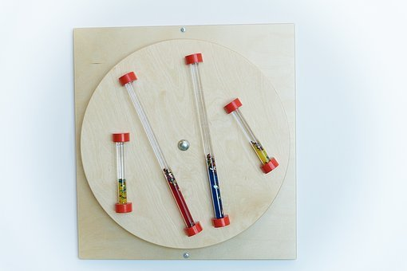
- Seat the child at the front facing the board and class teacher and check that they have a good sitting position for working with their feet flat on the floor and arms on the table at the right height.

- Give the child extra time and teach them how to organise
and plan their activities.

- Provide extra time for activities that require dressing and
undressing e.g. PE. Model strategies such as showing the child how to organise their clothes to make the task easier.

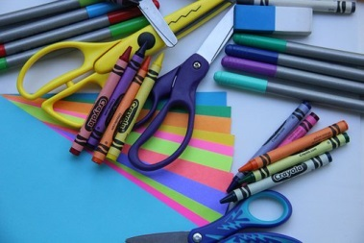
- If required reduce stimulation by removing other distractions e.g. Provide a quiet area with few distractions.

- Reduce the amount of written work that they have to do
through teaching and encouraging the use of alternate ways
of recording their work such as mind-maps and oral
responses.

- Do not ask the child to copy from the board or rewrite messy
work and always mark the content of work and never the
presentation.

- Find the child’s strengths and interests and build on them,
praising at least one piece of work everyday.

