Threes or Fours
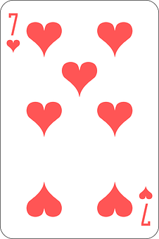

You need: a set of playing cards
Deal three or four cards. How many different one,
two, three and four digit numbers can you make?
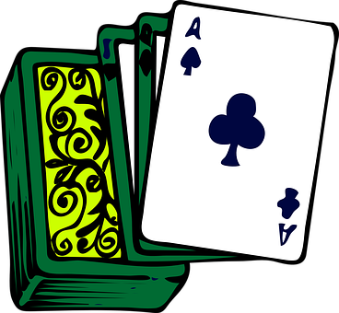
Put them in the right order.
Smallest to largest.
Largest to smallest.
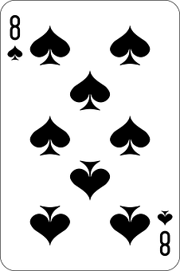
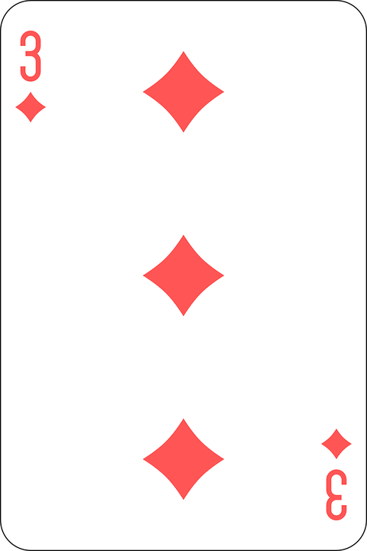
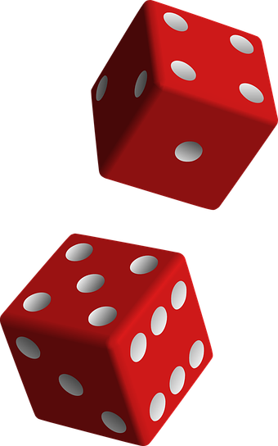
DICE SUMS
You need:
Two 1-6 dice
Throw two dice, use + and –

How many different sums can
you make in one minute?

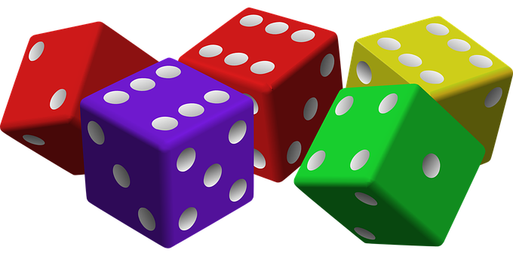
TOWERS

You need: Three 1- 6 dice
Throw the dice and make tower.
Add the numbers up each side of the tower.
Shake the dice and repeat

How many towers can you add up in three minutes?
MAKE A NUMBER

You need: One 1-6 dice.
? ? ?
Take turns to throw the dice. After each throw
choose in which box to put the number
shown on the dice. When everyone has had
their three throws who has the largest number?
Who has the smallest number?
This time decide before you play whether
the winner will be the person
with the largest/ smallest number.
DICE DECISIONS
You need: Three 1-6 dice and different coloured counters
Throw the three dice.
Use + and – to make a number and cover it,
For example 5,3,1 could be
5 + 3 + 1 = 9
5 + 1 – 3 = 3
0 | 1 | 2 | 3
4 | 5 | 6 | 7
8 | 9 | 10 | 11

Try to cover 3 in a row to win.

CHAINS
You need: A set of dominoes
Make a chain of 3 matching dominoes. What
is their total?
Try for a low total.
Try for a high total.
Try a different amount of dominoes.
This sum would be 5 + 3 + 5 + 3 + 3 + 5 = 24

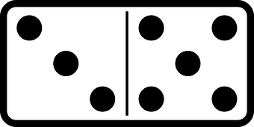

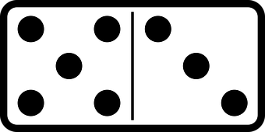


RING THE BELL
Total 10/20/50/100

Play this game with a friend. The aim is to
be the one with a number closest to 10/20/50 or
100.

Take turns throwing 2 dice and use any of the 4
operations ( +, -, x, ) to get a number.

Write the sum and keep score by adding the
totals together working up the chart
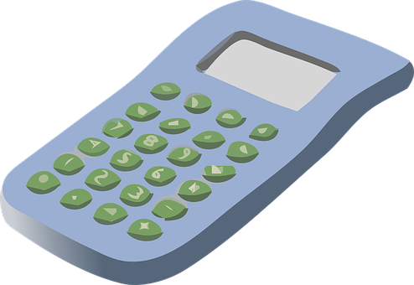
towards the bell.

Check each other with a calculator.
When you get close to your total you can ‘Stick’.
The person who gets closest to your given total is
the winner.

