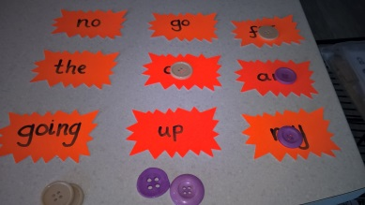
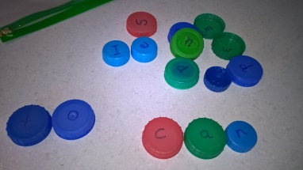
Spelling

Children should learn spelling in groups of words that are visually similar. Only teach 2 or 3 high frequency words/ common exception words a week and then add to them always remembering to revisit the words learnt. Try not to encourage rote learning but encourage him to analyse words – look for patterns, see likely combinations of letters and use this knowledge e.g. endings such as ‘ght’, look out for vowels and consonants and teach the child to check that every syllable will have a vowel or a pretend vowel in them e.g. ‘y’

Ideally the child will write in a joint up cursive script so that words are learnt as a unit rather than as separate letters. This should cut down on the opportunities to make errors. It will also give valuable kinaesthetic over learning of the words and will develop their motor memory.
Learn spellings in the following way.
- LOOK – Look in detail. How many letters? Are there any known letter strings in the word. Are there any surprises? Which is the difficult bit? Which bit might you get wrong? Underline it. Practice that first.
- COPY the word over and over on a piece of paper while saying the letter names until you can see the word in your head without looking. Keep doing this until you are sure.
- COVER the word up and try to visualise it.
- WRITE the word from memory, saying the letter names as you write and then the whole word e.g. ‘T’ – ‘H’- ‘I’ – ‘S’ – ‘This’. It is important that the whole word is written in one go. Any hesitation – start again
- CHECK – Have you written it correctly? If yes go on to the next word, if not start again from the beginning. If you got it wrong which bit was wrong? Why? Practice that bit on its own first. Then the whole word again.

Children should become self- monitoring with their spellings. Encourage them to revisit spellings previously learnt regularly. If they want support to spell a word at home or school encourage them to ‘have a go’ first either in a note book or a scrap of paper.

Always be positive and praise their attempts. Point out the correct part of the spelling and explain the bit that is wrong. Try to make them aware of spelling rules as you get to them e.g. ‘u’ always comes after ‘q’, etc.

Try to get children to observe common letter patterns so they can tell if a word looks or feels right. Split words into prefixes and suffixes but encourage them to write the whole word from memory rather than built it up. Find words with the same root or from the same visual family. Play games such as Scrabble to support spelling skills.
