Visual Sequences

Show the pupil the sequences for a few seconds. Get the pupil to draw or repeat the sequence with the cards.
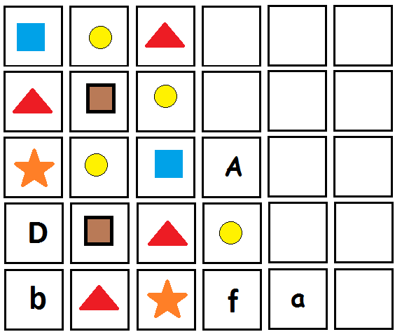

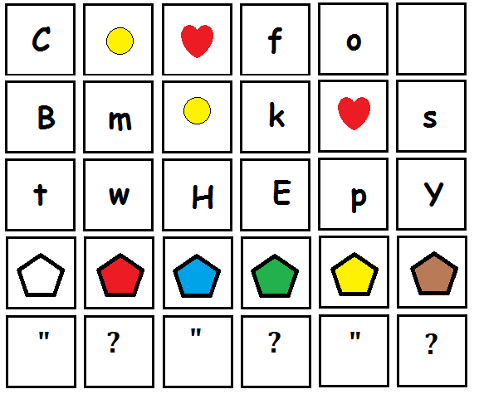
Visual Sequences

Show the pupil the sequences for a few seconds. Get the pupil to draw or repeat the sequence with the cards.

