- Play sound discrimination games. Say two words and see if they can tell if the words begin with the same sound or with a different sound. Gradually increase the number of words presented to children, where there may be two words with the same beginning sound and a foil. Have the children tell the word that begins with the different sound. This format can be used when working with ending and medial sounds in words.

- Have children generate chains of words that use a targeted beginning or ending sound.

- Have children use coloured blocks, chips, or felts to represent each sound they hear in a word. Touch each chip and say the sounds slowly. Slide the chips together and have the children pronounce the word. Create a Separate Sounds Activity to play with children.

- Use picture cards and have the children sort the pictures according to the targeted sound. When working with more than one sound, especially at the beginning, start with sounds that are not closely related, and gradually move to closely related sounds as students become proficient at distinguishing sounds.

- Have children tap the number of sounds they hear in a word on their fingers and blend the sounds to pronounce the word. After children separate the sounds, it is important to have them say the word normally to associate the sound pieces to the whole word.

- Isolate the sounds in the words and have the children blend the sounds to pronounce the word – for example say /s/…/a/…/t/ and have the children blend the sounds and say the word sat.

- Practice with substituting sounds in words. For example, say the word cat and have the children substitute the /c/ in cat with an /s/ to make sat. This activity can be done with beginning, medial, and ending sounds in words.

- Change name game – change children’s names by adding common endings such as adding /ious/ to the end of Jane to make the name Janious. Children find this activity amusing and will begin to add endings to change words to other objects and words.

- Sound bingos are useful whole class activities to support awareness of sounds in words.
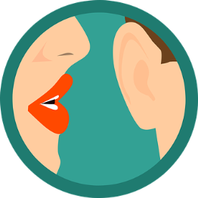
Sound Discrimination Games

