Mnemonics - ways of remembering spellings

Pupils could also draw these mnemonics to further help them to remember the spellings.
Remember they can always make up their own!

said | Silly ants in dresses  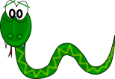  Snakes and insects dance
could  would  should | 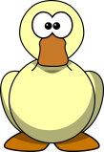  O u lucky duck
because | Big elephants can't always use small exits  Big elephants can add up sums easily
friend | Fred rushed in eating nine doughnuts.  Friends never end.
decide | I decided to join the C.I.D.
again  britain | It is raining in Britain again.  The rain in Spain falls mainly on the plain.
knew  know  answer  listen  fasten | Strategy - Pronounce all silent letters.  I often listen when you fasten the gate.
any  many  anything  anybody  anywhere  anyone | Learning and practising these words together provides over-learning of the spelling of any.
brought  thought  bought  fought  rough  tough  enough | Are you rough enough and tough enough to spell ough words?
laugh | 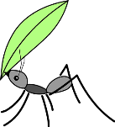  Laughing ants under green hats
Images taken from pixabay.com

