Memory Games Ideas
Visual Memory Games
1. Kims Game –
This game can be used from early childhood to adults to aid memory and observational skills.
To play this game you must choose 6+ items that are within the students vocabulary such as objects, letters, pictures etc.. Place them on a tray, (Make sure there are no distracting pictures or patterns)
Show them to the pupil allowing them to study them for a while. (This is usually based on the age and the level of the pupil).
Cover them up and get them to name the objects. Alternatively you can
remove one, two, three etc. The pupil has to guess what has been removed. Or
you can role a dice and the pupil has to name the number of items as indicated by
the dice.
Below is an example of the game being played:
https://www.youtube.com/watch?v=CNoZIHVSojM
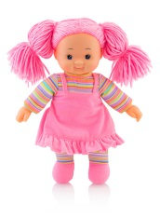  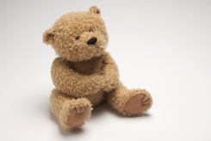  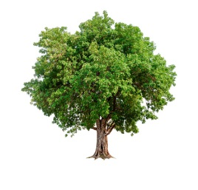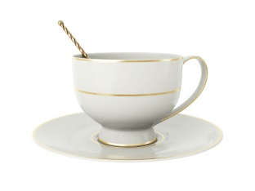 | 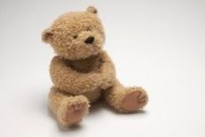  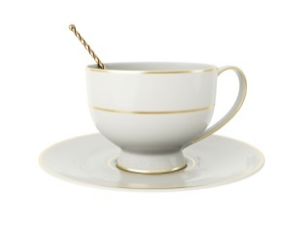

2. Letter recall:
Starting with 3 random letters and then covering them up. Then increase them to 4. You can make this fun by putting it in to game. It could be in a noughts and crosses game, toy theatre.
A H P | Cover up  A H P | A H P

3.Repeating a visual sequence.
This can be pictures, letters, shapes or words.
Start with 2 or 3 and increase. The pupil looks at the sequence and then has to repeat it with matching objects.
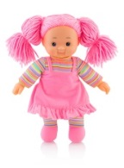
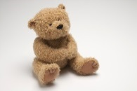

Yes Yes Maybe No Yes Yes Maybe No Yes

4. ‘Find the difference’ pictures.
5. Complete the shape – show the pupils a shape and then give them an incomplete
drawing of the same shape. Ask the pupils to complete the shape from memory.
Once shown – cover this up | :  complete the shape from memory
5. Complete the picture – show the pupils a simple picture and then give them an
incomplete drawing of the same picture. Ask them to complete the picture from
memory.
A
D
E
R

6. What can you remember game:
The pupil chooses a card.
They look at the card for about 10 secs. The pupil turns the card over or looks
away. They then shake one or two dice and recall that number of items from the
card.
7. Memory Matrix Game – (resource provided). The pupil turns a card over with a
pattern on a grid, they look at it for about 10 secs. They then have to copy the
matrix pattern on their grids using counters provided.
Auditory Memory Games
1. A Journey to Remember (resource provided). The pupil shakes the dice and moves that number of spaces to a square with a picture on it. They make a sentence
referring to the picture to start the story. The next player does the same but they
have to repeat the previous sentence and then add another – more detailed
instructions on the game.
2. I went to the shop and I bought…, I landed on the moon and I saw…, I went into the park and I played…, I went to the cinema and I saw…etc.
3. Pass the object, picture and add a comment about it, for example: a viking ship,
you sail in it, the Vikings build it … a book, you can read it, it has a picture on the
front…
4. Simon Says with 3, 4, 5, 6 instructions e.g. after you turn around three times, touch your head, clap your hands and stand on one leg.
5. Shopping – put items on the desk and ask the pupil to select a number of items.
Increase number and get them to place them in sequence to increase difficulty.
6. Give a series of instructions to a pupil to draw a picture. E.g. Draw a big square in
the middle of your paper, add a door, two circular windows with red curtains etc.
7. Ask the pupil to repeat sequences orally. You can also extend this activity by giving the pupil a range of letters and asking them to make a word and then read the word out loud. You could also give the pupil some wooden letters and ask them to sequence them. Once sequenced ask them to make as many words as they can from the letters.
8. Odd One Out – give the pupil 3,4,5 words and they have to repeat them and then
say which is the odd one out.
9. Opposites/Synonyms
Ask the pupil to recall sentences but tell them they have to give you opposites or
synonyms of key words, e.g. The young girl got out of the car and started shouting. becomes The older boy got in the car and sat quietly..
10.Barrier games – examples provided. In addition to grids and pictures, you can:
a. Make models with lego, bricks etc.
b. Make words with wooden letters then get the pupil to read the word. E.g. Put
the letter w in the second square, an s in the first square and a t in the last.
Then two e’s in squares 3 and 4. You can also have coloured squares, e.g. put
an s in the yellow square.
The following books are also very useful:
• Auditory Memory Skills by Mark & Katy Hill, LDA
• Visual Memory Skills by Mark & Katy Hill, LDA

