How parents who’ve applied for 30 hours already can access their account
Hi all,
Our call centre has been receiving a high numbers of calls from parents who have applied for 30 hours free childcare and/ or Tax-Free Childcare through the childcare service, but cannot recall how to access their account – and get their eligibility code.
Please share the information below with any parents who are having difficulty finding their code. This will mean that they do not need to contact our call centre.
Access to the childcare service can be found here - https://childcare-support.tax.service.gov.uk/
To get into their account, parents should click “”4. Apply or sign in to the childcare service as a parent”. They’ll then see this screen:

Parents can click “apply” and then will answer questions about their youngest child’s age before being asked to sign in using their Government Gateway ID, which they will have received when they applied.
Once they’ve signed in using Government Gateway, they will then see the childcare account screen:
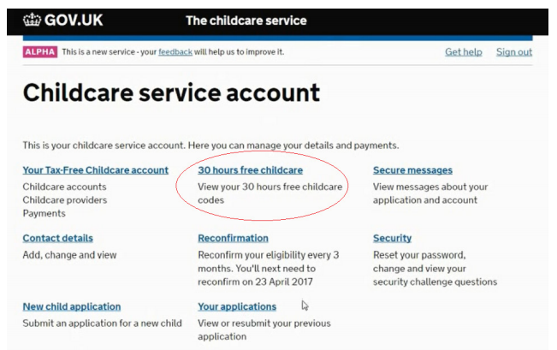

They can click on “30 hours free childcare” to see their 30 hours eligibility code. These normally start with “500”.
They will also find this code in their “secure messages”. An example secure eligibility message looks like this (this would be populated with the information of a real parent.
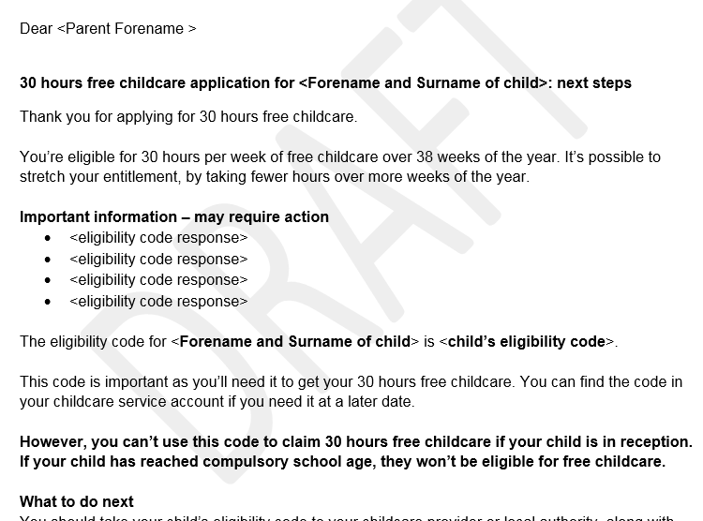

There may be a small number of parents who have a temporary code, starting “11…” They will have been given this over the phone, and will receive a letter containing this from HMRC too.
If any parents are still struggling to access their account, please ask them to contact our call centre on 0300 123 4097.
Please share this documents with any providers or other partners speaking with parents who might be struggling to find their eligibility code in their childcare account.

