General ideas for phonics and whole word teaching
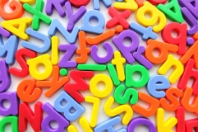

Suggestions for resources:
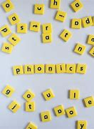
- Wooden & magnetic letters
- Picture cards, objects for alliteration
- Choose-it literacy app http://www.inclusive.co.uk/apps/chooseit-literacy#
- Jolly phonics - https://www.jollylearning.co.uk/
- Twinkl has a full phonics scheme plus lots of really useful resources www.twinkl.co.uk
- Phonics programme which has some free resources available to download https://monsterphonics.com/free-resources/
Teaching letter and sounds knowledge:
Make it multi-sensory

- Hear and say the phoneme.
- Hear and say the phoneme and use a sign.
- See the grapheme and say it.
- Say the phoneme and write it.

Sequence to introduce letters

Follow the sequence of letters and sounds. Start with SATPIN.
Start with two letters and when secure with one add another. Place letter they are secure with onto a ‘letters I know’ board.

Activities:

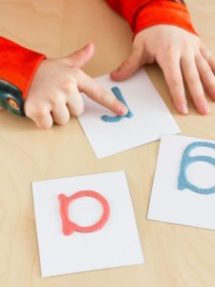
- Create a letter book. You can create one book and add a page
at a time or create a small book per letter. Stick in pictures or objects
beginning with the letter. Use pictures of the child going on a treasure hunt for objects beginning with that letter (showing what they found), a photo of models of the letter they have made using playdough/clay). You could stick pipe cleaner models of the letter in the actual book. You could also make letter books around topics, class stories.
- Have treasure boxes for each letter as they are introduced that they can add to, spend time decorating them and making them together. Make a clay model of the letter to add to the box and decorate.
- Play matching games, lotto, pairs etc.
  - Match letter to letter (play lotto, snap, games e.g. find as many letter a’s… etc. as they can around the room, use letter cards, wooden letter etc.
  - Match letter to picture cards which include the letter
  - Match letter to picture cars without the letter (pupil has to say the word and hear/identify the initial sound to match it to the letter)

Introducing whole words

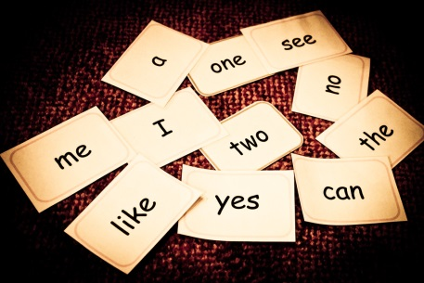
Make large flash cards of the words. Make sure the print is large. Create a words I am learning/have learnt wall/box

Activities:
- Match word to word, use a lotto board or simply have pairs of cards. Always say & (sign) the word together as pupil picks it up.
- Turn the cards over and play pairs.
- Have several copies of each word, group the words which are the same together. Every time pupil picks up a word say it together/also make the sign.
- Hold up a flash card whilst saying the word and ask pupil to find a matching word from their set.
- Say a word and pupil selects it from their words – only have about 4 words in front of him/her at any one time, if this is too much just have two words or one word and his/her name.
- Make the words using wooden/magnetic letters. Only give pupil the letters they need to make the word – jumble them up, provide him/her with a model to copy. Also do this every day with their name. Have pupil name (a model) and a photo on magnetic whiteboard with letters jumbled up underneath and get him/her to put them in the right order every morning. When they are ready you can remove the model.
Choose words that can make simple sentences, e.g. This is a, Here is a.
Make simple books using the vocabulary that link to topics, class books, hobbies, likes, family etc… For example: This is me. This is mummy. This is a dog, fish etc…
You can also use early readers with two or three word sentences that incorporate the words he/she can read or you are teaching.

