Games to play with a pack of playing cards

Number bonds to 10 (Remembered Facts)
Lay out the cards in a 3x3 grid.

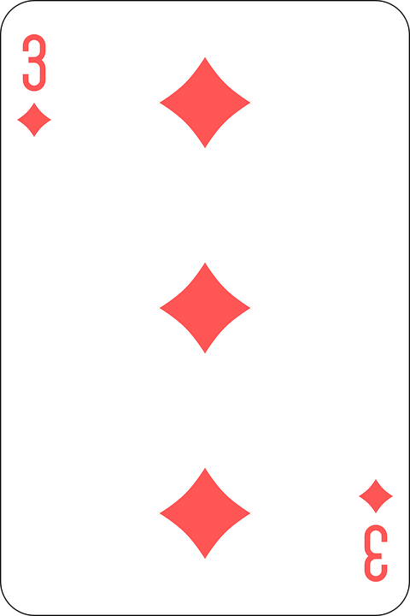
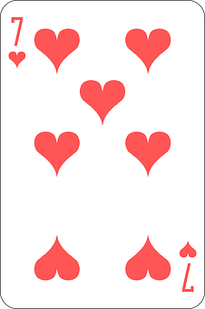
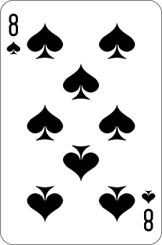

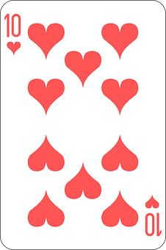
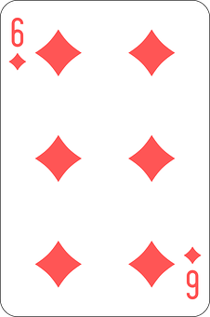
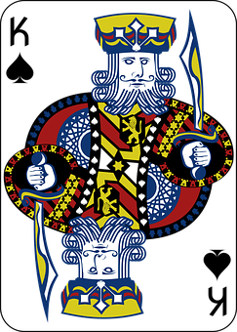

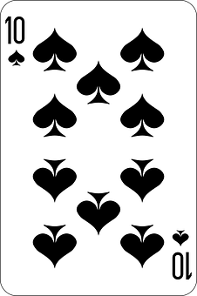
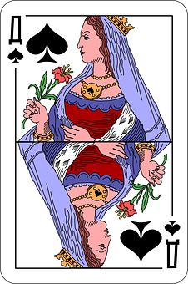
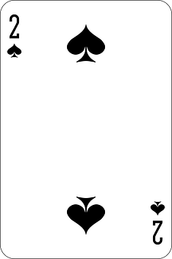

You can cover the pairs of numbers which total 10 with other cards. You can also cover the cards which are actually number 10 or the picture cards which are equivalent to 10.
With the example above you would straight away be able to cover King (=10) , 10, 10, 7&3, 8&2
The object of the game is to be able to deal out all of your cards.

Number Bonds (Remembered facts)
With the pack of cards turn over by one by one, ask the child to say the number which needs to be added to make 10.

Eg. The child would say 4 because 4+6 = 10

Change the total number eg. Ask the child what number needs to be added to make 7
Eg. The child would say 5 because 2+5=7

Once the child knows the game you can play it against the clock, or beat your own record.

Play this game but subtract from 10.
Eg. The child would say 7 because 10 – 3 = 7

Doubling Remembered Facts
Deal a card what is it doubled?

Derived Facts
Once the child is able to double confidently ask additional questions.
eg. Double 8 = 16 What would 8+7 be and how would you know?
What would 8+9 be and how would you know?

All these games could be adapted to different operations

Reading and Writing Numbers
Number range 1-10 – read the digit as you deal the card
Show a number ask the child to write the numeral or number word down?
Can the child match the same numerals?

Can the child sequence the numbers forwards and backwards? Largest to smallest, smallest to largest
Can they find a missing number in a sequence?
What number comes before/ after
What number is 1 more, 2 more, 1 less, 2 less

Counting Verbally
Count on/ back from a dealt card to a given number.

Hundreds, tens, and units
Number comparison – which is the largest? Smallest? What number could be between?
Using 2or 3 cards make a 2/ 3digit number, compare other 2/ 3 digit numbers – put in order from smallest to largest.

Higher/ Lower
Dealing out the cards ask the child to predict whether the next card will have a higher or lower value. Change language to include different mathematical vocabulary e.g. greater, less, more etc.

