

**FUNDED 30 HOUR CHECKER – USER GUIDANCE**

* The Funded 30 hour Checker is a secure web service for early years funded providers to enable providers to verify a 30 hour HMRC eligibility code.
* Parents will receive a 30 hour eligbility code following their application to [HMRC The Childcare Service](https://childcare-support.tax.service.gov.uk/).
* The code is an 11 digit number with the majority of codes beginning with 5000. Some parents may be issued a temporary code beginning with 11.
* Providers **must** check the codeis validbefore offering a parent any additional hours.
* Bradford Council will carry out audit checks on all submitted codes at least six times a year and any codes found not valid will not be funded.
* The Funded 30 hour Checker is located in the secure area of Bradford Schools Online, providers require a BSO account with level 2 access.
* This is a direct link to the [Funded 30 hour Checker](https://bso.bradford.gov.uk/secure/eligibility/checker.aspx)

**Completing the FUNDED 30 HOUR CHECKER online form**

* By using the Funded 30 hour Checker providers are confirming that they have the parent’s written consent to use their personal details.
* From September 2017 all parents must complete the Funded Place Parent Agreement to give their consent. Providers will be sent the Parent Agreement when it is finalised.
* Until the Parent Agreement Form is released providers must ask parents to complete an ELIGIBILITY CODE CONSENT FORM that can be found on [BSO 30 HOUR EXTENDED ENTITLEMENT](https://bso.bradford.gov.uk/Schools/CMSPage.aspx?url=30-hours) page under the Eligibility section.
* To check an eligibility code providers must complete all four sections of the form and click on *Check HMRC Eligibility Code.*
* An error message will occur if an invalid National Insurance Number or eligibility code is entered.
* Providers **must** print the check and **save** a copy as this will be required for Bradford Council audit purposes.

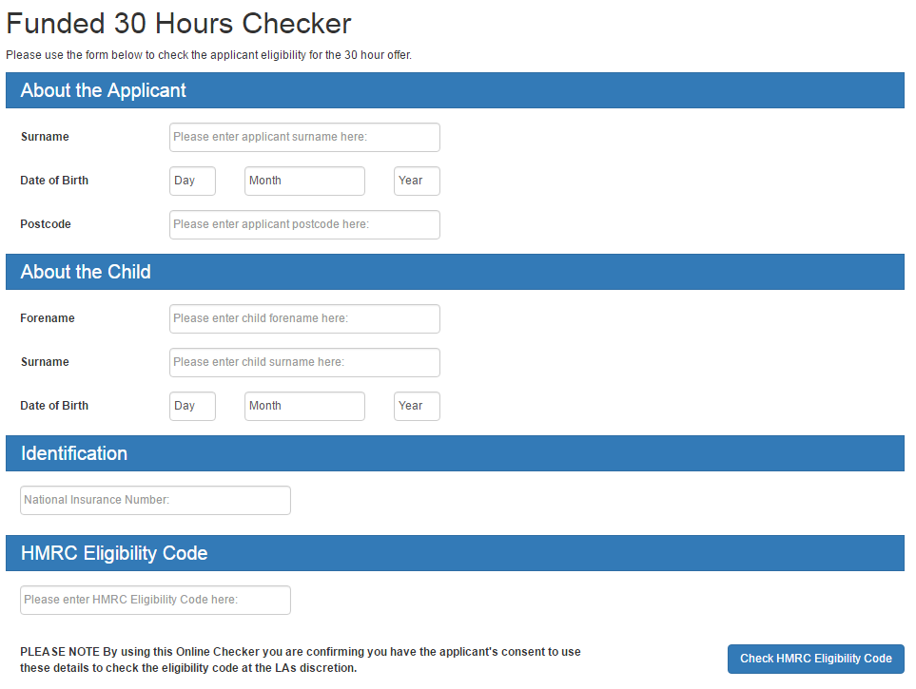

**FUNDED 30 HOUR checker RESULTS**

**There are 3 possible results**

1. Found (with dates)
2. Not Found (with dates)
3. Not found

**1. Found (with dates)**

This means the parents HMRC eligibility information was found and the parent is eligible for 30 hour extended entitlement.

***Screenshot of a Found (with dates) this is for illustration purposes and not an example of dates***

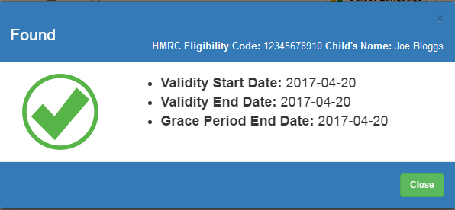

**A positive check will include the child’s name, the eligibility code and 3 dates, details on what the dates mean are sets out in the table below.**

|  |  |
| --- | --- |
| **Validity start date** | **This is the date the parent was issued the code.**  The funded hours can be offered from the start of the following term of the code date, subject to the child being of correct age which is a term after their 3rd birthday.  e.g. validity start date of a code of the 20th August then funded hours can start form the 1st September,  or a valid start date of the 1st September then funded hours can start from the 1st January  However if a child is in full time school including reception class then they are not entitled to the extended hours. This is regardless of a positive code check as the system does not check if a child is in full time school, providers must confirm with parents their child is not in full time school. |
| **Validity end date** | **This is the date the eligibility code is valid until**  The ‘validity end date’ is the parent’s ‘deadline’ for reconfirming. The parent is responsible for reconfirming and will be alerted by HMRC prior to the date.  Parents must reconfirm by this end date or they will enter the grace period.  E.g. validity start date of the 4th May for a child who is eligible from September will have a validity end date in August, the parent will have to reconfirm or they will enter the grace period and funded hours will only be available from the 1st September to the 31st December.  Bradford Council will inform the provider when a child goes into a grace period and when the funding will end. |
| **Grace period end date** | **This is the date the parent becomes ineligible for the extended hours**  A grace period end date is issued if   1. Parent and Partner has fallen out of eligibility i.e. either has lost their job 2. Child is no longer qualifying i.e. too old 3. Parent has failed to attempt reconfirmation on HMRC system when requested   This date will be one of HMRC grace period end dates set out in the Statutory Guidance |

**2. Not Found (with dates)**

This means the parent’s HMRC eligibility information was found but the eligibility code has expired.

There are several reasons for an expired code.

* Parent and Partner has fallen out of eligibility i.e. either has lost their job
* Child is no longer qualifying i.e. too old
* Parent has failed to attempt reconfirmation on HMRC system when requested.

If a parent believes they are still eligible after the grace period end date, providers should inform the parent to reconfirm with HMRC immediately or contact the Childcare Service helpline 0300 123 4097 for support.

The **Grace period** end date is when the parent’s eligibility ends and the funding will end; parents can choose to take up the funded hours up to this date, and provider can continue to claim funding if the child continues to attend.

Grace Period End Dates are always the last day in the term i.e. 31st March, 31st August, 31st December.

***Screenshot of a Not Found (with dates) this is for illustration purposes and not an example of dates***

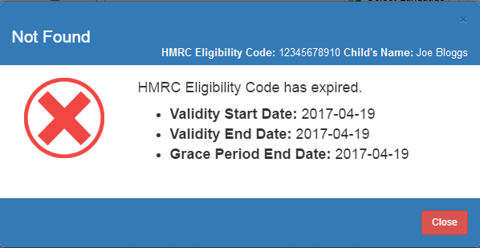

**3. Not Found**

This means the parents HMRC eligibility information was not found meaning the information entered did not return a positive result.

Providers should double check that the parent and child’s information is correct and carry out another check

Following a recheck if the result remains Not Found the provider should advise the parent to check the details they have provided and/or contact HMRC The Childcare Service for support. Providers must not be offer a place until they have a positive check.

***Screenshot of a Not Found***

