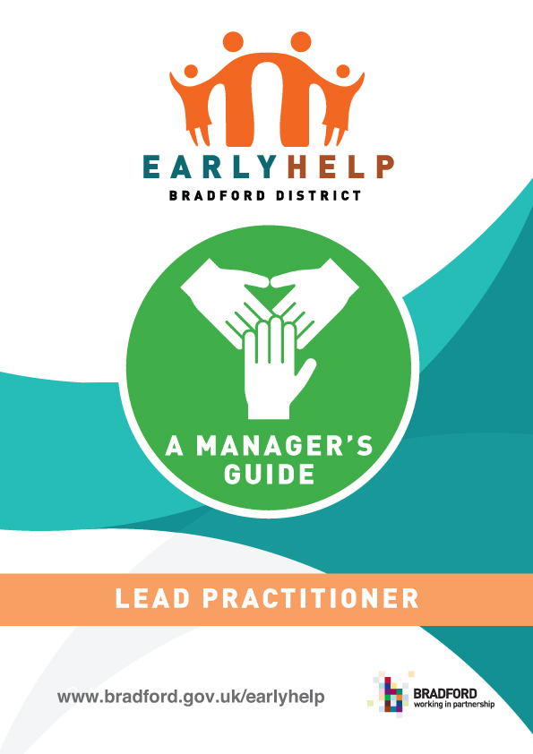

Section | Contents | Page No
1. | Introduction | 3
2. | Overview of Early Help and Lead Practitioner Role | 3
3. | Manager’s Responsibilities | 4
4. | Accountability and Early Help Quality Assurance | 4
5. | Appendices  Appendix A – Early Help Roadmap  Appendix B – Useful Links  Appendix C – Supervision Template | 6  7  8

- Introduction
This guidance is to provide support to those who have line management or supervisory responsibilities for their staff, who carry out the role of Lead Practitioner across the District that work with children, young people and families.

A Lead Practitioner is the named professional identified as the person who would be the main point of contact and who could be already working with, or be known to the family.

The Lead Practitioner could be any one of the following roles, but is not limited to these for example, a Teacher, any health professional, a Police Officer, a Housing Officer, a Family Support worker or other worker from the voluntary or community sector.

This guide is part of a suite of documents which supports Bradford’s Early Help approach and response: -

- Lead Practitioner Handbook provides an overview of the role and responsibilities of the Lead Practitioner as well as other professionals working with vulnerable children and families, across the Continuum of Need and Risk in Bradford District.
- Information Early Help Leaflet for families this provides information and an overview of Early Help and the approach available.
- Early Help Assessment and Team Around the Family Review this provides a step by step guide to carrying out the assessment.
- Bradford Impact Measurement Tool and Guidance this is used with families to record outcomes, impact and distance travelled.
- Lead Practitioner and Team Around the Family Audit and Guidance this helps to measure quality of practice and experience of the Lead Practitioner and Team Around the Family.

- Overview of Early Help and Lead Practitioner Role
Early Help is the term used to describe arrangements and services that respond to the needs of children, young people and their families as soon as problems start to emerge at any point in their lives, or when there is a strong likelihood that problems will emerge in the future.

Section 10 of the Children Act 2004 requires each local authority to make arrangements to promote cooperation between the authority, each of the authority's relevant partners and such other persons or bodies working with children in the local authority's area as the authority considers appropriate.

The Lead Practitioner is the named professional, identified as the person who will be the family’s main point of contact while they need a coordinated early help package of support. They will be one of a number of practitioners already working with the family.

Lead Practitioners play a key role in the effective frontline delivery of services for vulnerable children with a range of additional needs. They are vital in ensuring that support is well coordinated, resources are used effectively and good early decision making leads to better outcomes for both children and their families.

- Manager’s Responsibilities
To support you in your role as a manager or supervisor of a Lead Practitioner you should ensure your staff have completed the following activities/steps:

- Complete the Mandatory e-learning module “What Early Help is” on Bradford’s Learning Management System called “Learn and Develop”. This also offers a range of workforce development opportunities;
- Read the Lead Practitioners Handbook to understand the role of the Lead Practitioner;
- Access to the Early Help documents e.g. Assessment/Toolkit/Impact Measurement Tool/Team Around the Family meeting guidance;
- Know who your Early Help Locality Coordinators are and how to contact them for dedicated support, advice and guidance, at Appendix B;
- Read and understand the five steps of the Early Help Road Map, at Appendix A;
- Prepare your staff to discuss their casework and discuss this as part of their supervision with you;
- Managers to identify and escalate any barriers and/or workforce development requirements that are being identified by those carrying out the Lead Practitioner Role; and
- Managers to have an overview of how staff identify families and register the Early Help Assessments and the Team Around the Family reviews.

- Accountability and Early Help Quality Assurance
As a manager or supervisor of Lead Practitioners you are responsible for:

- Ensuring the Lead Practitioner understands the role of a Lead Practitioner and delivers this responsibility alongside their individual professional role in combination with other agencies to support the needs of families;
- Supporting your staff by providing regular supervision to discuss work capacity, wellbeing and any safeguarding issues that may need to be escalated ensuring that your staff have the capacity to carry out the Lead Practitioner role within current workloads as business as usual;
- Help to embed the culture of Early Help;
- Understand the performance and your organisation’s contribution to Early Help across the partnership;
- Encourage and direct staff to undertake the workforce development offer and support package available;
- To report any issues and/or improvements to the Early Help Coordinator;
- Attend relevant partnership/sub-group meetings;
- Partnership commitment to enhance the Team around the Family experience through an appreciative inquiry. Ensure that your Lead Practitioners are taking part in quality assurance audits, network and locality meetings and Lead Practitioner Panel meetings to help flag issues, drive practice and outcomes;
- Should a member of staff who is a Lead Practitioner not be able to attend a Team Around the Family meeting a written update is provided to the meeting;
- Should a member of staff who is a Lead Practitioner be unexpectedly absent from work, reallocate the role of Lead Practitioner to another member of staff and alert the Early Help Coordinator;
- Encourage your Lead Practitioners to be proactive in sharing information as early as possible to help identify, assess and respond to risks or concerns about the safety and welfare of children; and
- As a manager you may have your own supervision record for the direct work your staff carries out with families. Where you don’t we have attached a suggested template for you to use at Appendix C.

Appendix A

Appendix B - Useful Links
 | Link/Email Address | Useful Information
Learn and Develop Bradford | evolve@bradford.gov.uk | 01274 434503
Early Help Coordinators | Early Help Coordinators East:  ehcfamilyhubeast@bradford.gov.uk  Early Help Coordinators West:  ehcfamilyhubwest@bradford.gov.uk  Early Help Coordinators South:  ehcfamilyhubsouth@bradford.gov.uk  Early Help Coordinators Keighley/Shipley:  ehcfamilyhubkeighleyshipley@bradford.gov.uk | East Family Hub: 01274 437523  West Family Hub: 01274 436700  South Family Hub: 01274 434940  Keighley/Shipley Family Hub: 01274 01535 618005

Appendix C - Lead Practitioner Supervision Template

Lead Practitioner Supervision

Name of practitioner

Role
Name of Organisation

Name of the child / children
EHM Number (check)
Date of discussion
What is working well?

Identify what is going well for the child and family. Identify the strengths for the child and their network (this could be family or community).
What has worked well since the last TAF?
What are we worried about?

Set out what are the issues or concerns highlighting what has not worked since the last TAF. Capture a summary of the discussion identifying any particular events that are worrying the LP and any identified challenges.
What needs to happen

Identify whether any further support is required. Think about whether we need to change how we are working with the child and family. Consider whether Early Help the right level of support for this family and think about whether it would be helpful to speak to an EH coordinator.
How are we going to do this?
Set out your plan of work clearly with timescales and a point of review.
Name and role of manager

Date shared with LP

