Professional Portal
User Guide for Bradford Council

Table of Contents
Overview 3
Registering on the Professional Portal 4
Logging into the Professional Portal 5
Portal Home Page 6
SEND Portal Area 7
Key Points………………………………………………………………………………………………………………………………………….8

Overview
The Professional Portal is a secure online gateway provided by Bradford Council and Capita Business Services enabling professionals to self-register and then provide information to the Local Authority (in relation to SEN) about the children and young people they work with.
The main benefits of using the Portal are:
- More efficient information gathering
- More efficient information sharing
- Better engagement of child, young person & parent/carer
- Improved monitoring and sharing of the status of an application

Who will use the Professional Portal?
Any professional involved in the EHCP Assessment process, including:
- Schools / Academies
- Early Years Settings
- Post 16 establishments
- Educational Psychologists
- Social Care Professionals
- Health Professionals

Parents/carers and children/young people will have their own portal for submitting and sharing information, this is the Citizen Portal.

What you can do via the Portal:
- Request an assessment
- Submit advice/reports
- See other information submitted by professionals/parents involved with the assessment

Registering on the Professional Portal
To register on the Portal navigate to the following web address and save the web address to your internet favourites for easy access:
https://oneonline.bradford.gov.uk/ProfessionalPortal_LIVE/Account/Login?ReturnUrl=%2FProfessionalPortal_LIVE%2F

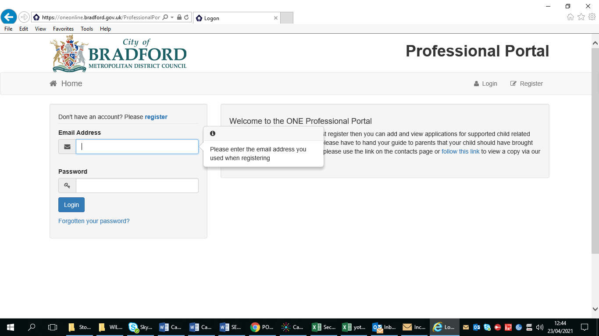

Once you are on the Portal you will have an option to Log in or Register as in the screen shot above. To register click on the Register link and follow the on screen instructions.
Please use your work email address to register and fill in all the fields such as work address and phone number.
You will also be required to set up Two Step Verification, this is an additional process to increase your security when logging on to the Portal. This process is mandatory if you wish to use the SEND aspect of the Portal. When enabling Two Step Verification you must select “Email” as your preferred method.
Please note, as part of the registration process, the Portal will send you an email to complete your registration. Please make sure to check your spam/junk folders if you cannot find the email in your main inbox.

Logging into the Professional Portal
Once you have registered and enabled Two Step Verification you will be able to use the Portal. Log in using the link provided. At this point you will receive a verification code. Enter the code into the box as per the screen shot below and click Verify.
Please make sure to check your spam/junk folders if you cannot find the email in your main inbox.

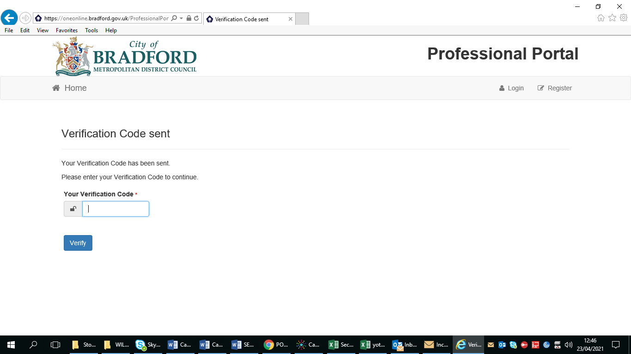

Portal Home Page

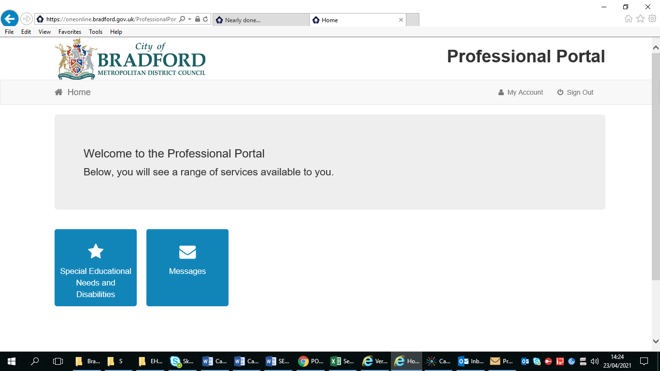
Once you have received and input your verification code you will be able to see your own Professional Portal home page. Here you can see messages that are sent to you that concern SEN for example the SEN Team can send a message here to let you know that you need to submit some advice regarding a child/young person.
If you click on the Special Educational Needs and Disabilities tile then you will see all the children/young people that are linked to you.

SEND Portal Area
In your SEND Portal Area you will see the children and young people that are linked to you, meaning you can provide and receive information via the portal on these records. Children/young people can be linked to you in 2 ways:

- By adding a record youself using the Add Person button. You will only add records yourself when you are initiating the intital assessment e.g. a school would submit a request for assessment via the portal.
- The SEN team will link a child/young person to you when requesting your input e.g. the SEN team have requested advice about a child from a professional. The child would then appear on that professionals SEND Portal area page as below:

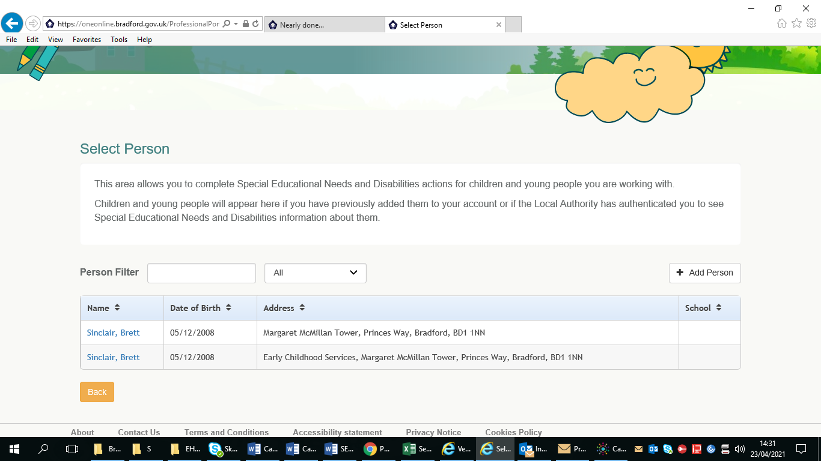
If the SEN team link a child/young person to you then you will receive a message into your Portal message inbox on the Portal Home page as well as an email notifying you.
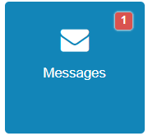
The Message tile will display a number in red when you have any messages

Key Points

- You need to register and enable Two Step Verification before you can use the Professional Portal
- Remember to check your emails for notifications that come via the Portal. Notifications will include your verification code that you will need every time you log on, and also messages from the SEN Team notifying you that you have an action to complete a form
- You can view other information submitted by Professionals or Parents such as the Parental Consent Form
- You must complete all parts of the form or your information might be rejected by the SEN Team
- You don’t have to complete a form in one go, you can come back to it at a later date

If you need any assistance with using the Professional Portal then please contact the SEN Team on 01274 435750 or email sen@bradford.gov.uk

