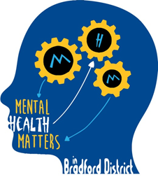
Mental Health Champions in Bradford Schools: A Future in Mind Initiative
Role description for Mental Health Champions
Opportunities include:
Making a difference to vulnerable young people in your school, through professional mental health intervention, supported by clinical group supervision
Developing professional skills and knowledge about mental health
Delivering evidence based interventions for individual s and groups
Taking a strategic role in a core aspect of educational provision
Collaborating with colleagues across a range of disciplines and professional backgrounds
Attending specialist training, and receiving accredited training to run accredited interventions in schools
Talking through professional concerns and developing targeted responses for vulnerable groups and individuals

Core responsibilities will include:
Attending Mental Health Champions Network Meetings, and participating in clinical group supervision
Liaising with mental health professionals from a range of services including CAMHS, the Educational Psychology and the voluntary sector to undertake individual and group work with children in your schools, where appropriate
Ensuring that any individual or group interventions undertaken in school have a robust evidence framework, and meet the quality assurance standards of the Mental Health Matters: Future in Mind Steering Group
Disseminating information about current mental health issues, including appropriate resources to colleagues in schools
Maintaining the Mental Health Matters Information stands with current resources which are shared through the network meetings
Developing skills and competences in understanding and addressing mental health issues through attending the Mental Health Champions network meetings, and other training co-ordinated through the network
Sharing information about training opportunities on mental health matters with staff teams, and liaising with senior school staff to ensure that all school staff receives appropriate training, as required by the Children Act 2004

